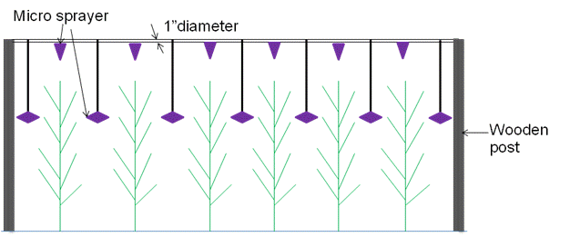

Figure1: Field layout of the SSCD system

