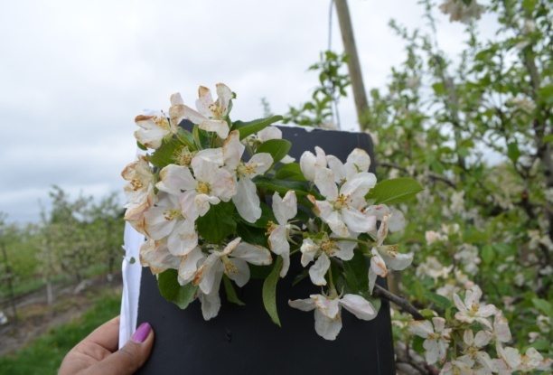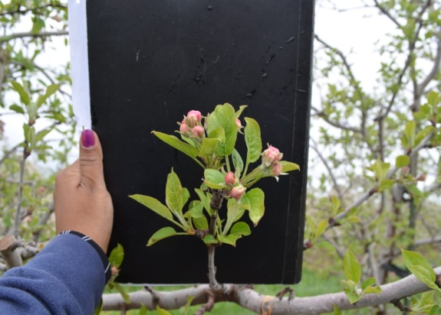

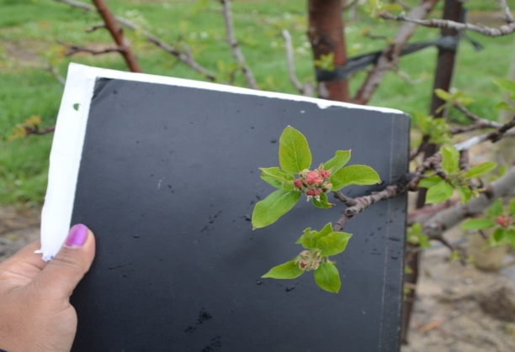

Figure 3: Visual comparison of phenological development of Control (upper left), Mist off on May 13(upper right), and Mist off on May 16 (lower left) on Red Delicious apples, May 16, 2014 at SWMREC site.

