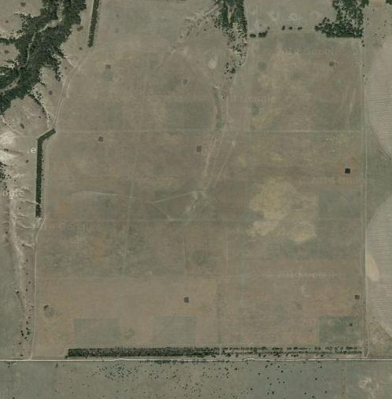
N

2km
Figure 1. A map of the study site from google earth, with areas burned in spring 2014 visible from space (circled in red). 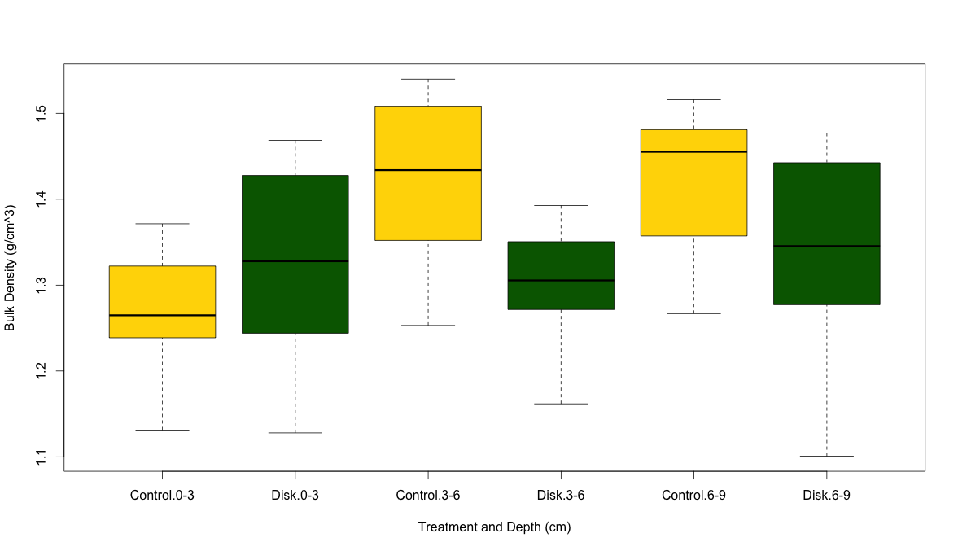
Figure 2. A box plot showing the effect of disk tillage on bulk density (g/cm³) across three depths (0-3cm, 3-6cm, 6-9cm).

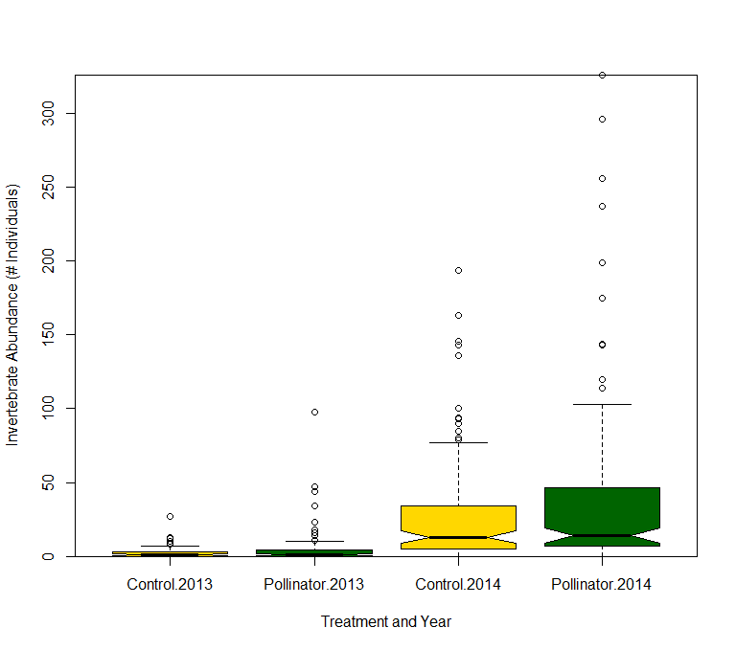
Figure 3. A boxplot of showing the effect of interseeding with a high diversity seed mix (“Pollinator”) on ground dwelling macroinvertebrate abundance in 2013 and 2014. Notches represent the median.

