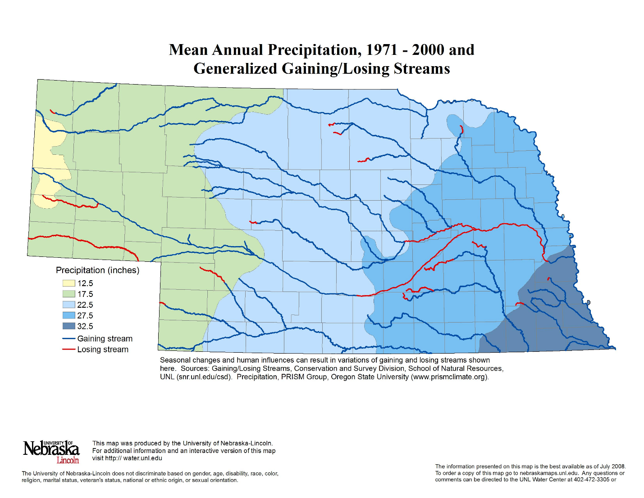

**Brule, NE (19 inch)**

**Silt loam**

**Clay Center, NE**

**(28 inch)**

**Silt loam**

**Lincoln**

**(29 inch)**

**Silty clay loam**

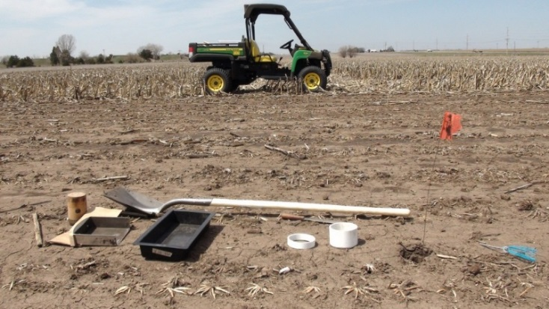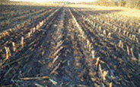

Fig. 2. Precipitation map of Nebraska (<http://water.unl.edu>) showing the study sites.