Final Report SARE project FNE 14-792
A comparison of traditional nitrogen and nutrient-dense fertilization regimes in organic potato production.
Summary
The goal of this project was to compare two different organic fertility programs. The first program uses fertilizer recommendations based on a University of Massachusetts soil test, followed by side-dressing of nitrogen based on the Pre-sidedress Soil Nitrate Test (PSNT). The second program follows recommendations of Advancing Eco-Agriculture (AEA), which emphasizes calcium, potassium, and micro-nutrient fertilization over nitrogen. The AEA program uses a plant-tissue sap test to determine fertilization during the crop season. This program claims to increase crop yields and avoid pest problems by supporting optimum plant health.
This project evaluated the effectiveness of fertilization strategies that are being promoted to organic farmers under the name “Nutrient Density”. While the claims of these programs are compelling and cohesive, I was not aware of rigorous scientific testing of any of these programs. Some of the recommendations of the AEA program are consistent with a more conventional approach to soil fertility, while others depart widely. One of the clearest contrasts between the AEA approach and a more conventional program is in the emphasis on the role of nitrogen fertilization. The conventional University recommendations would use soil testing to adjust most macronutrients before planting, but typically would call for nitrogen fertilization to be split into two applications: one made at planting and a second made mid-season. One tool that is commonly used to determine whether that additional side-dressing of nitrogen is needed is the PSNT—if nitrate levels in the soil are below a certain point at a critical growth point in the season, then nitrogen fertilization is recommended. The AEA program relies on testing of a wide range of nutrients in both the crop tissue and in the soil, and aims for a balanced level of all nutrients. The soil tests that are used differ between the two programs, and the recommendations of what adjustments need to be made differ, but in the AEA program, major adjustments to soil fertility are accomplished in the fall. In the AEA program, nitrogen is rarely the most limiting nutrient. In fact, the AEA program typically calls for fertilizing with other nutrients because over-fertilizing with nitrogen tends to encourage pest problems by increasing the levels of nitrates in the plant, making the plant more attractive to insects.
I have seen positive results of feeding liquid fertilizers from AEA through drip tape in fruiting crops. My approach with feeding through the drip tape has been to supply a general mix of nutrients, including micronutrients, supplemented by Ca during vegetative growth and K during reproductive growth. I feel that in recent years, I haven't been getting the yields I would like from heavy-feeding crops that I grow on a two-row system such as potatoes and brassicas. My hunch is that these crops would yield better with better in-season fertilization, and I wanted to compare these two fertilization programs within the season. I chose potatoes as the test crop because I grow potatoes with a large enough block of a single variety that it will be more convenient to make a replicated trial with large enough plots that treatments can be applied with tractor-mounted implements. Besides the soil amendments applied, our soil fertility regime over the past several years has also featured a rotation that puts land into pasture for one season out of four for soil-building. Both grazing and grain-fed animals are put on that pasture; thus we are importing nutrients in the form of organic grain, and building soil quality and organic matter through the pulses of root-pruning that occurs each time the pasture is grazed. We have also added rock powders and other amendments (sulfate of potash, gypsum, rock phosphate, micronutrients, and basalt quarry fines) according to recommendations based on soil test results from Logan Labs and from Lancaster Agricultural Products. We have seen definite improvements in our soil productivity over the last 9 seasons, which we attribute to all of these improvements being made in concert.
The “Nutrient Density” programs are being heavily promoted by the Northeast Organic Farming Association and other associated organizations, but there is a great deal of confusion among farmers about how to implement these programs, as well as strong skepticism from the University community and some segments of the organic farming community. The genesis of this project occurred in 2012, when I had mediocre growth in my fall broccoli plantings. My farm is next door to Extension Vegetable Specialist, Ruth Hazzard, and she is also a member of my CSA. We both saw the lackluster growth of my fall broccoli plantings, and had a strong interest in improving my broccoli yields. Ruth and I took a PSNT and a plant tissue test in my broccoli plantings, and found that while the PSNT called for nitrogen fertilization, the Logan Labs test plant tissue test found an excess of nitrogen, and instead called for additions of calcium and potassium to bring those nutrients into balance with nitrogen. This project tested these two contrasting fertility programs.
The results showed no significant differences in yield or in insect or disease pressure. The AEA program was able to support adequate nitrogen levels in the plant with minimal added nitrogen, and showed higher levels of potassium and micronutrients in the sap test results. The fertility program cost was higher for the UMass program, though the UMass program was much less costly if lower-cost fertilizer sources were used.

Methods
The field was separated into 6 plots, 3 of which were randomly selected to receive the AEA treatment, and three of which received the UMASS treatment. The plots were each 2 beds (4 rows or 12 feet) by 150 feet. The whole field was planted on May 9th, with Keuka Gold potatoes planted about 18 inches apart in 36” rows, by hand into furrows made by an offset potato hiller, and then the furrows were closed with a potato hiller. All plots received the same cultivation, hilling, and pest management throughout the season. This included approximately weekly sprays of Pyganic for control of Potato Leafhopper starting on June 12th and ending on July 16th for a total of four sprays. The first two sprays included Grandevo for additional leafhopper control, and the second two included Entrust for Colorado Potato Beetle control. On July 30th, late blight was confirmed in the field, and the whole field was mowed to prevent the spread of the disease to the tubers and to tomato plots nearby.
The fields were scouted weekly for presence of important insect pests, insect damage (0-100%) and severity of common diseases (scale of 1-4). Insect damage ratings represent a combination of “hopperburn” caused by PLH and feeding damage from CPB. Disease severity ratings represent almost exclusively damage caused by late blight, as the disease came in early and quickly consumed plants before other diseases were established.
Plant sap tests were taken in order to determine foliar nutrition needed for the AEA program. For this analysis, leaves were collected from the first fully expanded young leaf and the oldest mature yet healthy leaf on 30 leaves per plot. We also collected leaf samples and submitted them to the UMass Soil and Plant Tissue Testing Lab for plant tissue tests (total elemental composition of dry-ashed plant material).

Potatoes were harvested on August 20th and were assessed for marketable yield and tuber nutrient composition. Subsamples from each plot were taken from two 5-foot sections of the inner rows of each plot. Marketable yield was assessed in terms of both number of tubers, and weight of marketable tubers. Tuber size was classified according to industry standards into four classes: creamer = 0.75-1.25” diameter; small= 1.25-2.25” diameter; medium= 2.25-3.25” diameter; and large = >3.25” diameter. A subsample of 10 harvested tubers from each of the small and medium classes (total of 20 tubers) was also assessed for quality using a 1-10 scale (Falloon et al.) for external damage caused by diseases such as scab, late blight, and rhizoctonia, and internal damage was rated as incidence (yes/no damage present) and was largely attributable to insect feeding and not disease. Tuber samples were also submitted to the UMass Soil and Plant Tissue Testing Lab for total elemental analysis as a proxy for understanding nutritional quality of harvested tubers.
All data were subjected to statistical analysis using PROC GLM in SAS 9.0.

UMass Plot Fertility
Soil from the UMass plots was sampled April 15th, and sent to the UMass Soil Testing Lab. Based on the recommendations of this soil sample, we applied blood meal and sulfate of potash for a total of 100 pounds of actual nitrogen and 40 pounds of actual potassium. We took soil samples from within the potato hills on May 28th when the potatoes were approximately six inches tall to determine if more nitrogen was needed (a Pre-sidedress Soil Nitrate Test (PSNT)). This test was interpreted by UMass to indicate that there was no need for further nitrogen, so none was applied. The UMass plots then received the same pest control treatments and sampling that the rest of the field received.

AEA Plot Fertility
The program in the AEA plots was a generalized program that was modified only by testing of the plants in the season. Soil from the AEA plots was sampled on April 15th, and sent to Logan Labs for testing. The only recommendation from that soil test was to apply 300 pounds per acre of gypsum, but we received that recommendation too late to apply gypsum. The AEA plots were sprayed with 2 gal/A of Rejuvenate (a microbial stimulant) and 50 g/A of Spectrum (a microbial inoculant) after the winter rye cover crop was plowed in but before disking of the field. Then a mixture of Planter’s solution and Sea-shield (nutrient blends), and Bio-Coat Gold, Pepzyme, and Biogenesis (microbial inoculants and stimulants) was sprayed on the potato seed in the furrow before the furrow was closed. The recommended rate of these products was 3 gallons per acre of Planter’s solution, one pound per acre of Biogenesis, 12.5 oz./A Pepzyme, 2 qt./A Sea-Shield, and 4 oz./A Bio-Coat Gold. We had trouble with the sprayer and ended up spraying more than the recommended rate. Starting on June 5th, we applied a liquid side-dress to the soil every 3 weeks, consisting of 6 qt./A of Planter’s Solution and 2 qt./A each of Sea-shield, PHT Potassium and PHT Calcium. We also applied a weekly foliar feed mixture of 0.25 acres Micro 5000 (a microbial inoculant/ nutrient blend) at 2.66 oz. per acre, 0.25 acres Pepzyme Clear (a microbial stimulant) at 12.5 oz. per acre, 3 qt. Forage Foliar Blend (a general nutrient blend), 2 qt. Sea Shield (a liquid crab product), 1 qt. PHT Potassium, 1 qt. PHT Calcium (more specific fertilizer blends). We sampled leaves from the AEA plots and sent them to Crop Health Laboratories for sap testing on June 15th and July 13th. Based on results of the first sap test and the recommendations of our AEA consultant, starting June 23rd, the weekly foliar feed program was changed: the rate of Forage Foliar Blend was increased to 4 qt./A, and the PHT Calcium was increased to 3 qts./A, due to a deficiency in Ca interpreted from the plant sap test results. On July 18th the weekly foliar feed program was modified again based on sap testing to add 8 oz./A of MnS due to a deficiency of Mn interpreted from the plant sap test results

Results
Of all of the cropping outcomes we sought to evaluate in this study—insect damage, disease damage, and crop yield—the two fertility programs performed equally, as implemented. In the figures presented below, significant differences are indicated with the following symbol: ***. If no asterisks are present then differences between treatments were not significant. There were no significant differences in severity of insect damage, severity of disease (in this case, late blight), or in marketable yield of potato tubers, in either number or weight. The yield per acre was not different between treatments, and average 19,980 pounds per acre. There were also no significant differences in nitrate, ammonium or total N in plant sap tests, plant tissue tests or in harvested tubers.
The only significant differences that we found were in the plant sap tests: The AEA plots were higher in potassium, boron, and manganese. Potassium was higher in plant sap tests from both young and old leaves, but the UMass tissue tests did not show any differences in assimilated potassium between treatments. Boron was significantly higher in AEA plots relative to UMass plots according to results of both the plant sap tests and the plant tissue tests analyzed at the UMass Soil and Plant Tissue Testing Lab. According to the plant sap tests, the UMass plots had higher magnesium in the older leaves than in the younger leaves, which can be interpreted as a sign of excess magnesium, depending on the age and maturity of the crop.

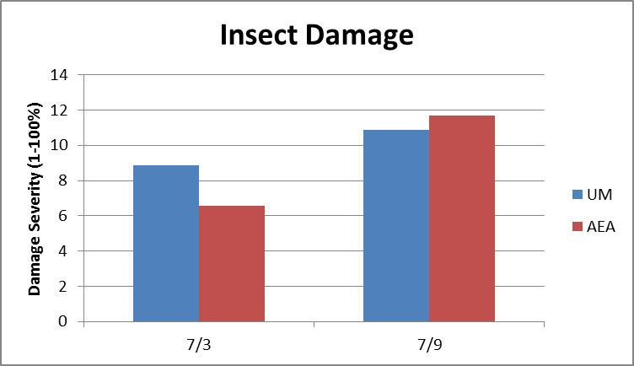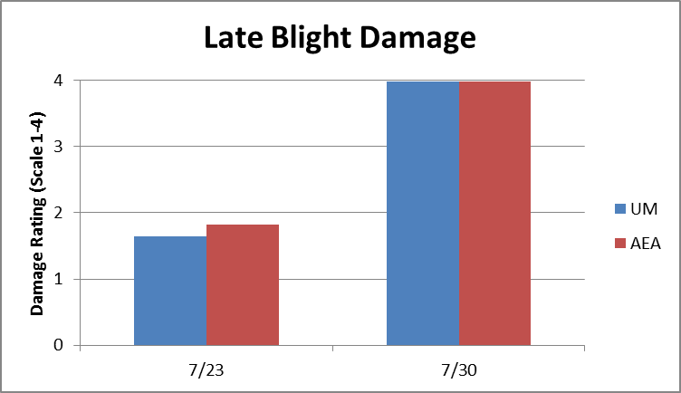
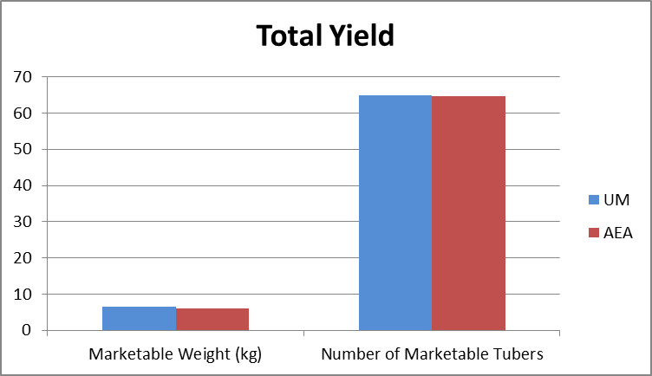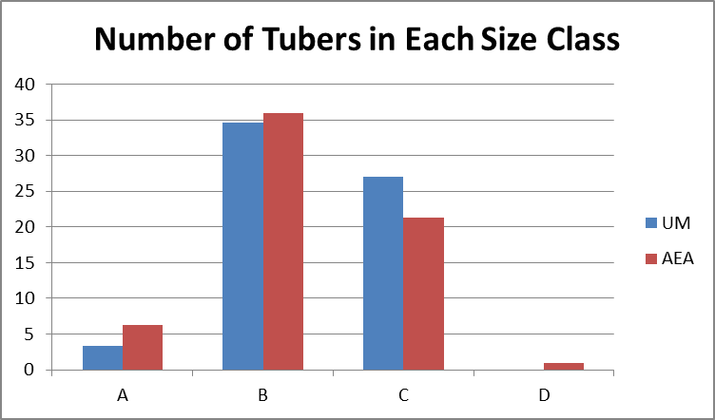

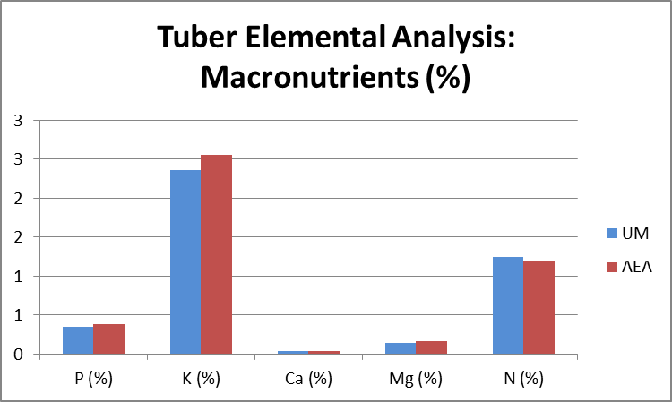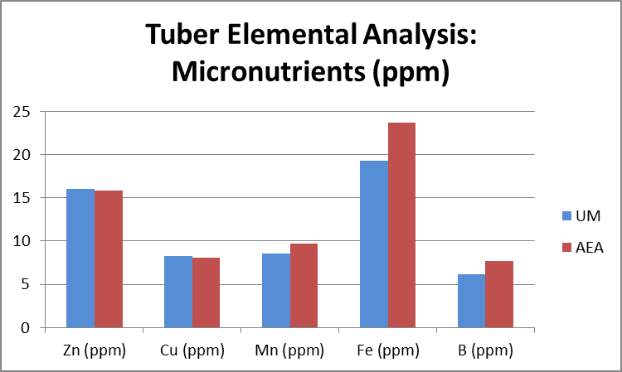

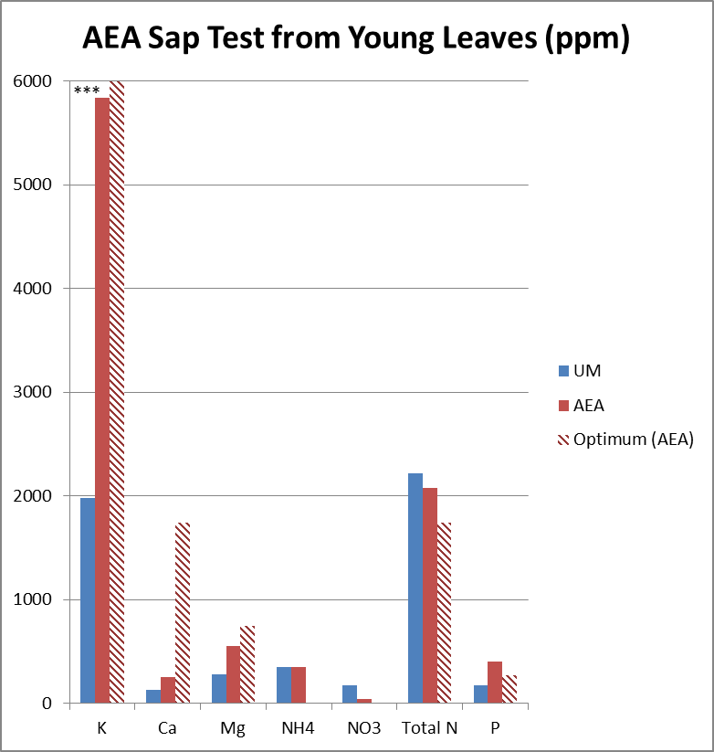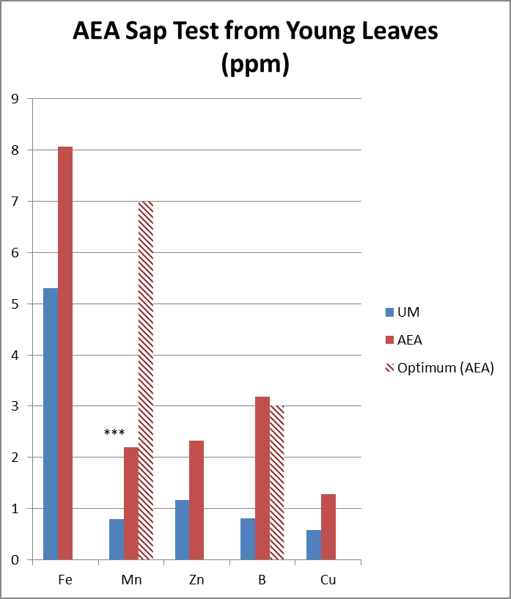

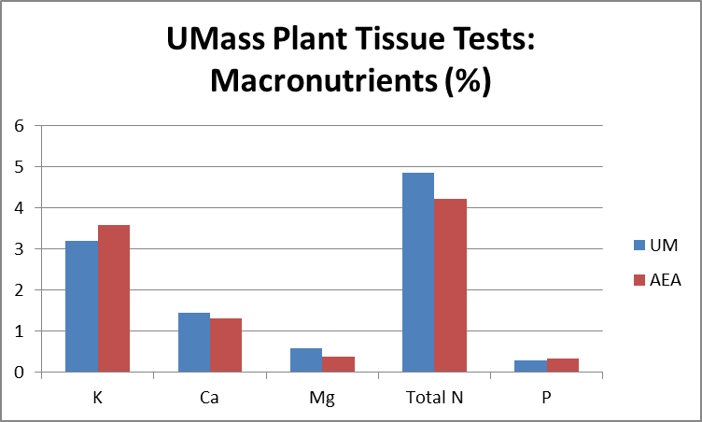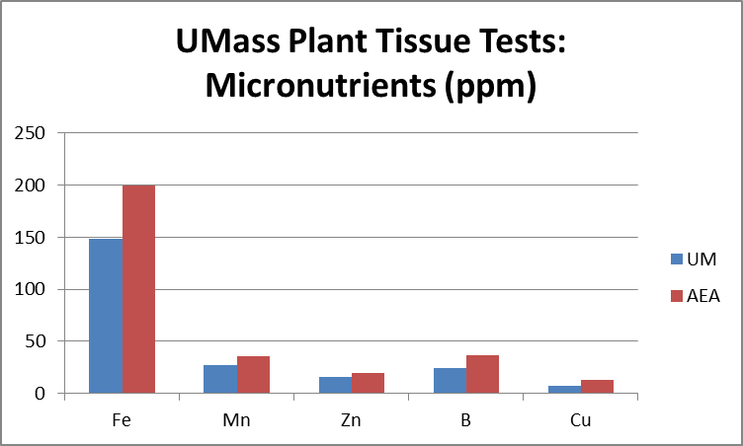

Discussion
The goal of this project was to compare two different systems of crop fertility: a “nutrient dense” approach focusing on micronutrient fertilization offered by Advancing Ecological Agriculture (AEA) with typical University/Extension recommendations based primarily on nitrogen fertilization. In order to evaluate success of each program, we compared insect damage, disease damage, and tuber yield and quality. The two fertility programs performed equally, as implemented, in all of these metrics. There were no significant differences in severity of insect damage, severity of disease (in this case, late blight), marketable yield of potato tubers (in neither number nor weight), or in tuber quality (in neither disease severity nor nutrient composition).
There were a few places where our implementation of each system deviated somewhat from the prescribed methods: in the AEA treatment plots, calibration errors resulted in over-application of some products on some dates; and in the UMass plots, results of PSNT soil tests did not call for additional applications of N mid-season (beyond the 100 lb/A applied based on pre-season soil tests) while Extension recommendations call for a total of 120-180 pounds of N per acre. The PSNT test has been well studied in many crops but potato is one crop for which precise data is lacking. For crops that have not been well-studied, soil testing labs often recommend a side-dress application of N if the PSNT is 25 ppm or less. Results of the PSNT test from UMass plots were 28 ppm. Based on these data we decided not to apply a side-dress of N. University/Extension guidelines call for a seasonal N rate of 120-180 pounds N per acre,but also allow for an N credit of approximately 20 pounds of N per percent of organic matter. At 4 % OM in our soils, this means that there was about 80 pounds of nitrogen available from the soil. In short, the UMass N recommendations for potatoes can at times be contradictory, and depending on the interpretation of those recommendations, we may have under-applied N.
Compared to the 100 lb/A of N that was applied in UMass treatment plots, the AEA treatments performed as well in terms of plant tissue N mid-season, tuber yield, and concentration of N in the harvested tubers while only receiving a total of about 1 pounds N per acre. If we estimate about 80 pounds per acre of “background” N from the organic matter in the soil, the total N/fertility program is closer to 81 pounds of N in the AEA plots compared to 180 pounds of N in the Umass plots. Nonetheless, the sap tests show adequate levels of nitrogen in the plant, and, with similar yield numbers between the two treatments, the yield per pound of applied nitrogen is astronomically higher in the AEA plots. This result is a startling contradiction to established wisdom about nitrogen fertilization.
This study only tested the effects of the two fertilization programs after one year, while managing a crop continuously under one or the other fertility program may show different results over time. For example, adding N at University recommended levels year after year may result in an excess of N, while following the AEA approach may result in sub-optimal N fertility after a few years of adhering to this system. On the other hand, the AEA approach claims to build up healthy microbial populations and balanced mineral and micronutrient levels over time, so a compared test of the two systems over time would be an interesting project. Our study did not address those long-term effects.
In order to implement AEA fertility recommendations, plant sap tests are taken mid-season in order to adjust the foliar fertilization program. These tests are known to be sensitive to sampling factors such as time of day, weather conditions such as sunlight and moisture, and crop stage and development at the time of sampling. The AEA program sees this responsiveness to conditions as a benefit in that it provides a more sensitive indicator of the health of the plant. The plant sap tests taken in this study showed significantly more K, Mn, and B in AEA plots relative to UMass-treated plots. The biological significance of these differences is hard to interpret, since plant sap is so mobile and the test is sensitive to various environmental conditions as mentioned above. Plant tissue tests were also taken at the same time and submitted to the UMass Soil and Plant Tissue Testing lab for tissue test analyses. Whole tissue analysis shows the nutrient composition of the total, dry-ashed, tissue, not just the plant sap. These tests showed only significant differences between treatments for Boron assimilation, and not K or Mn. It is interesting that according to the test used by the AEA program, the AEA program performed better, but that higher levels of nutrients in the sap samples was not corroborated by the results of the whole-plant tissue sample.
Our main goal was to compare tuber yield across the two fertility programs, but we found that yields were not statistically different between the treatments. The presence of late blight caused us to mow the potatoes during tuber sizing. There is some chance that if we had not mowed the crop early because of late blight, the higher potassium levels in the AEA plots, as determined by the plant sap tests, could have led to higher yields since potassium is needed by the plant during tuber sizing. However that is quite speculative, and no yield difference was observed.

Economic impact of the two different systems
Since the only difference in the two systems was in the fertility program, I estimated the cost of fertility inputs in the two systems, and assumed that all other costs were the same. I also estimated that there was more labor involved in the AEA system due to extra tractor passes involved in the foliar feeding and side-dressing. I estimated that there were an additional 4 tractor passes, since some of the foliar feed would have been mixed in with the pest control inputs (tractor passes were calculated at one hour per acre and $18/hour). The UMass program was much costlier, since it used blood meal, which is one of the more expensive organic nitrogen sources. Blood meal made sense in a small scientific plot where I wanted to apply only nitrogen. In a more typical farm field situation I would have used a pelleted chicken manure that is available in a high-nitrogen form (analysis 8-3-3), so I also calculated the fertility cost of following the UMass recommendations with that fertilizer. At 1250 pounds per acre, I would have provided the same amount of nitrogen as with the blood meal, 37.5 pounds of potassium, and 37.5 pounds of phosphorus that was not called for by the soil test. In that case, the fertility cost would have been much lower than the AEA program.

Table 1. List of AEA Products Used and Cost of AEA Treatments

Product | Purpose | Unit | Pre plant | Plant | Tri-weekly side- | Foliar feed A | Foliar feed B | unit cost | total cost
 | Number of applications |  | 1 | 1 | 3 | 2 | 4
Rejuvenate | microbial stimulant | gal | 2 |  |  |  |  | $17 | $33
Spectrum | microbial inoculant | 50 gram | 1 |  |  |  |  | $18 | $18
Planter's Solution | General soil nutrient blend | gal |  | 0.75 | 1.5 |  |  | $19 | $100
Biogenesis | microbial inoculant | acre |  | 1 |  |  |  | $61 | $61
Pepzyme | microbial stimulant | acre |  | 1 |  | 0.25 | 0.25 | $1 | $3
Sea Shield | liquid crab; N and Si | gal |  | 0.5 | 0.5 | 0.5 | 0.5 | $10 | $50
Bio-coat Gold | microbial inoculant | acre |  | 1 |  |  |  | $41 | $41
PHT Potassium | liquid K supplement | gal |  |  | 0.5 | 0.25 | 0.25 | $30 | $90
PHT Calcium | liquid Ca supplement | gal |  |  | 0.5 | 0.25 | 0.75 | $17 | $85
Micro 5000 | microbial inoculant | acre |  |  |  | 0.25 | 0.25 | $19 | $28
Forage Foliar Blend | general foliar nutrient blend | gal |  |  |  | 0.75 | 1 | $19 | $102
Overall Cost of Materials |  |  |  |  |  |  |  |  | $610

Table 2. Overall Costs of Fertility Programs.
 | Cost of Inputs (per acre) | Cost of Additional Labor (per acre) | Cost of Testing | Total Fertility Cost (per acre)
AEA program | $610 | $72 | $142 | $824
UMass Program | $1750 |  | $8 | $1758
UMass Program with pelleted chicken manure (8-3-3) | $375 |  | $8 | $383

Future Directions
As implemented, the two fertility programs evaluated performed equally in terms of crop health and yield. Below are described some of the questions that were not addressed in this study, or potential future directions for this type of research. The effect of using a “nutrient dense” approach over multiple seasons was not addressed in this trial. Companies promoting “nutrient dense” fertilization systems and products often acknowledge a need for building soil microbial communities and bringing soils into balance over time. Therefore, it would be interesting to determine changes in soil and crop fertility over time.
As we learned in this study, the nitrogen needs of potato are not well understood and the recommendations in the New England Vegetable Production Guide were contradictory in this case, with recommendations based on PSNT results differing from recommendations in the guide for overall N/acre. Clearly more research on N needs for vegetable crops is needed so that N is neither over- or under-applied.
Certainly this study would be interesting to repeat on additional crops, and for several reasons including uncertain N needs, the hypotheses might be better evaluated in crops other than potato. This is due to the complicated plant physiology associated with production of tubers, where primary insect and disease pests are acting on foliage, not directly on the tuber and potato plants can actually withstand quite a bit of damage without any injury or reduction in yield to tubers.
It would be very interesting to test the hypothesis that increased nitrate or other nutrients in plant tissues increases insect feeding or disease severity more directly. In order to accomplish this, one might apply an AEA or Extension fertility program as prescribed compared to a program with excessive fertilization of one or a few plant nutrients and then rate insect and disease damage.

Outreach
The results of this project have been shared at on-farm grower meetings and at the NOFA/MA summer conference. Furthermore, the authors intend to publish results in other trade magazines and in the UMass Extension newsletter, Vegetable Notes.

Conclusions
Would I use the AEA program again? The results of this project were fairly inconclusive as regards the AEA program. The yields, crop quality, and pest pressure were the same for the two treatments, and the AEA program was more costly than the UMass program would be if pelleted chicken manure were used instead of bloodmeal for N fertilization. I wouldn’t expect anyone to read the results of this project and start using a “nutrient density” program. For my part, I still find the system intriguing and intend to use some aspects of it on my farm. I was quite happy with my yields and quality in 2014 outside of these experimental plots where I used pelleted chicken manure as a pre-plant fertilizer and then used foliar feeds to supplement plant nutrition. I also used sap testing to modify my foliar feed program in 2014.

