Table 1. Soil characteristics and spring PSNT values† in Hickory Corners, MI (KBS) and E. Lansing, MI (MSU) (2012-2014).
 | 2012-2013 |  |  | 2013-2014
 | KBS | MSU |  | KBS | MSU
Soil characteristics
Type | Kalamazoo loam (fine-loamy mixed mesic Typic Hapludalfs) | Riddles-Hillsdale sandy loam (fine-loamy, mixed, mesic Typic Hapludalfs) |  | Kalamazoo loam (fine-loamy mixed mesic Typic Hapludalfs) | Capac loam (fine-loamy, mixed, mesic Aeric Ochraqualfs)
Slope (%) | 0-3 | 2-6 |  | 0-3 | 0-3
Soil pH | 6.4 | 5.4 |  | 6.1 | 5.8
Soil organic matter (%) | 2.6 | 2.5 |  | 1.7 | 3.8
Spring PSNT values | ___________kg N ha^{-1___________} |  |  | ___________kg N ha^{-1___________}
Radish | 30 | 15 |  | 16 | 24
Annual ryegrass | 11 | 11 |  | 14 | 22
Radish + ryegrass | 14 | 16 |  | 13 | 31
Control | 20 | 15 |  | 9 | 16
† Soil samples were aggregated by treatment prior to KCl extraction so no statistical analysis was performed.
Appendix 2 – Tables and Figures
Table 2. Field operation and data collection dates in Hickory Corners, MI (KBS) and E. Lansing, MI (MSU) (2012-2014).
 | 2012-2013 |  |  | 2013-2014
 | KBS | MSU |  | KBS | MSU
Field management
Fall tillage | 25 Jul. 2012 | - |  | 19 Aug. 2013 | -
Cover crop planting | 25 Jul. 2012 | 13 Aug. 2012 |  | 19 Aug. 2013 | 2 Sept. 2013
Cover crop chemical termination | 7 May 2013 | 8 May 2013 |  | 10 May 2014 | 19 May 2014
Spring tillage | 13 May 2013 | 20 May 2013 |  | 24 May 2014 | 28 May 2014
Corn planting | 15 May 2013 | 20 May 2013 |  | 24 May 2014 | 28 May 2014
Data collection
Fall biomass harvest | 2 Nov. 2012 | 5 Nov. 2012 |  | 29 Oct. 2013 | 25 Oct. 2013
Fall baseline gas sampling dates | 29 Oct. 2012 | 2 Nov. 2012 |  | 28 Oct. 2013 | 24 Oct. 2013
 | 5 Nov. 2012 | 9 Nov. 2012 |  | 20 Nov. 2013 | 15 Nov. 2013
 | 26 Nov. 2012 | 1 Dec. 2012 |  | 2 Dec. 2013 | 2 Dec. 2013
Fall soil sampling | 2 Oct. 2012 | 28 Sept. 2012 |  | 20 Nov. 2013 | 15 Nov. 2013
Spring gas sampling dates | 29 Mar. 2013 | 29 Mar. 2013 |  | 7 Apr. 2014 | 31 Mar. 2014
 | 3 Apr. 2013 | 5 Apr. 2013 |  | 10 Apr. 2014 | 7 Apr. 2014
 | 5 Apr. 2013 | 7 Apr. 2013 |  | 11 Apr. 2014 | 11 Apr. 2014
 |  |  |  | 18 Apr. 2014
Spring biomass harvest | 7 May 2013 | 8 May 2013 |  | 10 May 2014 | 13 May 2014
Spring soil sampling | 7 May 2013 | 8 May 2013 |  | 10 Apr. 2014 | 7 Apr. 2014
Summer gas sampling dates | 6 May 2013 | 3 May 2013 |  | 10 May 2014 | 11 May 2014
 | 17 May 2013 | 26 May 2013 |  | 1 Jun. 2014 | 31 May 2014
 | 4 Jun. 2013 | 9 Jun. 2013 |  | 9 Jun. 2014 | 6 Jun. 2014
 | 10 Jul. 2013 | 11 Jul. 2013 |  | 27 Jun. 2014 | 30 Jun. 2014
 | 25 Aug. 2013 | 20 Aug. 2013 |  | 29 Jul. 2014 | 1 Aug. 2014
 |  |  |  | 8 Aug. 2014
Corn height measurement | 23 Jun. 2013 | 27 Jun. 2013 |  | 27 Jun. 2014 | 30 Jun. 2014
 |  |  |  | 17 Sept. 2014
Corn VT SPAD | 5 Aug. 2013 | 9 Aug. 2013 |  | 4 Aug. 2013 | 7 Aug. 2014

Table 3. Fall and spring cover crop dry aboveground biomass production (kg ha⁻¹), C:N ratios, and N accumulation in Hickory Corners, MI (KBS) and E. Lansing, MI (MSU) (2012-2014).
 | Fall biomass |  |  | Spring biomass
 | KBS | MSU |  | KBS | MSU
Treatment | __________________________kg ha^{-1_____________________} |  |  | __________________________kg ha^{-1_____________________}
Radish | 1564 | 2631a† |  | 0c | 0c
Annual ryegrass | 1318 | 1862b |  | 1696a | 1425a
Radish + ryegrass | 1346 | 2460a |  | 1156b | 590b
P value | 0.18 | 0.002 |  | <0.0001 | <0.0001
 | ____________________Fall C:N ratio___________________ |  |  | ____________________Spring C:N ratio___________________
Radish | 19:1 | 13:1 |  | - | -
Annual ryegrass | 23:1 | 19:1 |  | 28:1a | 18:1
Radish + ryegrass | 22:1 | 16:1 |  | 25:1b | 16:1
P value | 0.09 | 0.22 |  | <0.0001 | 0.38
 | ____________Fall N accumulation kg ha^{-1_____________} |  |  | ___________Spring N accumulation kg ha^{-1____________}
Radish | 33 | 67a |  | - | -
Annual ryegrass | 25 | 44b |  | 22 | 28
Radish + ryegrass | 21 | 32b |  | 16 | 24
P value | 0.19 | 0.002 |  | 0.20 | 0.67
† Within each column, values followed by the same letter are not significantly different according to the Tukey test (α ≤ 0.05).

Table 4. Soil NO₃ values during fall and spring cover crop phases and after corn harvest in Hickory Corners, MI (KBS) and E. Lansing, MI (MSU) (2012-2014).
 | Fall-cover crop phase† |  |  | Spring–cover crop phase |  |  | Fall-after corn harvest
 | KBS | MSU |  | KBS | MSU |  | KBS | MSU
Treatment | ___________ kg ha^{-1___________} |  |  | ___________ kg ha^{-1____________} |  |  | _______________kg ha^{-1_______________}
Radish | 5a‡ | 12b |  | 7a | 17 |  | 12 | 18
Annual ryegrass | 1b | 8b |  | 4b | 12 |  | 11 | 26
Radish + ryegrass | 2b | 13b |  | 6ab | 13 |  | 12 | 18
Control | 7a | 30a |  | 7ab | 16 |  | 11 | 20
P value | 0.0001 | 0.0001 |  | 0.04 | 0.61 |  | 0.95 | 0.63
† Data presented were from the fall of 2013, not data combined across years.
‡ Within each column, values followed by the same letter are not significantly different according to the Tukey test (α ≤ 0.05).

Table 5. Corn height at stage V6, SPAD at stage VT, ear leaf N, and corn grain yield in Hickory Corners, MI (KBS) and E. Lansing, MI (MSU) (2013-2014).
 | Corn height |  |  | VT SPAD |  |  | Corn ear leaf N |  |  | Corn grain yield
 | KBS | MSU |  | KBS | MSU |  | KBS | MSU |  | KBS | MSU
Treatment | ___% of the control__ |  |  | ___% of the control__ |  |  | ___________%________ |  |  | _________ kg ha^{-1___________}
Radish | 106a† | 107a |  | 108a | 99a |  | 1.4 | 2.0 |  | 4556 | 9786
Ryegrass | 94c | 98c |  | 97b | 90b |  | 1.3 | 1.9 |  | 4368 | 8331
Radish + ryegrass | 109a | 104ab |  | 102b | 98a |  | 1.4 | 2.0 |  | 4671 | 9153
Control | 100b | 100bc |  | 100b | 100a |  | 1.5 | 2.0 |  | 4383 | 9280
P value | <0.0001 | <0.0001 |  | <0.0001 | <0.0001 |  | 0.70 | 0.97 |  | 0.95 | 0.77
† Within each column, values followed by the same letter are not significantly different according to the Tukey test (α ≤ 0.05).

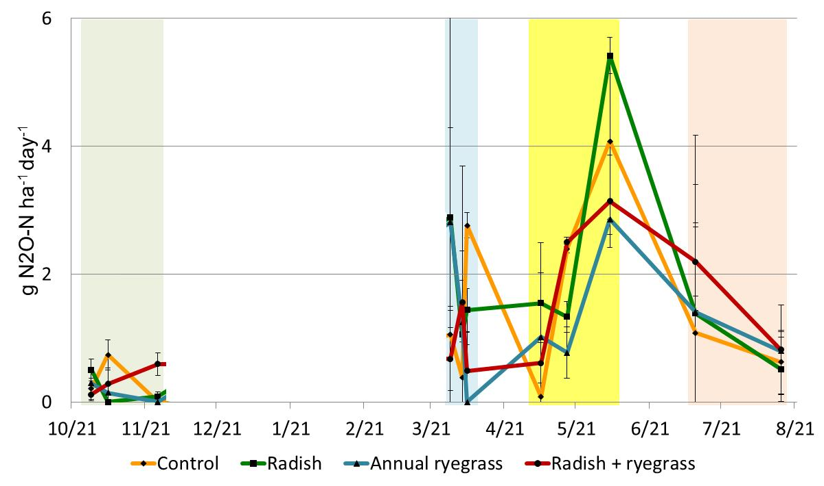
Figure 1. Temperature (°C) (jagged lines, top graph), daily precipitation (mm) (bars, top graph), and nitrous oxide emissions (g N₂O-N ha⁻¹ day) (bottom graph) from 29 Oct. 2012 – 15 Aug. 2013 in Hickory Corners, MI (KBS). Each error bar represents one standard error from the mean.

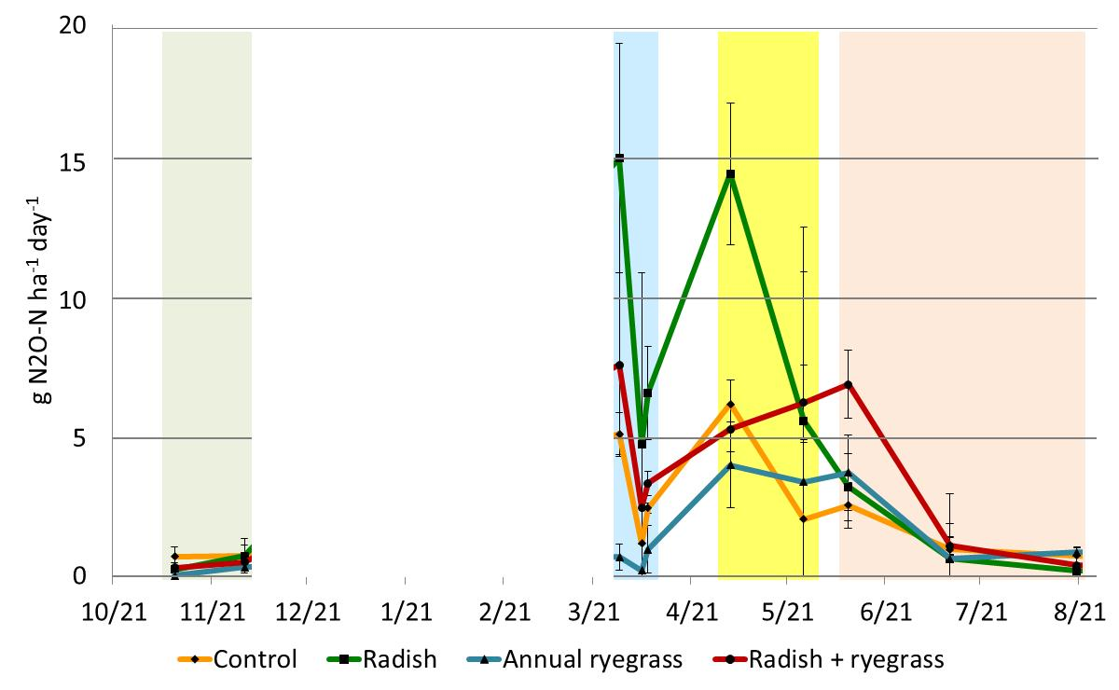
Figure 2. Temperature (°C) (jagged lines, top graph), daily precipitation (mm) (bars, top graph), and nitrous oxide emissions (g N₂O-N ha⁻¹ day) (bottom graph) from 11 Nov. 2012 – 20 Aug. 2013 in E. Lansing, MI (MSU). Each error bar represents one standard error from the mean.

Figure 3. Temperature (°C) (jagged lines, top graph), daily precipitation (mm) (bars, top graph), and nitrous oxide emissions (g N₂O-N ha⁻¹ day) (bottom graph) from 28 Oct. 2013 – 20 Aug. 2014 in Hickory Corners, MI (KBS). Each error bar represents one standard error from the mean.

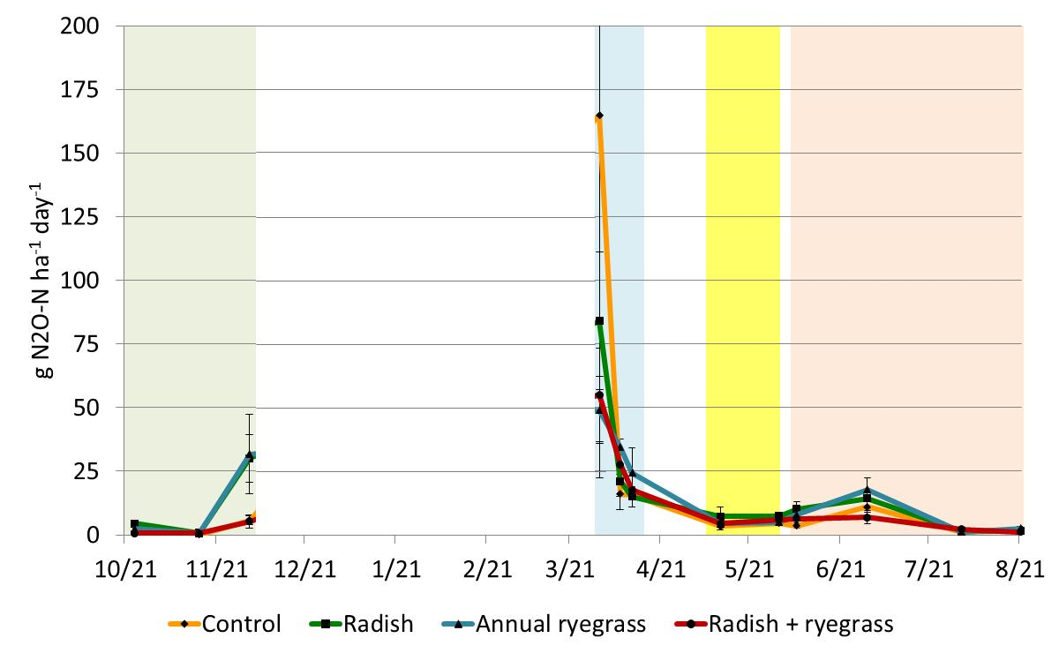

Figure 4. Temperature (°C) (jagged lines, top graph), daily precipitation (mm) (bars, top graph), and nitrous oxide emissions (g N₂O-N ha⁻¹ day) (bottom graph) from 24 Oct. 2013 – 21 Aug. 2014 in E. Lansing, MI (MSU). Each error bar represents one standard error from the mean.

