Multiply garlic callus tissue cultures from newly developed cultures:
About 8 weeks of growth.
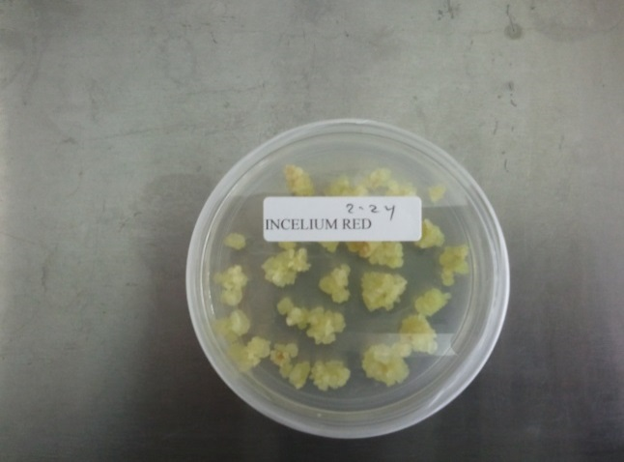

Produce stems from garlic callus tissue cultures:
Transferred onto sprouting medium
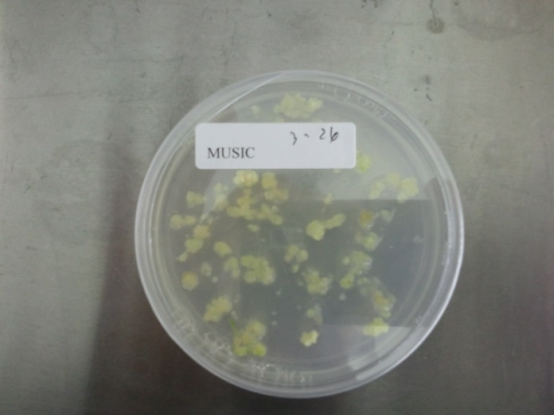

Transferred to stem medium
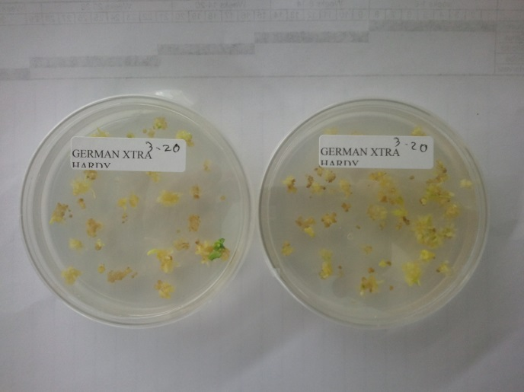

Produce bulbs from garlic callus tissue cultures with stems:

