Table . Cropping systems instrumented on Isherwood Farms (Plover, WI).



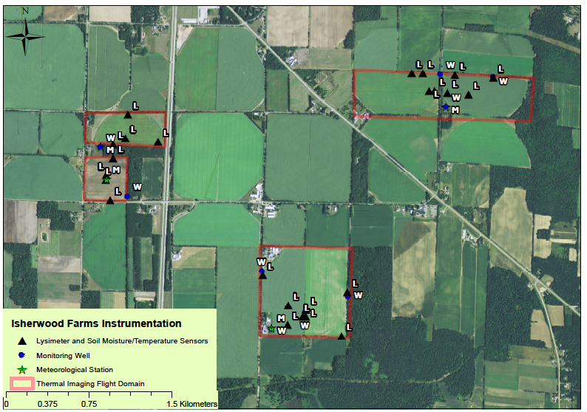

Figure . Isherwood Farms field instrumentation surveyed with RTK GPS system (0.03 m accuracy). Georeferencing conducted using 2013 National Agriculture Imagery Program data for Portage County. Target thermal imaging domains are marked by red boxes.

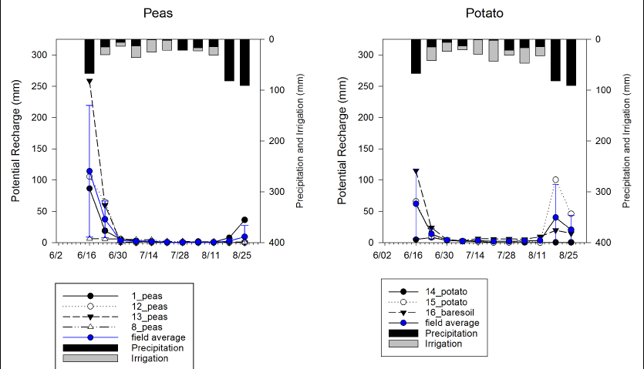

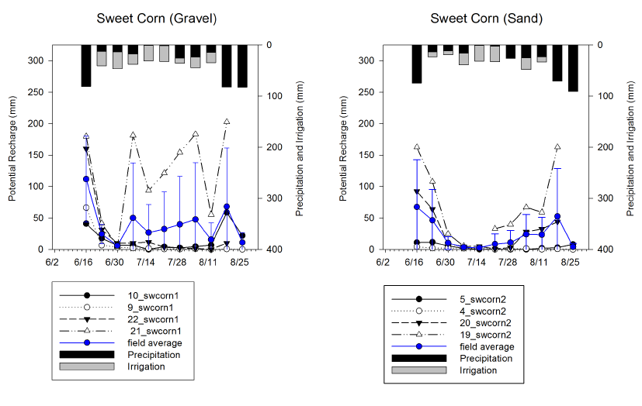

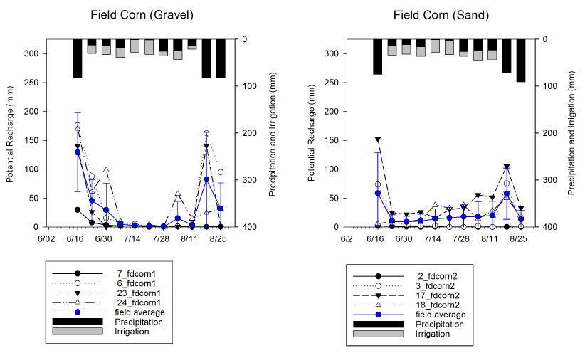

Figure . 2014 weekly potential recharge during the irrigated season estimated via vadose zone lysimetry from all instrumented cropping systems on Isherwood Farms including peas (top left), potato (top right), sweet corn-gravel (center left), sweet corn-sand (center right), field corn-gravel (bottom left), and field corn-sand (bottom right)

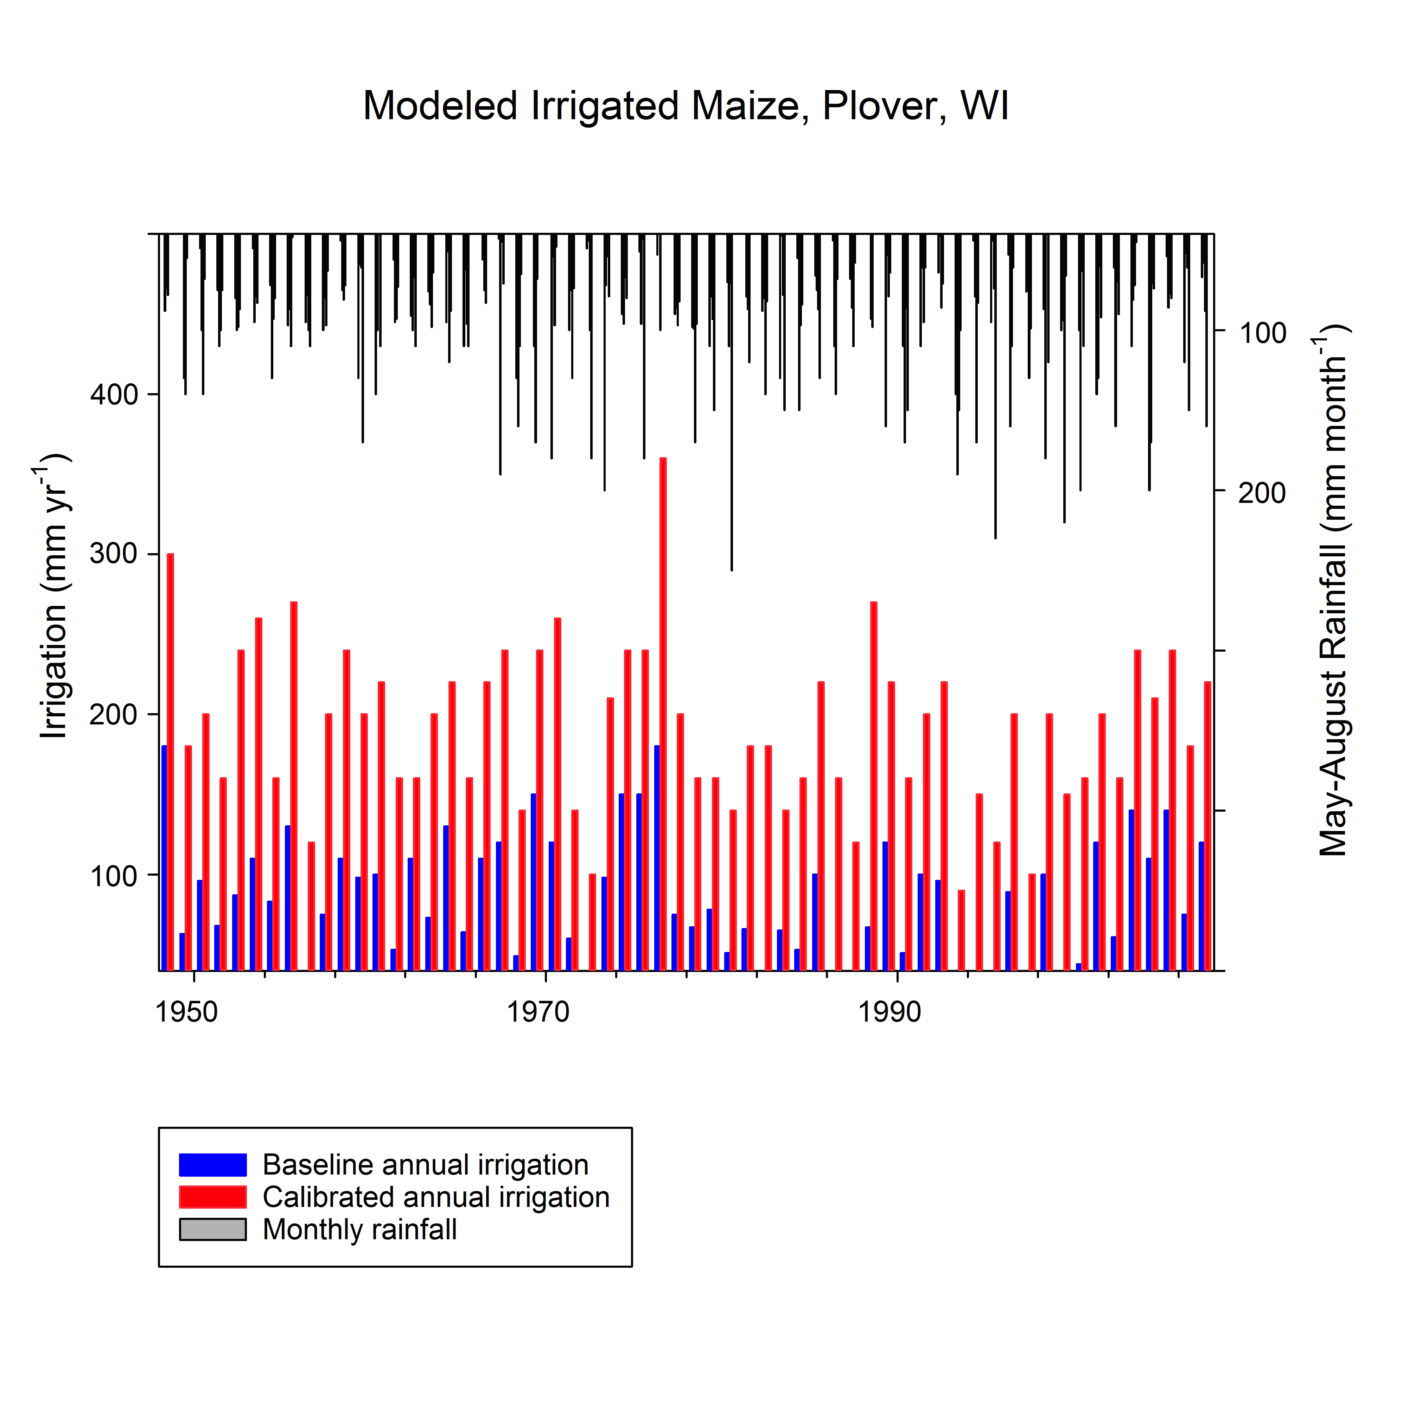

Figure . Baseline vs. calibrated annual irrigation function in the Agro-IBIS agroecosystem model. Total annual irrigation modeled for continuous maize on Isherwood Farms (Plover, WI) is displayed from 1948-2007. Baseline annual irrigation where model is parameterized to trigger irrigation at 50% plant available water and irrigate to field capacity. Calibrated annual irrigation matches soil moisture profiles measured during 2013 field season.

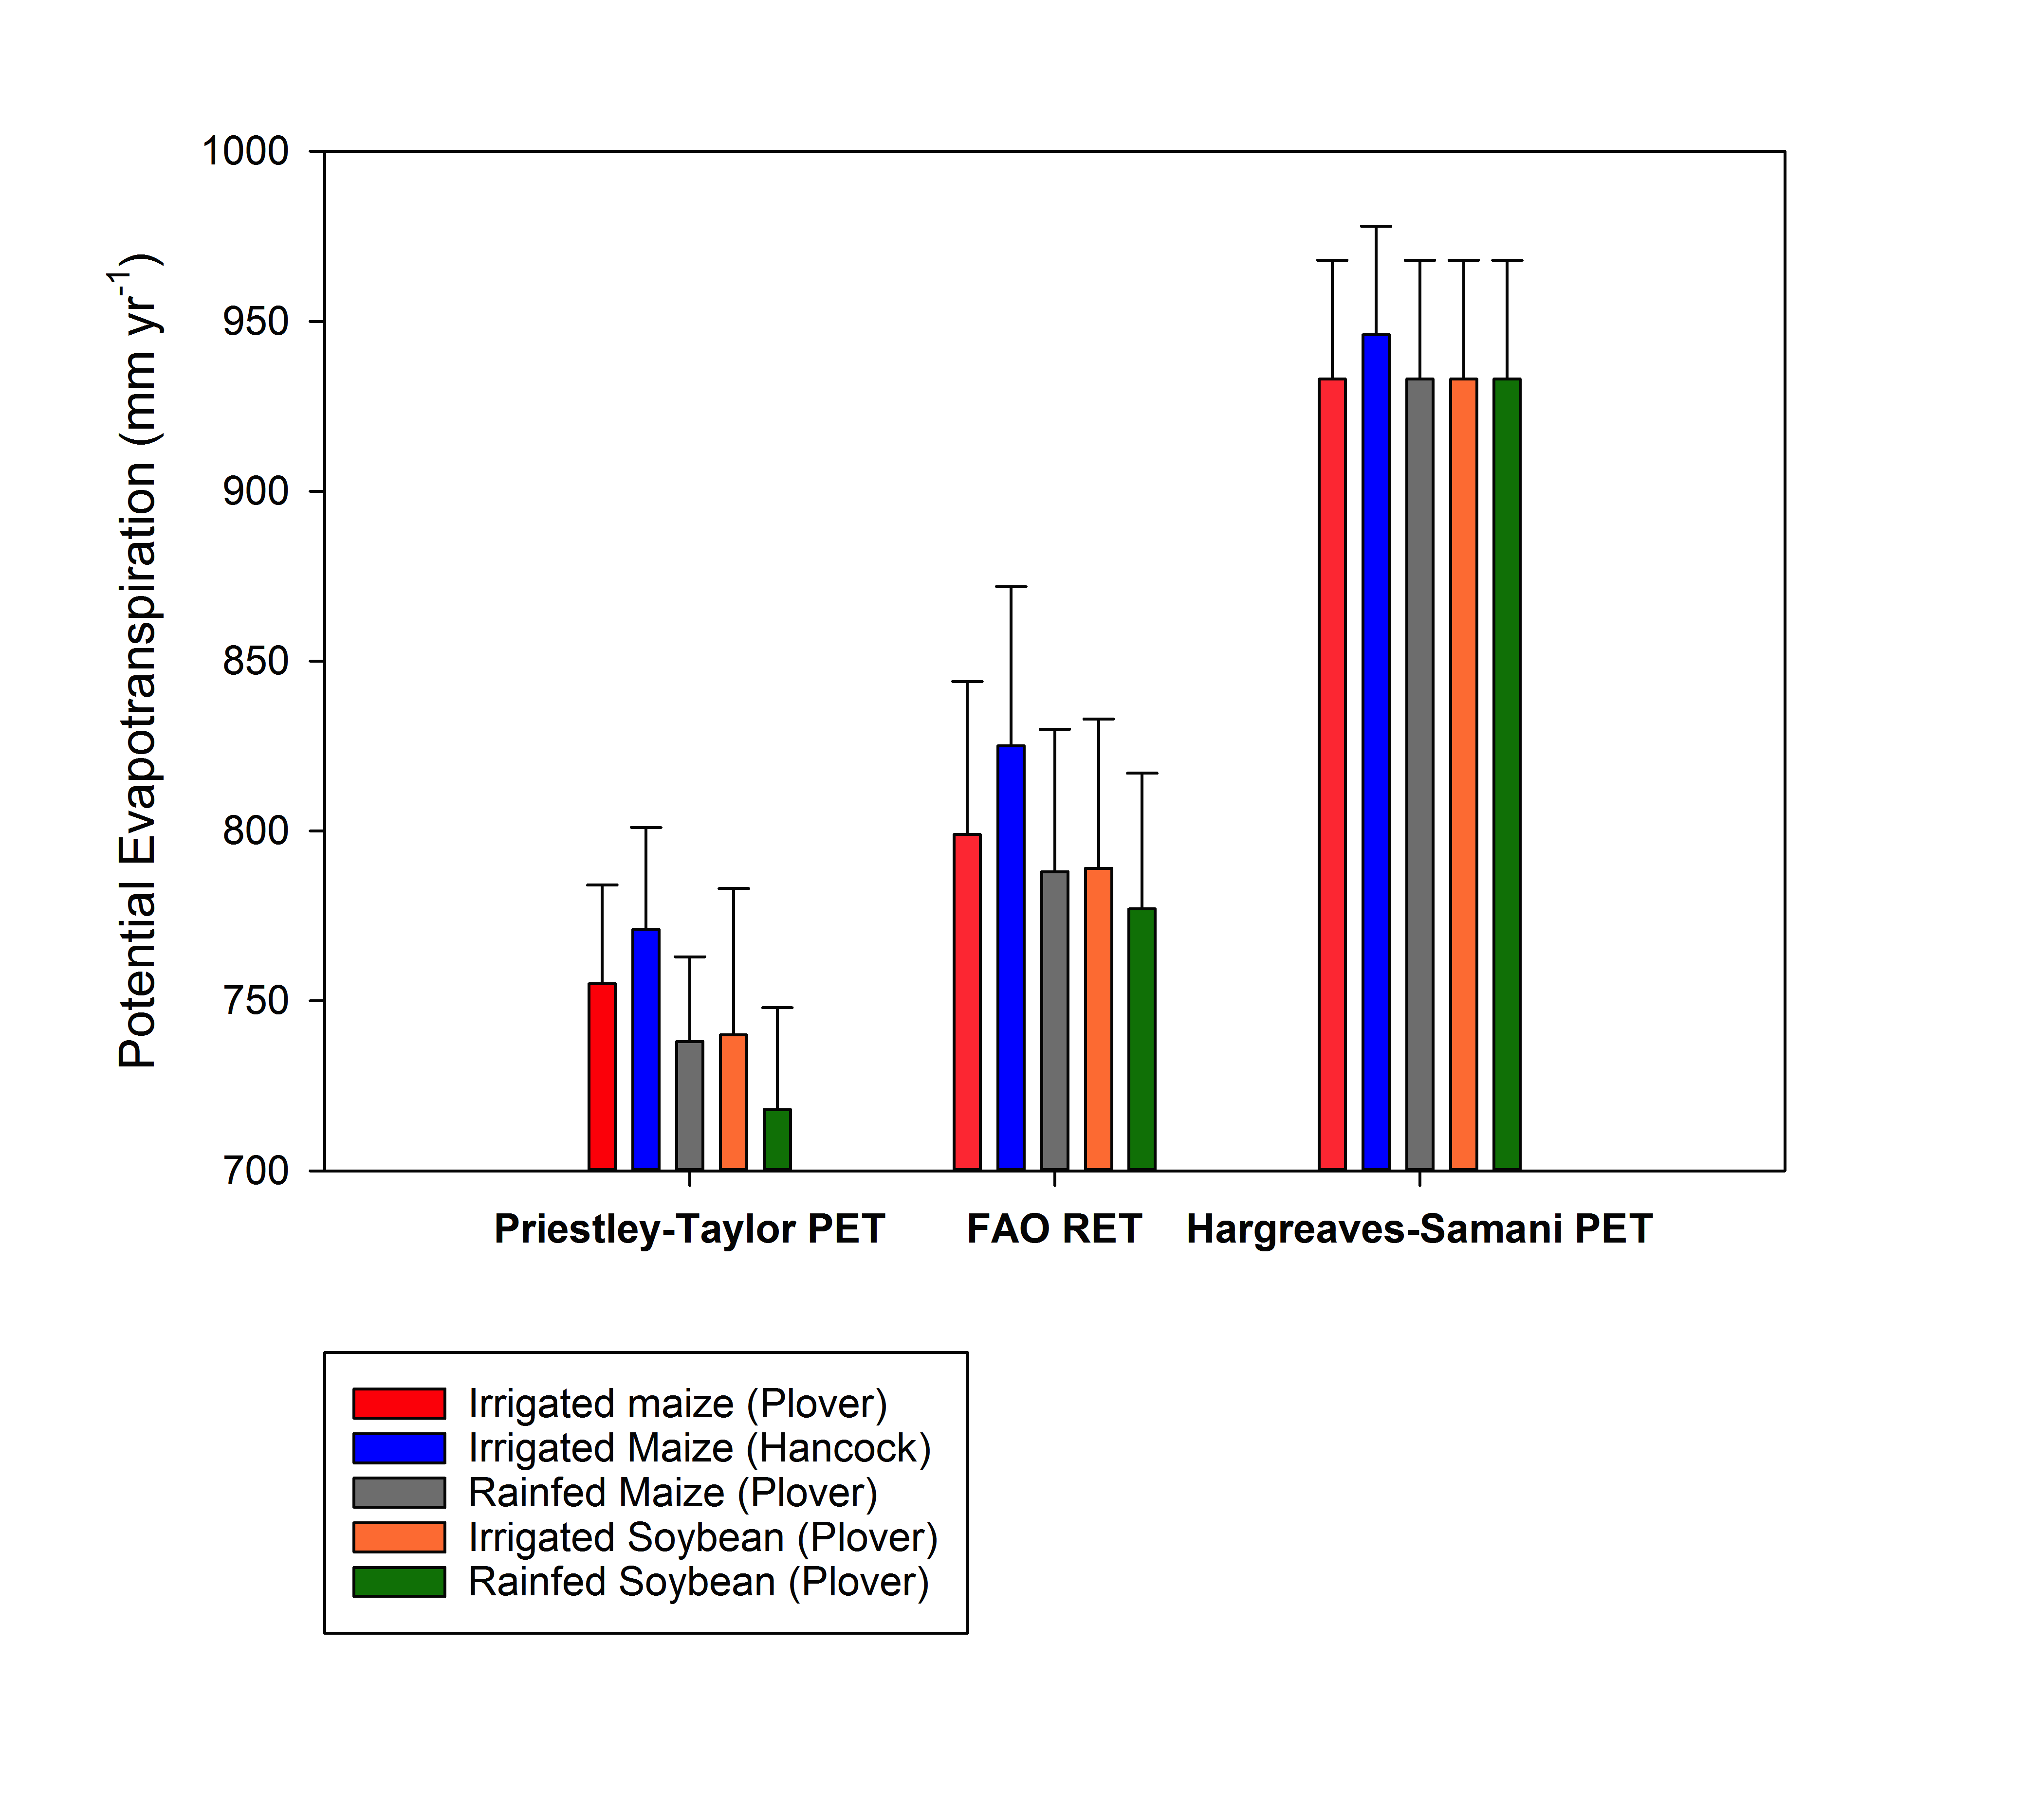

Figure . Average annual potential evapotranspiration (PET) modeled over 60 years (1948-2007) for Isherwood Farms (Plover, WI) and Hancock Agricultural Station (Hancock, WI) in different cropping systems.

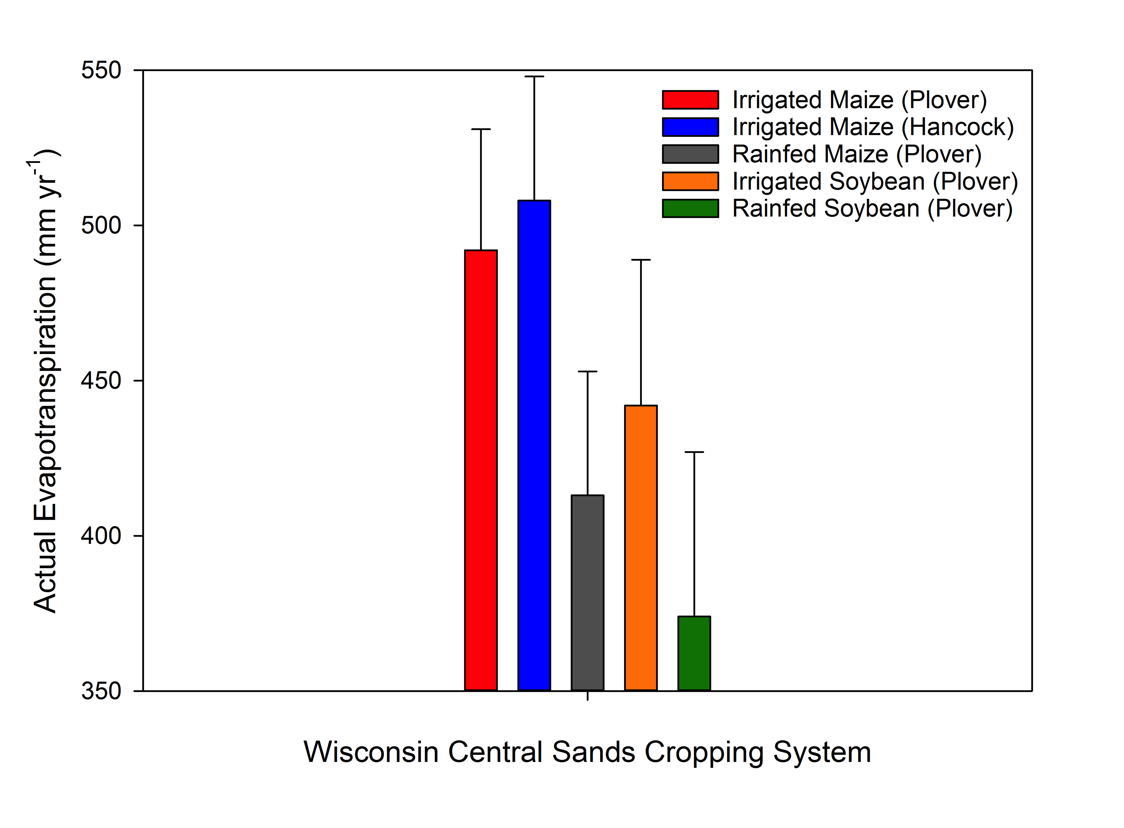

Figure . Actual evapotranspiration (ET) modeled over 60 years (1948-2007) for Isherwood Farms (Plover, WI) and Hancock Agricultural Station (Hancock, WI) in different cropping systems.