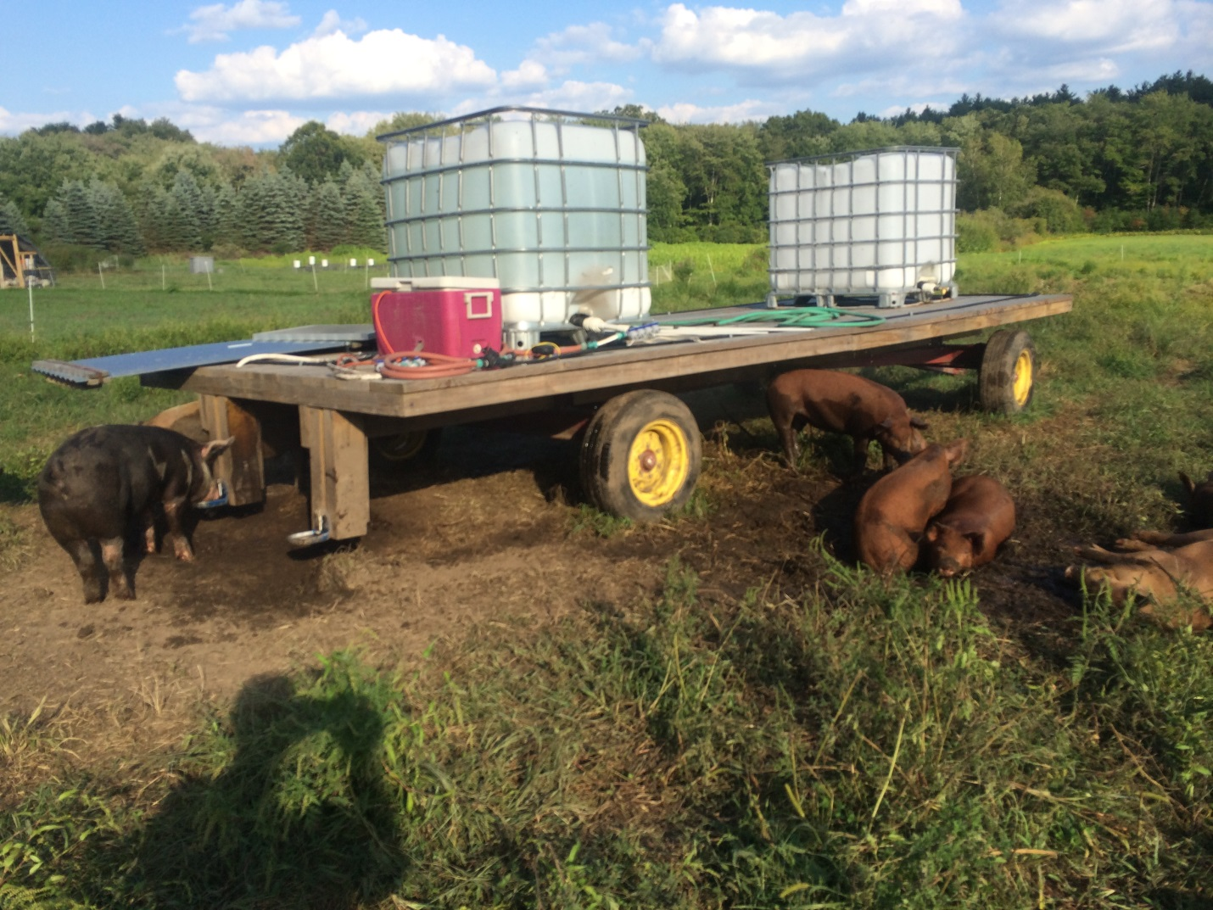

Water tank, cage type, 225 gallons

Cooler containing pump, battery, charge controller – version 1.0

Cup waterers with 4x6 lumber