Time | Topic | Resource Person
6:00 – 6:15 | Welcome | Rich Sherman, WVU Extension Agent Cabell County
6:15 - 7.00 | Conservation Planning Process | Corine Powell, USDA-NRCS, District Conservationist
7:00 – 7:30 | Nutrient Management 101 | Corine Powell, USDA-NRCS, District Conservationist
7:30 – 8:00 | Understanding the CAFO Final Rule and How it Applies to your Operation | Joshua Faulkner  Agricultural Engineering Specialist, WVU Extension Service
8.00 – 8:30 | Feed and Animal Management to Minimize Nutrient Waste | Rich Sherman, WVU Extension Agent, Cabell County
8:30 – 9:00 | Simple Record-Keeping System for Small and Medium-Sized AFOs | Dee Singh-Knights  Ag. Econ Ext. Specialist, WVU Extension Service
AGENDA – On Farm Nutrient Management -“How to better utilize what your animals leave behind!”
April 15th, 2014, Cabell County Extension Office, 6.00-9.00pm

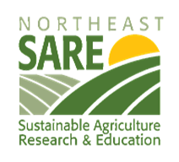

This work is supported by Northeast Sustainable Agriculture Research and Education Professional Development Grant Program.

