**1.  I am raising the same types of animals at the end of this project as at the beginning.**

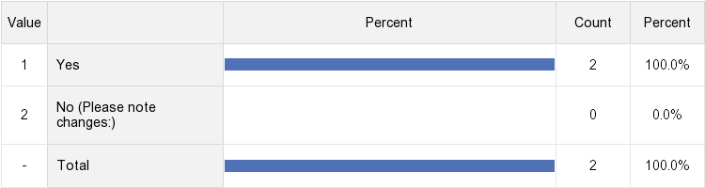

**2.  I am raising:**

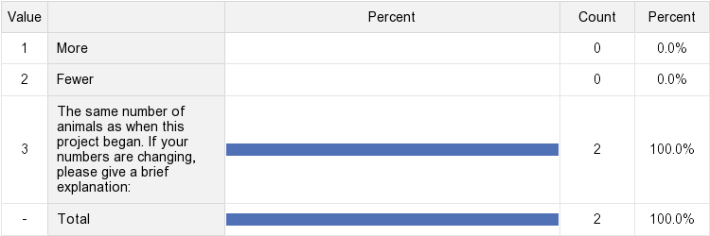

**3.  At the start of the project, I included the following expenses in my pricing formula: (Check all that apply)**

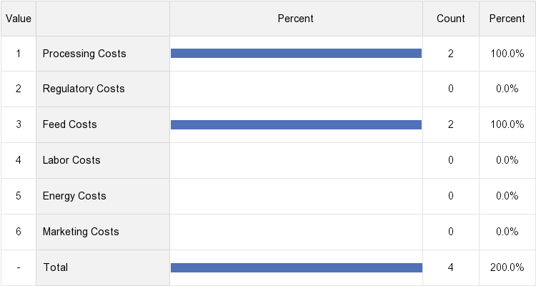

**4.  At the end of this project, I included the following expenses in my pricing formula: (Check all that apply)**

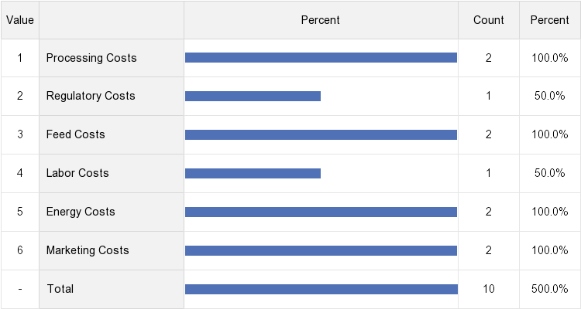

**5.  The pricing calculator tool tested in this model was (Check all that apply):**

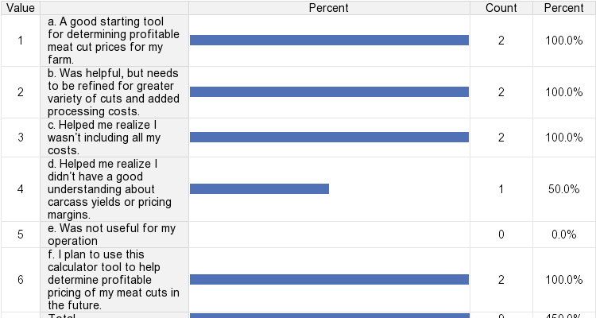

**6.  Since the launch of this project  marketing outlets have:**

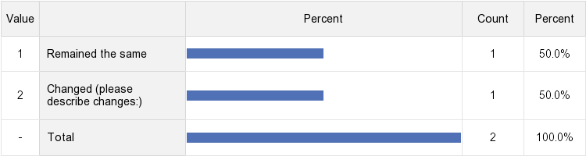

**7.  I utilized the market strategies assessment tools that were included on my thumb drive to evaluate my marketing outlets.**

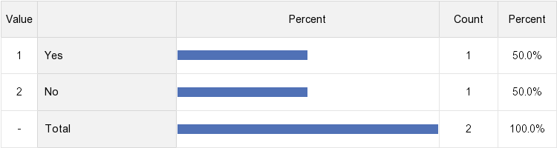

**8.  As a result of my participation in this project , I have changed the way I set pricing for my farm raised meats:**

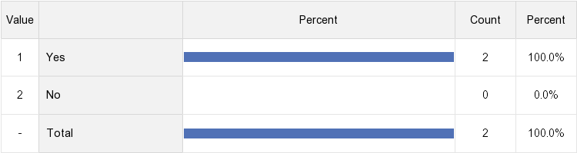

**9. The most important thing I learned from participating in this project was:**

