What meat animal(s) do you raise? Please select all that apply
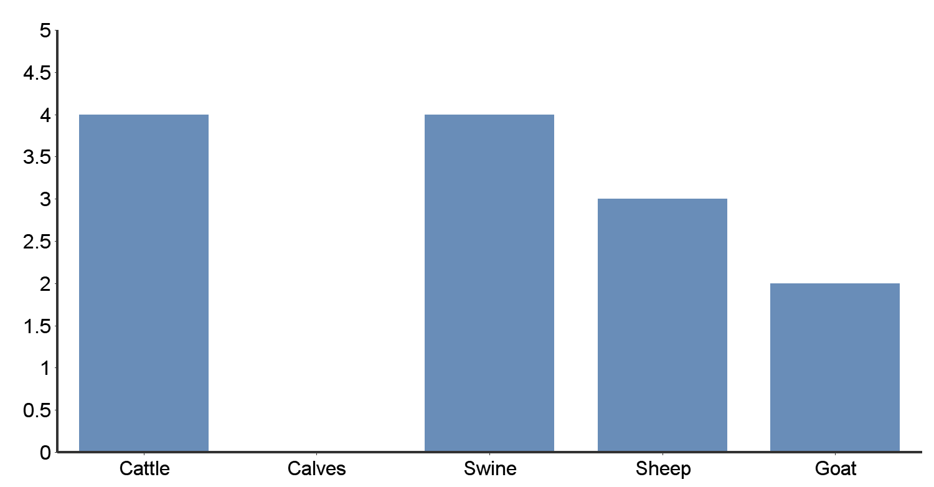
# | Answer | Bar | Response | %
1 | Cattle |  | 4 | 100.00%
2 | Calves |  | 0 | 0.00%
3 | Swine |  | 4 | 100.00%
4 | Sheep |  | 3 | 75.00%
5 | Goat |  | 2 | 50.00%
 | Total |  | 13 | 100.00%
Min Value | Max Value | Average Value | Variance | Standard Deviation | Total Responses | Total Respondents
1 | 5 | 2.92 | 2.24 | 1.50 | 13 | 4

Can you provide the approximate number of animals you raise per year?
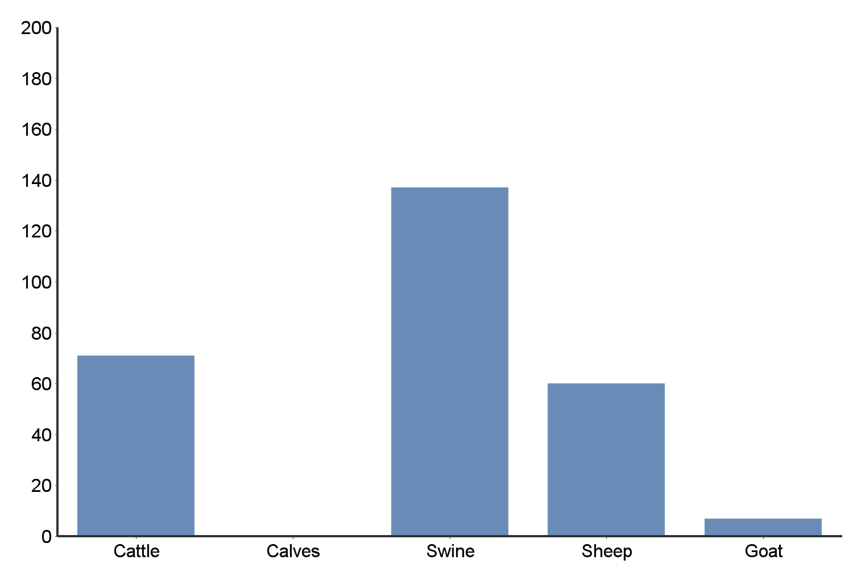
# | Answer | Min Value | Max Value | Average Value | Standard Deviation
1 | Cattle | 4 | 30 | 17.75 | 11.90
2 | Calves | 0 | 0 | 0.00 | 0.00
3 | Swine | 12 | 75 | 34.25 | 28.15
4 | Sheep | 0 | 30 | 15.00 | 12.91
5 | Goat | 0 | 5 | 1.75 | 2.36

Please select all your current marketing outlets?
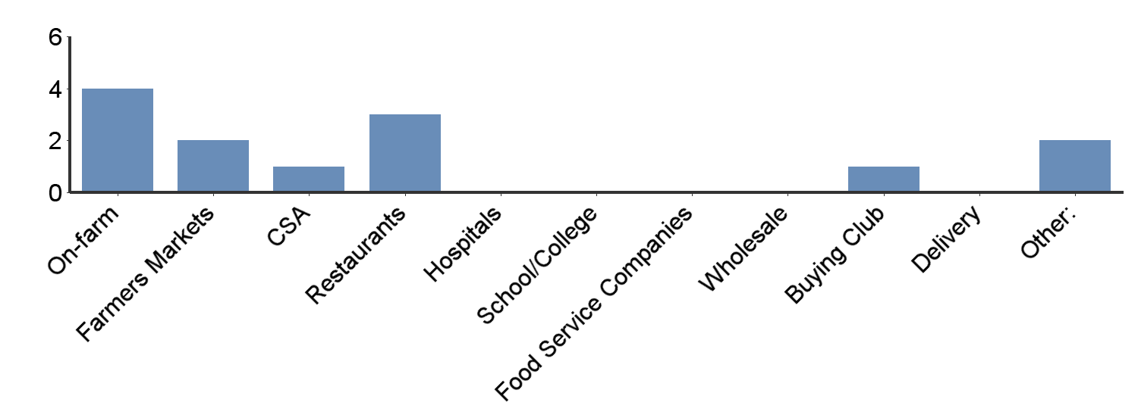
Other:
Food Cooperative
Charcuterie,
# | Answer | Bar | Response | %
1 | On-farm |  | 4 | 100.00%
2 | Farmers Markets |  | 2 | 50.00%
3 | CSA |  | 1 | 25.00%
4 | Restaurants |  | 3 | 75.00%
5 | Hospitals |  | 0 | 0.00%
6 | School/College |  | 0 | 0.00%
7 | Food Service Companies |  | 0 | 0.00%
8 | Wholesale |  | 0 | 0.00%
9 | Buying Club |  | 1 | 25.00%
10 | Delivery |  | 0 | 0.00%
11 | Other: |  | 2 | 50.00%
 | Total |  | 13 | 100.00%
Min Value | Max Value | Average Value | Variance | Standard Deviation | Total Responses | Total Respondents
1 | 11 | 4.15 | 13.97 | 3.74 | 13 | 4

Can you provide your percentage of total sales through the following venues?
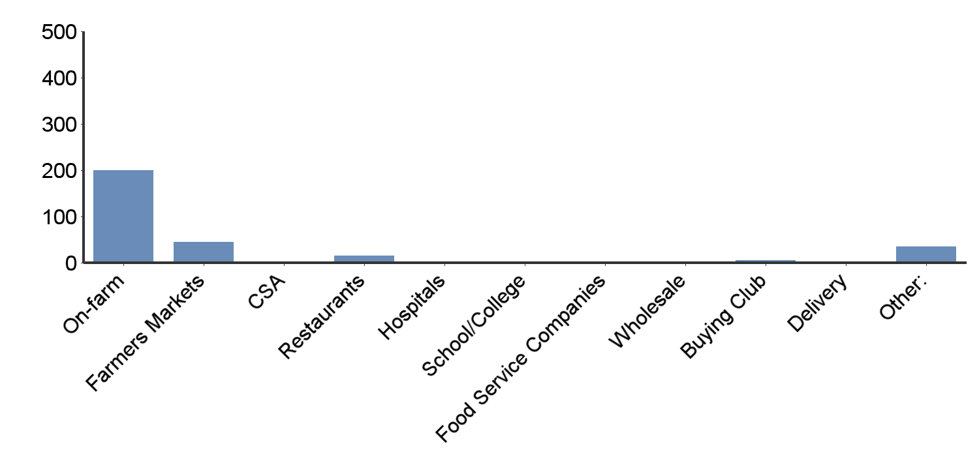
# | Answer | Min Value | Max Value | Average Value | Standard Deviation
1 | On-farm | 0 | 100 | 50.00 | 43.97
2 | Farmers Markets | 0 | 45 | 11.25 | 22.50
3 | CSA | 0 | 0 | 0.00 | 0.00
4 | Restaurants | 0 | 10 | 3.75 | 4.79
5 | Hospitals | 0 | 0 | 0.00 | 0.00
6 | School/College | 0 | 0 | 0.00 | 0.00
7 | Food Service Companies | 0 | 0 | 0.00 | 0.00
8 | Wholesale | 0 | 0 | 0.00 | 0.00
9 | Buying Club | 0 | 5 | 1.25 | 2.50
10 | Delivery | 0 | 0 | 0.00 | 0.00
11 | Other: | 0 | 25 | 8.75 | 11.81

Not including your current marketing venues, what additional marketing outlets would you like to pursue? Please select all that apply:
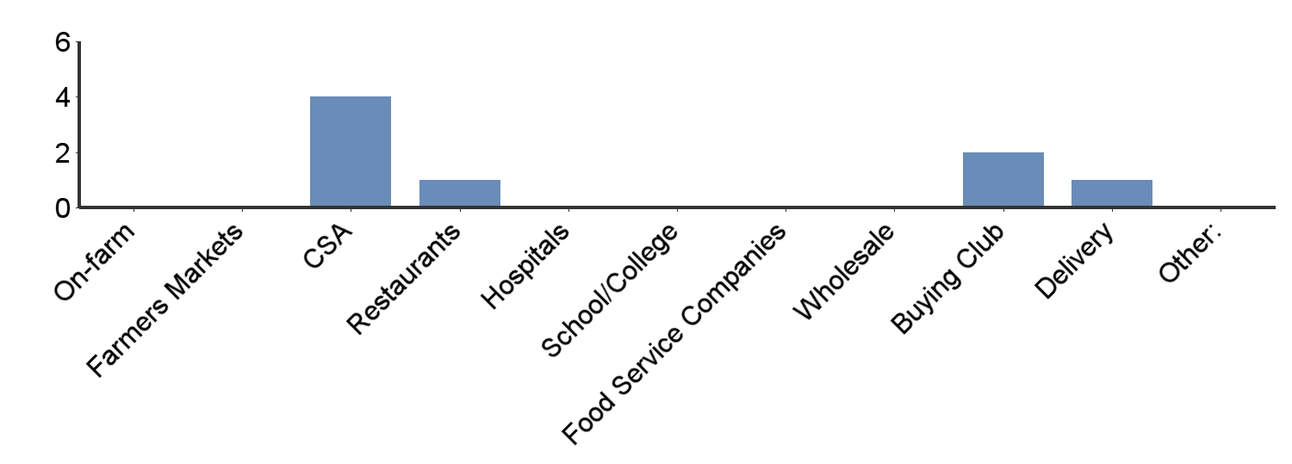
Other:
# | Answer | Bar | Response | %
1 | On-farm |  | 0 | 0.00%
2 | Farmers Markets |  | 0 | 0.00%
3 | CSA |  | 4 | 100.00%
4 | Restaurants |  | 1 | 25.00%
5 | Hospitals |  | 0 | 0.00%
6 | School/College |  | 0 | 0.00%
7 | Food Service Companies |  | 0 | 0.00%
8 | Wholesale |  | 0 | 0.00%
9 | Buying Club |  | 2 | 50.00%
10 | Delivery |  | 1 | 25.00%
11 | Other: |  | 0 | 0.00%
 | Total |  | 8 | 100.00%
Min Value | Max Value | Average Value | Variance | Standard Deviation | Total Responses | Total Respondents
3 | 10 | 5.50 | 10.29 | 3.21 | 8 | 4

Which product attributes do you think are important to your customers?
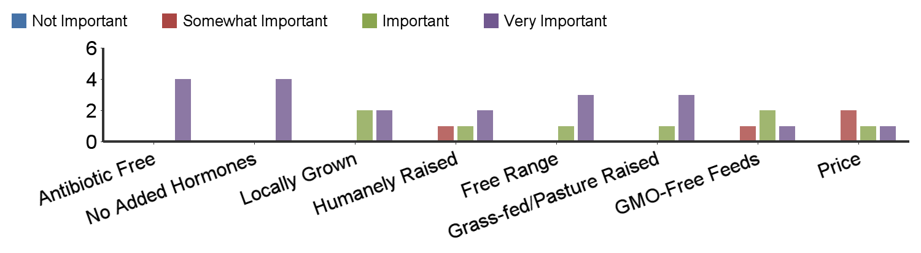
# | Question | Not Important | Somewhat Important | Important | Very Important | Response | Average Value
1 | Antibiotic Free | - | - | - | 4 | 4 | 4.00
2 | No Added Hormones | - | - | - | 4 | 4 | 4.00
3 | Locally Grown | - | - | 2 | 2 | 4 | 3.50
4 | Humanely Raised | - | 1 | 1 | 2 | 4 | 3.25
5 | Free Range | - | - | 1 | 3 | 4 | 3.75
6 | Grass-fed/Pasture Raised | - | - | 1 | 3 | 4 | 3.75
7 | GMO-Free Feeds | - | 1 | 2 | 1 | 4 | 3.00
8 | Price | - | 2 | 1 | 1 | 4 | 2.75
Statistic | Antibiotic Free | No Added Hormones | Locally Grown | Humanely Raised | Free Range | Grass-fed/Pasture Raised | GMO-Free Feeds | Price
Min Value | 4 | 4 | 3 | 2 | 3 | 3 | 2 | 2
Max Value | 4 | 4 | 4 | 4 | 4 | 4 | 4 | 4
Mean | 4 | 4 | 3.5 | 3.25 | 3.75 | 3.75 | 3 | 2.75
Variance | 0 | 0 | 0.33 | 0.92 | 0.25 | 0.25 | 0.67 | 0.92
Standard Deviation | 0 | 0 | 0.58 | 0.96 | 0.5 | 0.5 | 0.82 | 0.96
Total Responses | 4 | 4 | 4 | 4 | 4 | 4 | 4 | 4
Total Respondents | 4 | 4 | 4 | 4 | 4 | 4 | 4 | 4

Which of these attributes do you include in your promotional materials? Please select all that apply
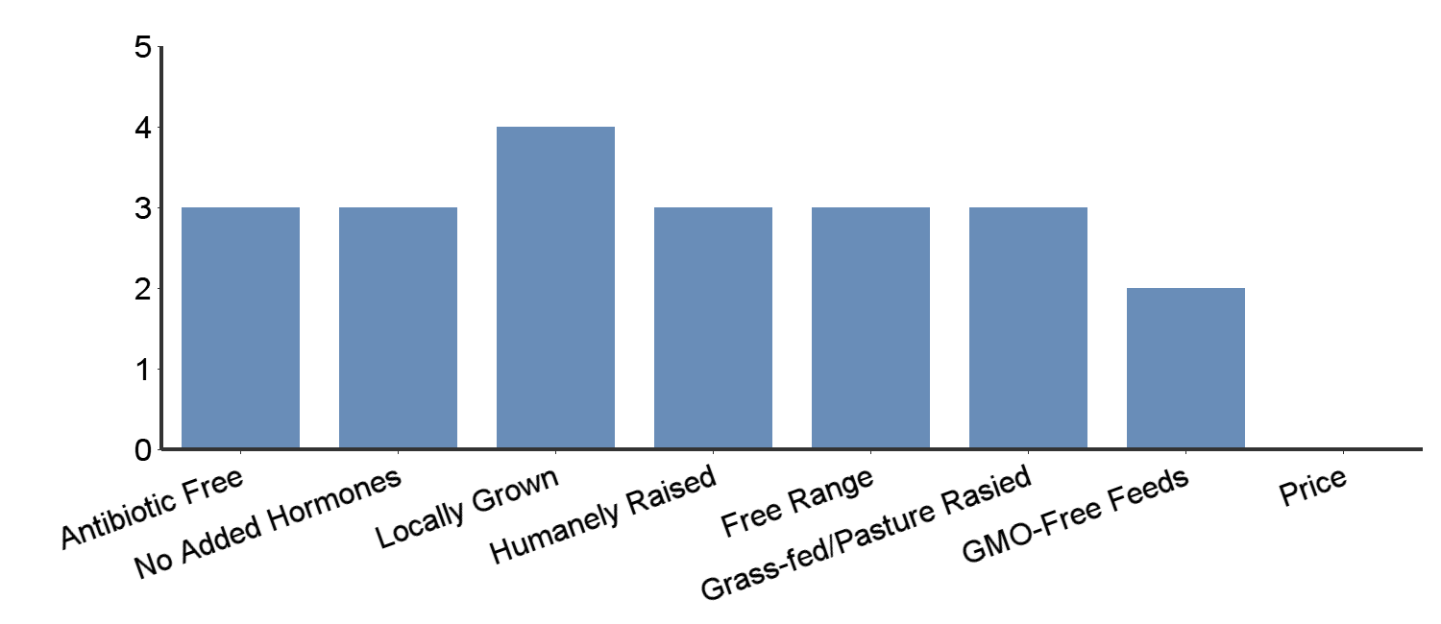
# | Answer | Bar | Response | %
1 | Antibiotic Free |  | 3 | 75.00%
2 | No Added Hormones |  | 3 | 75.00%
3 | Locally Grown |  | 4 | 100.00%
4 | Humanely Raised |  | 3 | 75.00%
5 | Free Range |  | 3 | 75.00%
6 | Grass-fed/Pasture Rasied |  | 3 | 75.00%
7 | GMO-Free Feeds |  | 2 | 50.00%
8 | Price |  | 0 | 0.00%
 | Total |  | 21 | 100.00%
Min Value | Max Value | Average Value | Variance | Standard Deviation | Total Responses | Total Respondents
1 | 7 | 3.81 | 3.76 | 1.94 | 21 | 4

Do your customers attribute a higher value to your meats because they are available direct from the farmer?

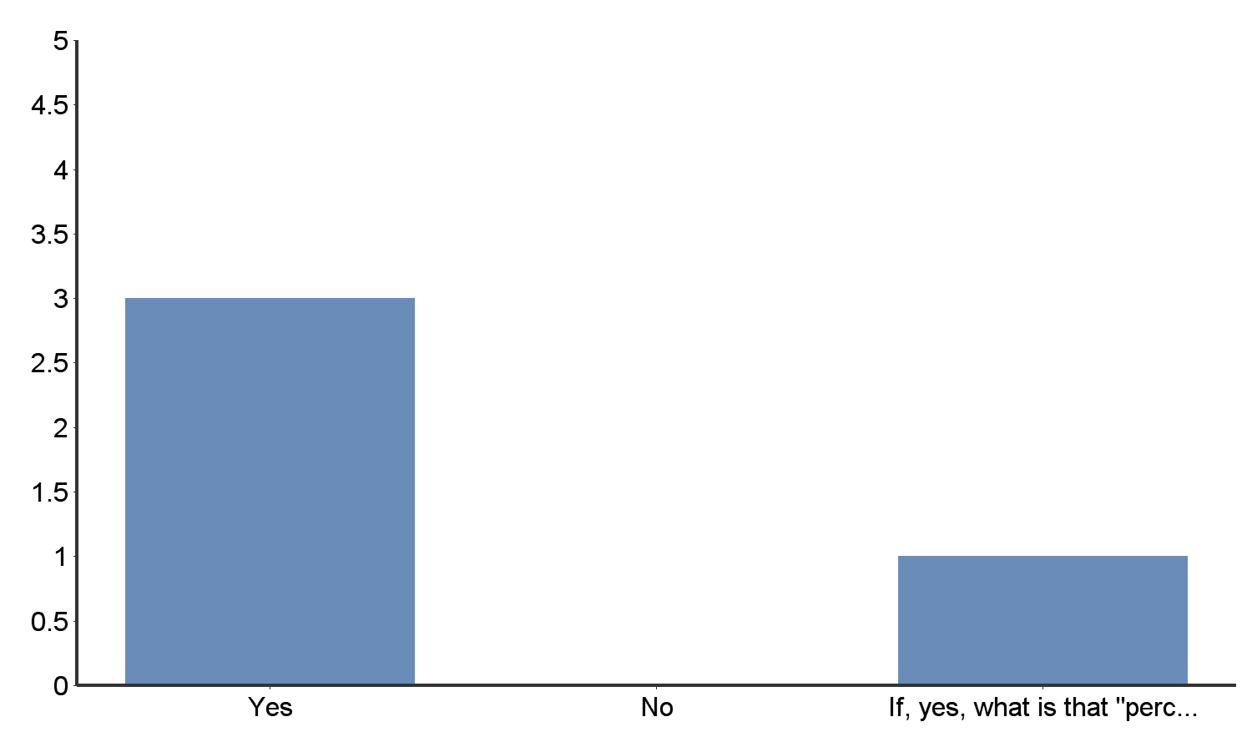
If, yes, what is that "perceived value?"
A safer production since it is bought straight from the farmer
# | Answer | Bar | Response | %
1 | Yes |  | 3 | 75.00%
2 | No |  | 0 | 0.00%
3 | If, yes, what is that "perceived value?" |  | 1 | 25.00%
 | Total |  | 4 | 100.00%
Min Value | Max Value | Average Value | Variance | Standard Deviation | Total Responses | Total Respondents
1 | 3 | 1.50 | 1.00 | 1.00 | 4 | 4

In my experience, my customers are willing (or not) to pay a premium price above their grocery store meat purchases. They will pay this % more than for store brand meats.

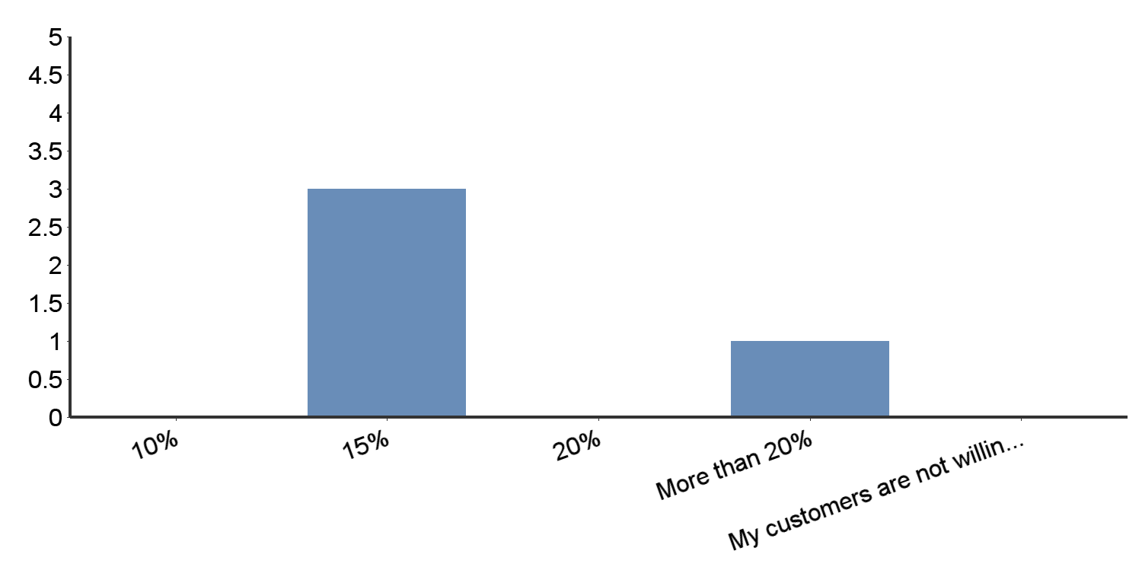
# | Answer | Bar | Response | %
1 | 10% |  | 0 | 0.00%
2 | 15% |  | 3 | 75.00%
3 | 20% |  | 0 | 0.00%
4 | More than 20% |  | 1 | 25.00%
5 | My customers are not willing to pay a premium price |  | 0 | 0.00%
 | Total |  | 4 | 100.00%
Min Value | Max Value | Average Value | Variance | Standard Deviation | Total Responses | Total Respondents
2 | 4 | 2.50 | 1.00 | 1.00 | 4 | 4

The greatest expense I have that affects my pricing is: (Select only one)

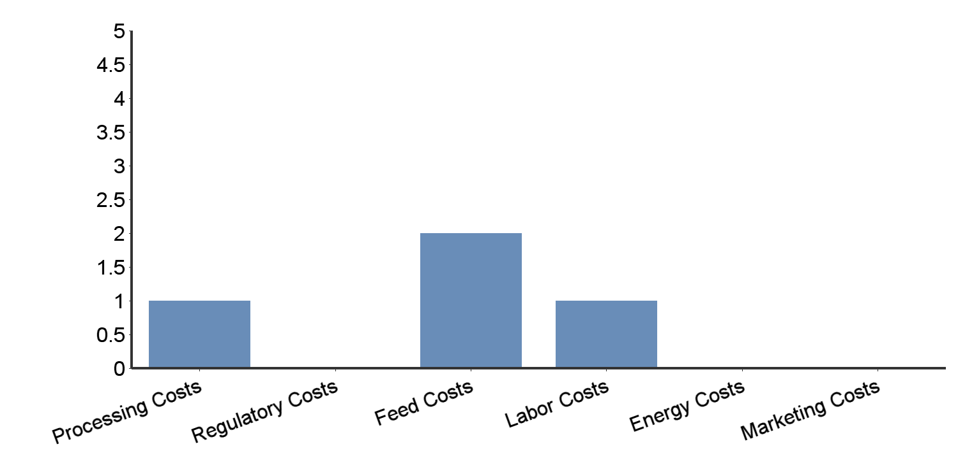
# | Answer | Bar | Response | %
1 | Processing Costs |  | 1 | 25.00%
2 | Regulatory Costs |  | 0 | 0.00%
3 | Feed Costs |  | 2 | 50.00%
4 | Labor Costs |  | 1 | 25.00%
5 | Energy Costs |  | 0 | 0.00%
6 | Marketing Costs |  | 0 | 0.00%
 | Total |  | 4 | 100.00%
Min Value | Max Value | Average Value | Variance | Standard Deviation | Total Responses | Total Respondents
1 | 4 | 2.75 | 1.58 | 1.26 | 4 | 4

The second greatest expense I have that affects my pricing is: (Select only one)

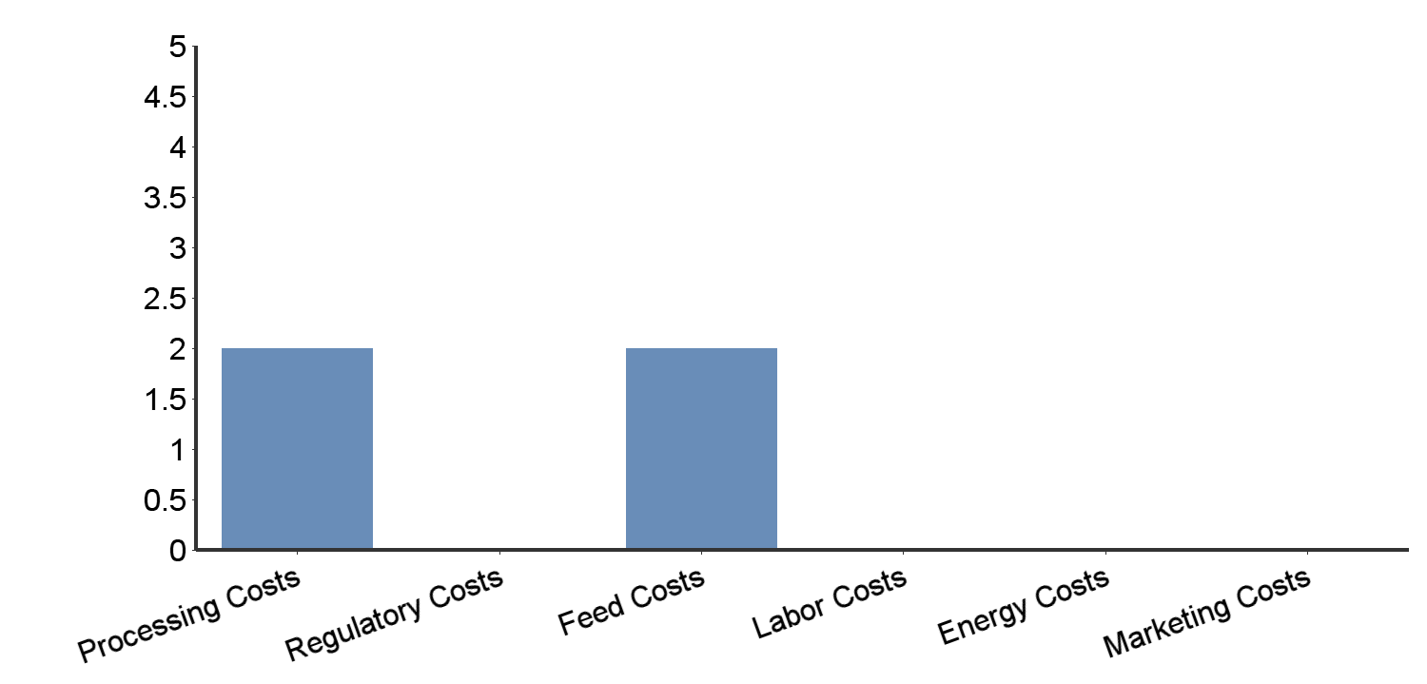
# | Answer | Bar | Response | %
1 | Processing Costs |  | 2 | 50.00%
2 | Regulatory Costs |  | 0 | 0.00%
3 | Feed Costs |  | 2 | 50.00%
4 | Labor Costs |  | 0 | 0.00%
5 | Energy Costs |  | 0 | 0.00%
6 | Marketing Costs |  | 0 | 0.00%
 | Total |  | 4 | 100.00%
Min Value | Max Value | Average Value | Variance | Standard Deviation | Total Responses | Total Respondents
1 | 3 | 2.00 | 1.33 | 1.15 | 4 | 4

Please check the one statement that best describes your current pricing margins.

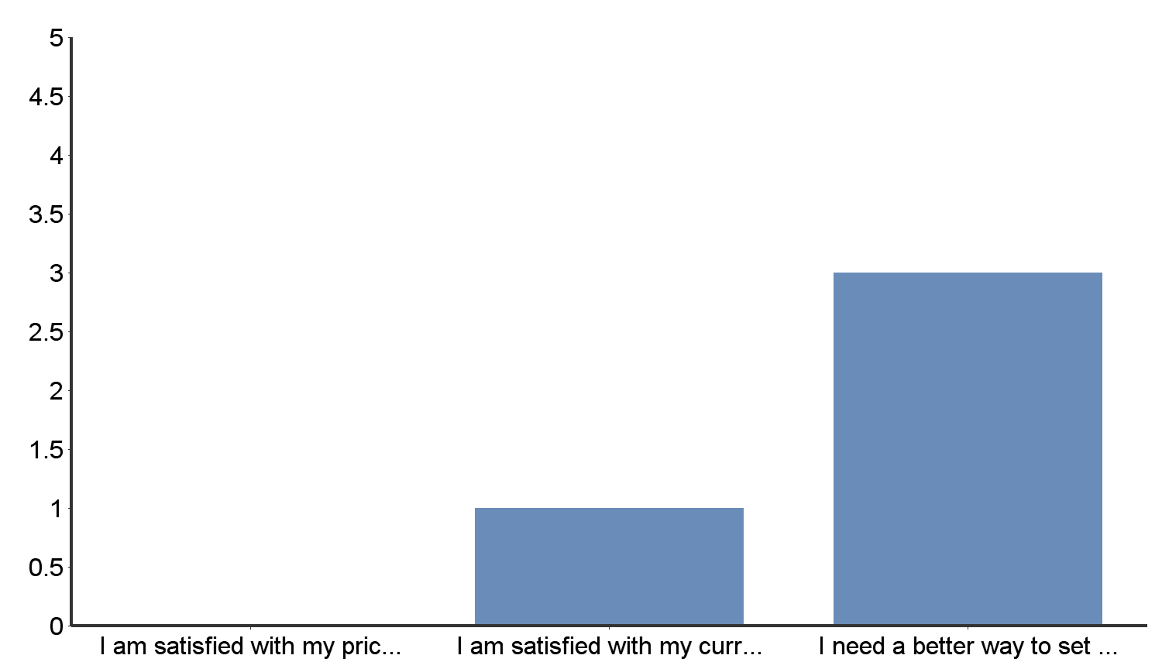
# | Answer | Bar | Response | %
1 | I am satisfied with my prices and current profit margin. |  | 0 | 0.00%
2 | I am satisfied with my current prices, but I’m not sure about my profit margin. |  | 1 | 25.00%
3 | I need a better way to set my prices and maximize my profit margins. |  | 3 | 75.00%
 | Total |  | 4 | 100.00%
Min Value | Max Value | Average Value | Variance | Standard Deviation | Total Responses | Total Respondents
2 | 3 | 2.75 | 0.25 | 0.50 | 4 | 4

