“Am I Making a Profit? - Utilizing Calculators to Develop Profitable Prices for Farm-Raised Meats”- Case Study of Project # ONE14-216-27806 funded by Northeast SARE
Ginger S. Myers
University of Maryland Extension
Agricultural Marketing Specialist
Director, Maryland Rural Enterprise Development Center
gsmyer@umd.edu
In any business endeavor, keeping good records is essential to knowing if you are going to be profitable or not. When marketing farm-raised meats, it’s not enough to just know your costs of production. Producers need to know how much marketable product is returning to the farm from the live animals that they are have processed and their total costs per pound to get their product from farm-to-table. These numbers can then be inputted into a “calculator” to develop a profitable pricing strategy.
Several on-line calculators exist for converting an animal into a carcass and then making cuts out of the carcass (yield in pounds). There are different calculator tools for different species. However, these vary in their ease of use. And, although they provide a spreadsheet of the total product availability, most still do not address the how to differentiate pricing of those cuts, for example ground beef vs. filet mignon, or a way to view various mark-up scenarios.
Matt LeRoux, Cornell Extension, developed a calculator that both totals carcass costs and provides differentiated pricing of cuts based on a projected profit margin as a secondary tool for NESARE Project ONE11-145. That project developed a Marketing Channel Assessment Tool for Livestock Producers. LeRoux’s meat costs and pricing calculator was developed to help him determine the value of different cuts from different participant farms and plug those values into his marketing channels assessment tool. Yet, few livestock farmers outside of New York State know about either of these tool, have ever used them, or have made it a practice to regularly check carcass costs and yields and then adjust their per cut prices.
The “Am I Making a Profit? - Utilizing Calculators to Develop Profitable Prices for Farm-Raised Meats” project worked with five progressive Maryland livestock producers who direct marketing the majority of their meats. These producers conducted on-farm testing of LeRoux’s current calculator for ease of use, processing costs, pricing recommendations, and then made recommendations for any refinement to the tool. The pricing calculator does not include apportioning labor, mileage, or storage costs for the product. Therefore, the next step involved utilizing the per cut data collected with the pricing calculator combined with a combination of production, marketing and overhead costs evaluate their most profitable market outlets. Project participants were then involved in outreach efforts to educate of the farm-raised meat producers in the tool’s application and a more detailed pricing and marketing strategies.

Principle Investigator:
Ginger S. Myers
University of Maryland Extension Marketing Specialist
Western Maryland Research and Education Center, UME
18330 Keedysville Road, Keedysville, MD 21756
gsmyers@umd.edu, 301-432-2767, fax 301-432-4089

Director of the Maryland Rural Enterprise Development Center and Extension Marketing Specialist, College of Agriculture & Natural Resources, University of Maryland Extension. Myers brings over 30 years of experience in production agriculture, agri-business and consulting to these positions. She currently works with rural entrepreneurs and new and beginning farmers, helps to develop new markets and networking opportunities, and assists with business development and business planning. She also publishes several newsletters, maintains both a rural business development and a marketing website, and is a regular contributor to the agricultural press. She has received numerous grants and is currently working on several community development projects including enhancing and expanding rural entrepreneurship in Maryland. She and her husband also operate a small grass-based livestock and poultry farm in Carroll County, Maryland.

Project Cooperating Farmers:
The farmers who were invited to participate in this project were drawn from the 42-Member Maryland Niche Meats Producers’ Group. A directory for this group is updated annually to provide consumers with a list of local meat and poultry producers they purchase product from directly. While part of the larger producer group, these five producers all:
- Have several years of experience with direct marketing their products or other retail sales venues.
- Maintain annual production and sales records.
- The Market more than one species.
- Utilize a variety of marketing channels including but not exclusive to on-farm sales, farmers’ markets, CSA, and direct wholesale to specialty stores and restaurants.
- Are still in growth mode for both their number of animals produced and their target sales volumes.
Another very important trait emerged and at the project’s first face-to-face meeting. While each farm has its own market strategies and outlets, when given the opportunity, these producers offered a free exchange of successes, failures, mutual challenges and product and service resources. They exhibit what could be called “co-opetition” amongst themselves. They intuit that growth in the direct farm-to-table meat market in Maryland will require more successful direct marketing meat producers. While the cooperating farmers each want a larger market share, they recognize the need for increased supply capacity if the farm-to-table market is to expand significantly.

The Cooperating Farmers

- Nora Crist, Clark’s Farm, 10500 Clarksville Pike, Ellicott City, MD 21042
clarksbeef@gmail.com
410-730-4049

Clark's Farm is part of the farming operation of the Clark family, which is proud to be entering its 214th year of farming in Howard County. The main link between the seven generations of farmers in our branch of the Clark family has been raising beef cattle. The sixth and seventh generation, Martha Clark and Nora Crist, are pleased to be providing for the first time to their retail market, 100% grass fed beef. They raise Berkshire hogs and sell all their pork through their retail store. Nora also operates the family’s popular produce stand, growing many varieties of organic vegetables and flowers.
- Robin Way, Rumbleway Farm, 592 McCauley Road, Conowingo, MD 21918
rumbleway@hotmail.com
410-658-9731
Rumbleway Farm is a 62-acre organic grass based farm located in Cecil County, Maryland. They raise chickens, turkeys, cows and pigs on pasture and rabbits in house. In 2000, they built an onsite processing area and applied for and received the right to process their birds under USDA inspection. They choose this avenue for processing because of their proximity to Delaware and Pennsylvania and the opportunity for sales across state lines. In 2001 they added a certified kitchen to provide added value from their products. They utilize their commercial kitchen to host Dinner at the Farm and cooking classes from Dec through April. The farm sells custom processed beef and pork as well as freezer cuts direct to customers. The Ways received a NESARE grant to produce a video about their diversified livestock farm.

- Cindy Thorne, Zekiah Farms, 5235 Bryantown Road, Waldorf, MD 20601
info@zekiahfarms.com
240-216-4065
Zekiah Farms practice sustainable agriculture, produce naturally raised meats, and offer alternative agriculture enterprises that include on-farm learning experiences. Naturally raised beef, pork, lamb, and goat are available year round. Poultry is available seasonally. Local vegetables fruit and honey. They also offer educational and agritourism events to local schools and clubs.
- Deana Tice, Enticement Farm, 231 Polling House Road, Harwood, MD 20776
enticemnetstables@msn.com
443-336-8492
A family owned and operated farm, this farm feeds many families and supplies a few restaurants in the Southern Anne Arundel County area. Pasture-raised (beef) that is grain/corn-finished. Antibiotics used only when medically necessary, no growth implants or hormones. The family also operates two nationally recognized performance horse operations.
- (This farm decided to leave six months into the project due to time constraints. Their data is included in the initial surveys but no processing data worksheets were collected.) David and Lori Hill, Cabin Creek Heritage Farm, 18235 Clagett Landing Road, Upper Marlboro, MD 20774
doug@cabincreekheritagefarm.com
301-430-0170
A first generation family owned & operated farm, established in 2000 in Upper Marlboro, MD. They are a local, pasture-based farm. Animals are never given steroids, antibiotics or hormones. They describe themselves as an old-fashioned sustainable farm that uses modern technologies coupled with historically proven practices such as rotational grazing, to produce the highest quality products.

Pre-Project Launch Farmer Survey Results

Prior to the launch of the project at a face-to-face meeting of all the project participants, the cooperating farmers were asked to complete a brief survey that examine their current marketing outlets, Pricing methods, and initial attitude toward their current pricing procedure. The same survey was conducted at the end of the project to determine changes in marketing strategies, pricing of their cuts, and any change in their attitude and skill sets in direct marketing and product pricing.

- What meat animal(s) do you raise?
Answer |  | Response | %
Cattle |  | 5 | 100%
Calves |  | 1 | 20%
Swine |  | 5 | 100%
Sheep |  | 4 | 80%
Goat |  | 2 | 40%

- Please select all your current marketing outlets
Answer |  | Response | %
On-farm |  | 5 | 100%
Farmers Markets |  | 3 | 60%
CSA |  | 2 | 40%
Restaurants |  | 4 | 80%
Hospitals |  | 0 | 0%
School/College |  | 0 | 0%
Food Service Companies |  | 0 | 0%
Wholesale |  | 1 | 20%
Buying Club |  | 1 | 20%
Delivery |  | 1 | 20%
*Other: |  | 2 | 40%

*Other: Food Cooperative, and Charcuterie

- Not including your current marketing venues, what additional marketing outlets would you like to pursue?
Answer |  | Response | %
On-farm |  | 0 | 0%
Farmers Markets |  | 0 | 0%
CSA |  | 4 | 80%
Restaurants |  | 1 | 20%
Hospitals |  | 0 | 0%
School/College |  | 1 | 20%
Food Service Companies |  | 0 | 0%
Wholesale |  | 0 | 0%
Buying Club |  | 2 | 40%
Delivery |  | 1 | 20%
Other: |  | 0 | 0%

- In my experience, my customers are willing (or not) to pay a premium price above their grocery store meat purchases. They will pay this % more than for store brand meats.
Answer |  | Response | %
10% |  | 1 | 20%
15% |  | 3 | 60%
20% |  | 0 | 0%
More than 20% |  | 1 | 20%
My customers are not willing to pay a premium price. |  | 0 | 0%
Total |  | 5 | 100%

- Please check the one statement that best describes your current pricing margins.
Answer |  | Response | %
I am satisfied with my prices and current profit margin. |  | 0 | 0%
I am satisfied with my current prices, but I’m not sure about my profit margin. |  | 2 | 40%
I need a better way to set my prices and maximize my profit margins. |  | 3 | 60%
Total |  | 5 | 100%

Methodology
All participants attended a training session on how to use the Excel calculator tool. They were encouraged to use it for at least four animals and submit the finished sheets to the PI. The PI visited each participating farm and went over the submitted worksheets with the farmer, fielding questions, and concerns. All the participants had made significant errors in entering data or calculating the hanging carcass weights. They were encouraged to try the tools with four more animals and submit those worksheets.
In November, the participants met to review blind samples of the submitted sheets, identifying errors and making recommendation on how to improve the tool. They also noted gaps in their knowledge of their total marketing and productions costs and having only a cursory understanding of carcass yields, percentages of cuts, and the use of profit margins when setting prices. At this meeting the group also moved forward with how to quantify their true labor and marketing costs and how to incorporate that information in their overall pricing.
Challenges
The Beef Price and Yield Estimator Excel worksheet developed by Matt LeRoux is an excellent tool to help producers start to differentiate prices of cuts of their farm raised beef, pork, lamb or goat. The worksheets were originally designed for producers who were working in the freezer market who then wanted to determine the price margins for specific cuts, differentiating their value from the whole carcass price.
In the Northeast SARE grant, “Am I Making a Profit? - Utilizing Calculators to Develop Profitable Prices for Farm-Raised Meats”, four cooperating Maryland farmers, who market their animals primarily as cuts and specialty products, conducted on-farm testing of LeRoux’s current calculator for ease of use, collecting regional production, processing costs, and pricing recommendations, and then make recommendations for refinement to the tool. While finding the tool to be very useful for increasing their awareness of yield calculations, marketing terms, and really making them consider all their production and marketing factors, they offered the following recommendations for changes to the worksheet tool.
- Step One of the Worksheet is to enter the base price and any premium-
The producers struggled with how to determine the base price in lb. /HCW (hot carcass weight). Should they try to calculate their total costs of production per animal and then calculate the per pound costs on a % carcass yield on a hot weight basis? They did not want to use weekly market reports, but wanted a way to address their own production costs.
They recommended more guidelines on how to determine their base price including whether they breed and raised the animal, purchased seed stock and finished raising the animal, or purchased the animal live and had it slaughtered.
They also requested some guidelines on how to set a premium price.
- Step 2 addresses costs, carcass weight and yields.
They found this area helpful however, they wanted a way to capture additional processing costs such as smoking, slicing, cost of having patties made, etc. If it isn’t added in this section, where can it be considered? None understood where the percentage yield came from.
- Step 3 is to review estimated yields for primal cuts
Here’s where a table of yield estimates could be included and the formula for determining their own yields if they have the live weight and the HCW. None of these producers had live weight and their processor only provide HCW.
- Step 4 is to record that actual pounds received for each cut
Producers needed more slots to list all the variety of cuts they received
- Enter the desired mark-up above costs (%)
Producers uncertain as to what is a reasonable mark-up, what are industry standards, and /or what will the market bear. Where looking for more guidance in selecting this percentage.
- Adjust pricing to meet goals
While the producers recognized that the columns in this section were in a certain order to facilitate Excel sheet calculations, they found the order of information confusing and also recommended changing the headings of the columns. The recommended that after the column listing the names of the cuts:
- The next column be “Your
Farm Prices” then
- “Actual Total Sales”, then
- “Mark-up”, then
- “%of Carcass”, then
- “Suggested Mark-up Price”, then an additional final column
- “Suggested Price per Pound”
Finally, the color of the box for the difference between target mark-up and current pricing should not be pick or any form of red as some producers thought the color of the box indicated they were pricing product at a loss.
Lessons Learned
Before moving forward with a direct marketing farm-raised meats, producers
need to know the answer to a fundamental question: Why do you want to market your meat directly? Many consumers in the Maryland metro areas want to have a closer connection with the production of their food, and this trend has increased sales of niche farm raised meat products. Many producers are motivated by the higher prices they can command and by a desire to produce and market locally raised food. It is important, though, to understand that higher prices do not automatically translate to higher profits.

While each participating farm in this project is an excellent producer and has been direct marketing their meats for several years, they discovered they still didn’t have much depth of knowledge about carcass yields and varietal cuts. They weren’t really calculating prices based on the total pound of meat that returned to their farm but were only looking at the hanging weight. There is a considerable gap between the pounds returned to the farm and the hanging weight and none of the farmers really could document how many pound of meat per animal they were selling. Also, most only requested the cuts that were listed on their processors cut sheet without consideration for newer cuts or value-added products. These producers also struggled with the concept of profit margins to consider different pricing scenarios based on changing their margin mark-ups.

When calculating their per pound cost of production, all the participating farmers only calculated feed and replacement costs. They did not include labor, marketing costs, or mileage for sales. They were using other farmer’s prices or grocery store prices to set their prices regardless of their total costs.

Results of End of Project Survey

An end-of-project survey was conducted with participants. The survey tool included several of the same questions as the project launch survey with the addition of questions concerning increased knowledge about pricing their product, comments on the usefulness of the price calculator tool, and their best “take away” from participating in the project.

While there were few changes in the number of animals or species raised, all participants included production and marketing costs not previously considered when establishing their product pricing.

At the start of the project, producers only included feed and processing costs into their pricing formulas. After their participation; survey question:

At the end of this project, I included the following expenses in my pricing formula: (Check all that apply)
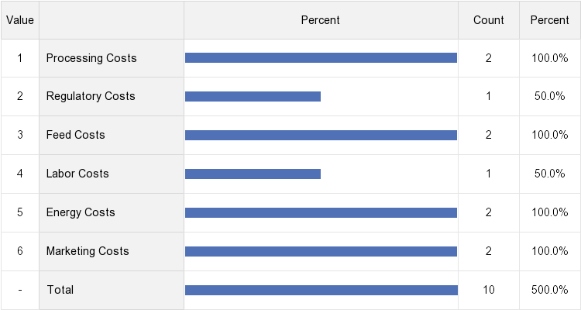

During the project the participants developed a list of edits and suggestions for revisions in the pricing calculator tool. These suggestions were sent on to the calculator developer, Matt LeRoux. Still, the participants found the tool in its present form very useful. After their participation; survey question:
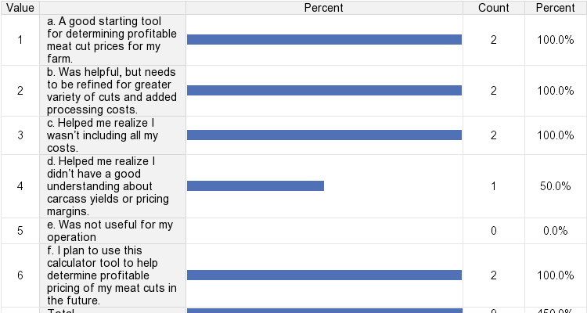
The pricing calculator tool tested in this model was (Check all that apply):

As a result of their participation in the project, participants felt that the most important thing they learned: survey question:
The most important thing I learned from participation in this project was:
- Include all costs for raising and marketing in the price of their cuts.
- How to value the live animal and how important it is to include all the associated costs into the value of the live animal so you can find the baseline for your price per cut.
- Raising prices did not change the volume of their sales.
- Increased profitability through more accurate knowledge of total costs and setting a better profit margin based on that baseline price.
Summary
The most positive outcome from this project was to raise the participants’ awareness of all their product costs and then determine their individual cut prices based on those cost and the percent margin of their choosing.

