Growing Food Businesses:
Opportunities under Montana’s New Food Law
Final Report April 2017

- Workshop Purpose and Context

Montana’s new Food Policy Modernization Law (Food Law) passed during the Montana Legislative Session of 2015, offers new and exciting opportunities to encourage food entrepreneurship in Montana. The Food Law goes a long way to clean up confusing and contradictory language of past laws and regulations and opens new pathways for Cottage Food and other retail food enterprises. The Cottage Food provisions enable Montana entrepreneurs to test new ideas for non-potentially hazardous food products before scaling-up to a retail or wholesale food facility license.

Montana’s new Food Law and its regulations came into full force in October 2015. AERO saw the need for and value in educating Montana producers, food entrepreneurs, local health officials, nonprofits, and business and economic development educators about the Food Law and, most importantly, how to take full advantage of the new opportunities the Food Law creates. Day-long workshops were held in Bozeman, Billings, Arlee, Great Falls and Kalispell between April 5 and May 12, 2016. A total of 118 people participated in the workshops. (See Table 1 for attendance numbers by workshop.)

AERO partnered with employees of the Food and Consumer Safety Section (FCSS) of the MT Department of Public Health and Human Services (DPHHS) in the preparation of workshop content, and workshop delivery. This public-private partnership worked well and participants appreciated the opportunity to interact with both the state regulators and the county sanitarians whose participation was solicited by the FCSS leadership. “Putting a face to the names of people who will be administering these rules is very helpful to me, along with the fact that they all seem to be willing to work with the people navigating them.” (Bozeman participant) Other organizations and agencies co-hosted the workshops including: the Montana Department of Agriculture, the Montana Food and Agricultural Development Network, the High Stakes Foundation, and USDA’s Western Sustainable Agriculture Research and Education (SARE) program.

The stated purpose of the workshops was to educate and excite Montana’s agriculture and food entrepreneurs to use the new Food Law to grow successful businesses. Eighteen participants completing the workshop evaluation survey said they planned to pursue a new product or business opportunity as a result of the workshop.

Workshop Objectives:
- Learn about Montana’s Food Law history, new opportunities and implementation requirements and strategies.
- Build relationships among Montanans who want to start or grow a food business, the Food Law’s regulators, and resource people who can provide assistance and support.
- Help participants better formulate their food business ideas and plans.
- Identify questions, needs, further research and next steps in implementing the Food Law.

- Workshop Design

AERO’s intention was to make the workshops serve as “interactive labs”—a place where key users, regulators and resource people could have lively discussions, explore questions and raise new issues about the new Food Policy Modernization Law and its implementation. The workshops were participatory and responsive to the needs, questions, plans and ideas of participants at each workshop. Participants’ narrative comments on page three express how much they appreciated this tailored approach. (See Appendix A for the Workshop Agenda.)

In order for this interactive or laboratory concept to work, AERO needed to recruit a diverse and balanced mix of attendees for each workshop. Each workshop was limited to around 30 participants and had a targeted mix of participants to ensure lively and fruitful discussions and to meet the workshop objectives:
- Food producers and entrepreneurs (about15)
- Local county sanitarians (2 to 3)
- Food business development resources and educators including: MSU Extension, Food and Ag Development Centers and Department of Agriculture (4 to 5)
- Farmers Market managers and agriculture and food systems nonprofits (4 to 5)
- Other (4 to 5)

- Workshop Evaluation Ratings and Comments

Workshop Evaluations were completed either through an in-person survey following a workshop or an online evaluation survey emailed after the workshop. A complete summary of the responses can be found in Appendix B.

A summary of the results follows.

Figure 1 below shows the mix of participants that completed the on-line evaluation survey and how they self-identified.

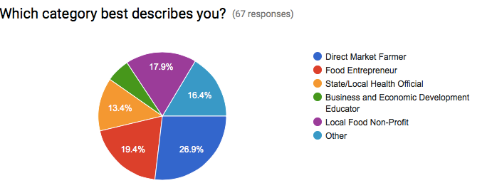

Table 1: Attendance and Evaluation Survey Response Rate by Workshop
 | Bozeman | Billings | Arlee | Great Falls | Kalispell
Number of Participants | 25 | 29 | 23 | 14 | 27
Evaluation Survey Response Rates | 65% | 62% | 61% | 35% | 48%

Table 2: Evaluation Survey Ratings
Evaluation questions were rated on a 1 to 5 scale where 1 is low and 5 is high. What follows are rating averages by workshop.

Evaluation Questions | Bozeman | Billings | Arlee | Great Falls | Kalispell
The workshop gave me a good understanding of Montana’s new food law. | 4.7 | 4.1 | 4.6 | 4.2 | 4.5
I felt welcomed, included, and enjoyed working with other workshop participants. | 4.7 | 4.5 | 4.8 | 4.8 | 4.9
The workshop helped me to see new opportunities for food business development. | 4.1 | 3.8 | 4.3 | 3.8 | 4.2
I learned from other workshop participants and anticipate using the on-line Peer Learning Forum. | 4.1 | 4.0 | 4.0 | 5.0 | 4.2
The speakers, resource people, and facilitators were helpful. | 4.4 | 4.3 | 4.6 | 4.4 | 4.5
Would you recommend this workshop to others? | 15 - Yes  1 - No | 17 - Yes  0 - No | 14 - Yes  0 - No | No responses | 13 - Yes  0 - No

Helpful and Useful Workshop Aspects
Workshop participants were asked what was most helpful/useful about the workshop in both the evaluation survey and in a short oral evaluation at the close of each workshop. The following content and process themes were mentioned most often:
- The explanation of the new Food Law with all of its intricacies.
- “Explanations of which foods are allowed as cottage foods and why they have to be low-risk.” (Arlee participant)

- The workshops’ interactive and participatory design.
- “The attendee interaction and questions.” (Arlee participant)
- “The interactive small cohort groups in the afternoon where individuals’ specific questions could be asked and addressed directly.” (Bozeman participant)
- “I thought coming together in an open discussion kind of way was very helpful. It seemed that many of the questions people had regarding the regulations were answered.” (Kalispell participant)

- Individual networking with other participants and resource people.
- “One-on-one with sanitarians and food safety specialists.” (Bozeman participant)
- “Connecting and learning from others in the same field was very helpful. Talking to people who know about what help is available for growing my business was very helpful. I feel like I know who to talk to for additional help with my business.” (Billings participant)
- “The small group discussions and lunchtime networking.” (Arlee participant)

- Hearing the perspectives of DPHHS and local sanitarians.
- “I really appreciated having the people responsible for writing and enforcing the law right there in the room!” (Billings participant)
- “Networking w/state and county officials. They were reassuringly encouraging about wanting more value-added businesses in Montana.” (Kalispell participant)

- The diversity of participants.
- “The mix of voices represented -- great to hear different perspectives.” (Billings participant)
- “Being in the same room with people from all parts of the process (funding, Health Dept, business planning, process, farming, etc.)” (Arlee participant)

- Continue information sharing and discussion through the on-line peer learning forum. The forum is titled Growing Food Businesses: Opportunities Under Montana’s New Food Law (referred to in this report as New Food Law Peer Learning Forum) and can be found at: http://www.mtfoodeconomy.org/forums/forum/growing-food-businesses/ It is housed in AERO’s Montana Food Economy Initiative website: mtfoodeconomy.com.

Participant Suggestions to Improve the Workshop
There were several suggestions for improving the workshop:
- “The questions that were answered ONLY seemed to prompt further questions and the attempted clarification was often confusing.” (Billings participant)
- More participation from potential business funders.
- Field trips.
- More explanation about the interface of GAP and the MT Food Modernization Law.
- “I would have liked more specific examples and less " you need to talk to your sanitarian." (Billings workshop participant)
- Fewer acronyms.

- Other Program Contributions to Date

Policy Clarifications:
- The interactive workshop process surfaced and led to clarification of an important apparent contradiction between a DPHHS regulation and The Montana Produce Act, which is under the authority of the Montana Department of Agriculture. FCSS staff believed, based on one of the DPHHS rules, that farmers selling raw produce to anyone other than direct to a consumer––such as a co-op, restaurant or grocery––requires a wholesale food license. Workshop participants challenged DPHHS on this policy and an AERO consultant followed up with DPHHS staff with evidence that the policy in question was the result of an old rule that got missed during the process of deleting rules under the previous food law that are no longer consistent with the new Food Law. It turns out that an old DPHHS rule was accidentally left on the books in the clean-up required following the DPHHS food law revisions made by the 2015 Montana Legislature. It was simply an oversight. Attorneys from both agencies reviewed the relevant DPHHS rule and The Montana Produce Act and were able to clarify that the Department of Agriculture holds the authority for sales of raw agricultural products, including raw produce, and therefore no license is required of farmers selling their raw produce into retail or wholesale markets. To be precise: "Wholesale" means the sale of produce intended for resale,” 80-3-302 (10), MCA. The term does not include the sale of Montana-grown produce when sold by the Montana grower for purposes of resale or vegetative seed potato products intended or used for planting purposes.” We now know that the Montana Produce Act is clear that wholesale sales by growers of their fresh, raw produce are exempt from the DPHHS wholesale food laws, and thus are not required to have a license for either their wholesale or retail sales of the fresh, unprocessed produce they grow.

- FCSS answers the question of when a raw agricultural commodity (RAC) becomes a consumer commodity in need of a license for that specific activity on a case-by-case basis. In general, the answer to the licensing question is when produce is further processed and packaged, beyond field cutting or field washing, it becomes a consumer commodity in need of a license. Field cutting and field washing a RAC does not constitute processing. This view is consistent with the legal definition of a RAC, in 50-31-103(31), MCA. However, additional cutting or packaging may constitute an activity that needs a license.

- With regards to raw honey: it is exempt from retail licensure, if the honey is sold directly to a consumer. However, wholesaling honey to retailers is not exempt from licensing.

Educational Resources:
- Several handouts were developed for the workshops by FCSS staff and AERO. (See Appendix C). These are now available to the public on the DPHHS FCSS website and AERO’s New Food Law Peer Learning Forum.

- As suggested at the Billings workshop, DPHHS is developing a “decision tree” to help food businesses understand what the certification and/or licensing requirements and options are by type of food product and market.

- AERO has created an on-line New Food Law Peer Learning Forum to continue the conversations and inquiry begun at the workshops. This web-based forum was demonstrated at the workshops and participants were encouraged to sign-up and invite others to do the same. New information, resources and links will be added over this year. Individuals can pose topical questions and learn what others are doing. AERO will monitor the site and request responses from state agencies as appropriate.

- Lessons Learned for Future Workshops

AERO learned several lessons from our first time organizing these workshops, including from successful outcomes.

- The value of county sanitarian participation in the workshops. Sanitarians attending (usually around 3 per workshop) did an outstanding job of answering local regulatory questions and encouraging producers and food entrepreneurs to meet with them to solve “sticky” business and food safety issues. In the past, food business people did not always view sanitarians as helpful and positive. The interactions in these workshops helped to change that perception and create the opportunity for better communication between the regulators and the regulated.

- Diverse Resource Staff attendance: People really worked their way through the laws and gained a sense of where the cottage food law ended and the need or opportunity for other permits and additional technical assistance and funding support began. In addition to having very smart and knowledgeable people from DPHHS, was having the technical assistance providers there, like county sanitarians and local economic development professionals, who could offer info and support for the next level up. More trainings like this are an opportunity to assist growers and entrepreneurs better understand the whole picture and get help with making the transitions from starting with cottage food and when its necessary to move into broader entrepreneurial activity. Having people there who could help with the next steps in funding and permitting was really valuable in Billings.

- Attendance by Department of Agriculture and Food and Ag Development Center staff. Jan Tusick, Mission Mountain Food Enterprise Center, attended two workshops and was a great asset to workshop participants.

- Recruit Food and Consumer Science Extension agents to future workshops. These professionals will have a significant role in educating Cottage Food entrepreneurs in food safety practices. In addition, DPHHS should consider conducting training on the new Cottage Food provisions for these Extension agents and discuss the importance of their educational role under the new Food Law.

- Engage more potential business funders in workshops. Staff from including USDA Rural Development, Western SARE, MT Department of Agriculture GTA staff and others attending the workshops, particularly in Billings, helped participants think about potential financing options for new ideas.

- Scheduling and recruitment lessons learned:
- Schedule future workshops in February and early March (not April and May).
- Consider charging a small registration fee ($10 to $15) to encourage those who register to show up. (No charge for resource people.)
- Close workshop registration at four or five people beyond the desired limit. AERO assumed there would be walk-ins but that wasn’t the case, so those folks that did not show and did not cancel in advance meant the people on the waiting lists did not have the opportunity to fill those seats.

- Additional Flexibility in Topics Covered by Workshops. Be willing to follow the needs and questions of the workshop attendees. Each workshop was slightly different and being flexible and attentive to participants was appreciated.

- Value of Prearranged List of Participants. The diverse mix of participants at each workshop and the spirit of group inquiry was a great addition to the success of the workshops.

- Follow up Surveys, the Forum and Personal Stories

A follow-up survey with 12 questions was developed by AERO staff and shared with the 118 workshop participants via Google Forms (Appendix D). The survey was shared in November, 2016 and follow-up reminders were sent in January and March, 2017 via email. Two questions addressing future workshop locations and “willingness to pay” were added in January due to an uncertainty of funding for future workshops and a significant interested for more workshops expressed to AERO staff.

The follow up surveys assessed the benefits of the workshops, law changes, forum use, and ongoing challenges; a total of 44 follow-up surveys were completed and provided to AERO. The greatest number of responses came from workshop attendees from Arlee, Kalispell and Bozeman and direct market farmers, non-profit representatives and regulatory agencies were most likely to respond. Responses are excerpted below and continue to highlight the value of networking and gathering various representatives of the regulating agencies into one place with those attempting to understand and use those new regulations. Responses also emphasized the continued need for additional workshops as the laws are standardized across counties, as questions arise, and as success stories continue to occur and can be used as viable examples for those looking to grow their businesses and food production. The surveys will help AERO staff plan and shape future workshop offerings, as well as identify additional needs around the state including communication barriers, locating appropriate equipment and resources, breaking into new markets, and engaging with successful marketing and advertising.

When asked about how the workshop knowledge and training had been used or applied to new business opportunities, or changed business approaches and outcomes, comments included:
- “My neighbors are planning (and did get a start on) a neighborhood market. This workshop helped by giving us the confidence to get started, contacts in our local county health department, and a set of guidelines for inclusion in our market.”
- “We are just slowly nudging the value added idea along. We are gathering materials, ideas, knowledge, trainings, etc. We are confident in the next 3-5 years our farm will offer something value added.”
- “Because of the law, the farmers market vendors I work with have been encouraged to create new products (spice blends, soup mixes, etc) with success.”
- “I have a clear understanding of labeling and what I need to add to my labels. Also, that the labeling requirements for the “cottage food law” is in line with what would be needed for wholesale labeling.”
- “I have decided to add jams and jellies for a value added product, also some breads”.
- “Yes, I am generally the first stop for our farmers market vendors when they are considering making a new product. I like to have the general answers before sending them to the county health person”.
- “We haven't acted on any ideas, but it deepened my understanding of the process that would need to be followed to implement such ideas”.

When asked about connecting with other farmers and producers, and applying group knowledge through the forum or other online opportunities, participants noted that challenges included:
- “Too many people trying to do the same thing or recreate programs that are already functioning. Groups not doing adequate market research and not identifying existing programs.”
- “There are a lot of listservs but not everybody is on all of them.”
- “Producers are so busy growing that marketing and communication IS the barrier, the importance of "others" helping to educate the consumers.”
- “Yes, I find it easy to network. The best way is to attend various workshops/meetings and get to know other farmers.”
- “I feel like it's fairly easy to network through word of mouth. A challenge is that many of our local producers and buyers do not use the internet or email.”
- “Barriers I have faced is not enough knowledge of the fabrication (i.e. cuts of meat, new varieties of veggies, fruits, sauces); restaurant industry needs to stay viable and at least with the curve but hopefully ahead of the curve”.
- “Everyone is very helpful and willing to share information in my experience. Having a sufficient marketing budget is the biggest challenge”.

Attendees were asked what additional resources or opportunities could continue to help them again important knowledge and resources to use the law to their benefit. Answers included:
- “I would love to work with AERO to host workshops in our area. We don't have an extension agent or many experienced farmers so our pool of knowledge/resources is limited. We have put on several workshops for the farmers market vendors on our own with great attendance. The vendors would love to have more!”
- “Organizing a series of work parties/farm days; helping more people start value added businesses.”
- “Business type classes (accounting, bookkeeping, budgeting, marketing), and insurance classes (not all insurance policies cover CSA's, what about the liability of people coming on to the farm etc.)”
- “More on-farm research information availability to small producers.”
- “I really enjoy all educational workshops. I am learning of more livestock ranchers that would increase their production if they had a place to process the animals. Education on no-till organic produce production would be great. Education on dryland produce production would be great”.
- “I would love to spend a day or 2 with someone living the way I envision my business to be. Market farming and running a CSA”.
- “Any type of online, pre-recorded workshops, etc would be helpful for us in Troy. I can always gather the growers for a class on a big screen. They are hungry for knowledge.
- You need a workshop where the restaurateurs tell the people how to package and fabricate things”.
- “More information on cash flow and startups for farming and ranching”.
- “I value the opportunity to get together with local food producers and share ideas most”.
- “Regional meet-ups. Perhaps in conjunction with CFAC and the Red Lodge Food Partnership Council so that we are effectively connecting people in appropriate regions”.
- “Marketing and how to get into local stores.”

The last 3 questions of the survey focused on the value of the new law and the value of the workshops. Over 90% of the workshop participants answered that they would recommend the workshop to others. Results of the other two questions are highlighted below.
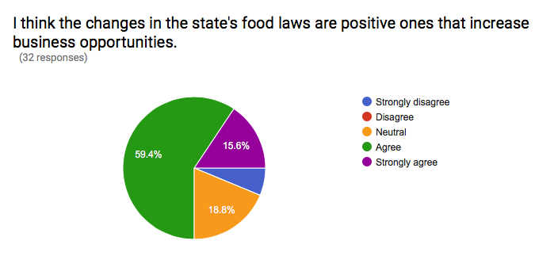
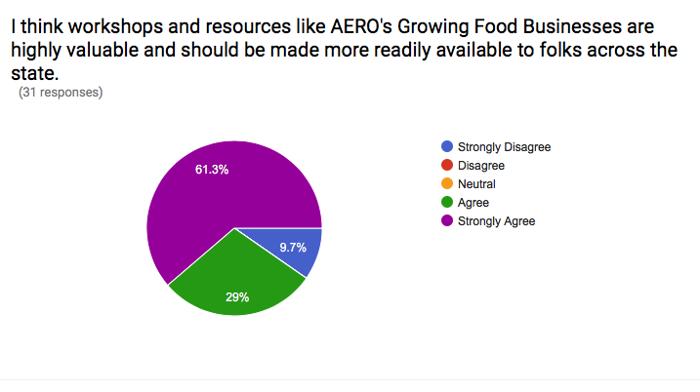

When asked where future workshops should be held, 21 of the 44 respondents provide input. Suggested locations included: The Bitterroot valley, eastern Montana, the High Line, Cascade County/Central Montana, southeastern Montana, Flathead County, Lake County and Lincoln County in NW Montana. The majority of respondents (89%) would be willing to pay between $15-25 for the workshop.

Success Stories, Challenges and Boots-on-the-Ground Stories

Follow-up interviews with the remaining 10 participants to gain their personal stories were scheduled for January through March, 2017 (Appendix E). During the final months of the project, AERO staff completed the remaining interviews of workshop attendees to assess and share their successes, challenges, and continued questions as they work to grow their food production and business opportunities in accordance with the state’s new laws. These interviews were shared through AERO’s networks in the form of articles in our quarterly print newsletter, the Sun Times (circulation of 600), as well as on AERO’s social media, blog, e-newsletters, and the MFEI website (Montana Food Law tab on the website). Appendix E, a document titled: “Success Stories, Challenges and Boots-on-the-Ground Stories”, summarizes the 10 personal interviews. It will be provided to news outlets, circulated to AERO membership and other non-profit partners.

The Montana Food Economy Initiative Forum

AERO staff promoted the use of the online forum to growers, producers, and business owners interested in Montana’s Food Modernization Law of 2015. The Forum located on the Montana Food Economy Initiative (montanafoodeconomy.org) has been monitored and moderated by AERO and shared with addition local partners and groups.

The majority of survey respondents had either not been on the Forum or their visits were limited to 1 or 2 times. Comments from the survey suggested that the forum is a useful tool, but admitted there were many ways other than the forum to gain feedback of share information with a fellow producer. Staff is continuing to promote the site, and plan other ways of directing questions there so that they can be fully answered by staff, with the assistance of DPHHS staff.

VII. What Next?

2017/2018 Workshops
- Workshop participants and DPHHS-FCSS staff suggested that a second round of workshops be slated for late 2017/early 2018, post- or pre-growing season, and led by the AERO and FCSS team. Suggested changes to the workshop format could include a panel of food entrepreneurs sharing their experiences with having created new, or expanded food businesses using the opportunities under the new Food Policy Modernization Law. Also, FCSS staff and local sanitarians would talk about their experiences working with food producers and entrepreneurs operating under the New Law––how they worked together to solve sticky issues and problems. The lessons learned listed above would also be incorporated into workshop recruitment and design.

- DPHHS should consider conducting training on the new Cottage Food provisions for Food and Consumer Science Extension agents and discuss the importance of their educational role under the new Food Law.

Items for Further Exploration
- Participants requested further explanation/definitions on:
- Food safety requirements of homemade pet treats.
- Could you have a “Process Your Own” station at a Farmers’ Market?

Policy Options Discussed at Workshops
- Begin discussions with the MT Department of Livestock on the need for clearer regulation of its egg laws and rules, and for implementation of the USDA Poultry Exemptions the Livestock Department adopted but has not allowed to be implemented. Both of these actions were recommendations coming out of the 2013 study involving the departments of Health, Ag and Livestock that have yet to be addressed by the Livestock Department. If the recommendations are implemented, these educational workshops could include information on new requirements. These regulatory clarifications could be a significant driver of food entrepreneurship in Montana.

- As some other states have done, consider expanding the Cottage Food provisions to include dried herb mixes and some minimally hazardous products, such as salsas and pickles.

- Consider legislation allowing the sale of pasteurized milk products at farmers markets under strict compliance with storage and temperature controls, similar to those that allow meat to be sold at farmers markets.

- Appendices:
Appendix A: Workshop Agenda
Appendix B: Complete responses from in-person/online evaluation of workshops
Appendix C: List of Workshop Handouts
Appendix D: Follow-up Survey, November, 2016 - March 2017
Appendix E: Participant Interviews: Success Stories, Challenges and Boots-on-the-Ground Stories

The original plan was for four workshops, but demand and fundraising success allowed for an additional workshop in Kalispell.
The Great Falls and Bozeman attendance suffered from spring snowstorms that prevented some registrants from attending. This was especially true for Great Falls.

