The Winooski Natural Resources Conservation District received grant funding from the Lake Champlain Basin Program for the purchase of an aeration tiller and the District is making this equipment available to local farmers for $3 per acre in addition to a small per mile transport fee.
The aeration tiller is a Genesis Tiller Model 1200 S.
We promote the usage of the aeration tiller because of the water quality benefits it provides. The tiller increases infiltration into the soil, decreases compaction of the soil and prevents excess nutrient runoff. The aeration tiller leaves crop residue on the surface of the soil, retaining organic matter and preventing soil erosion.
If you would like more information about the aeration tiller, please contact Laura Dlugolecki
802-288-8155, ext. 104 or email laura@winooskinrcd.org.
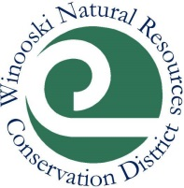
Agricultural Outreach Initiative
One of our programs, the Agricultural Outreach Initiative (AOI), has the potential to continue for a second year. Funding permitted; we will be hosting workshops and doing farm visits through the Winooski Conservation District (including Chittenden, Washington and parts of Orange Counties) with regards to Accepted Agricultural Practices (AAP) and offering technical assistance. If this is something that might interest you, please indicate it below or email us at: info@winooskinrcd.org to let us know. Thank you!

Preferred Contact (circle one)
Farm Name:
Owner's Name: Operators Name:
Owner's Address: Operator's Address:
Owner's Phone: Operator's Phone:
Owner's Email: Operator's Email:
To see what kind of information we gathered last year, go to: http://winooskinrcd.org/work/agriculture/.

