BASKETS TO PALLETS FARMER-BUYER VIDEO INTERVIEWS

Wegmans Food Markets and Blackman Homestead: 4 CLIPS
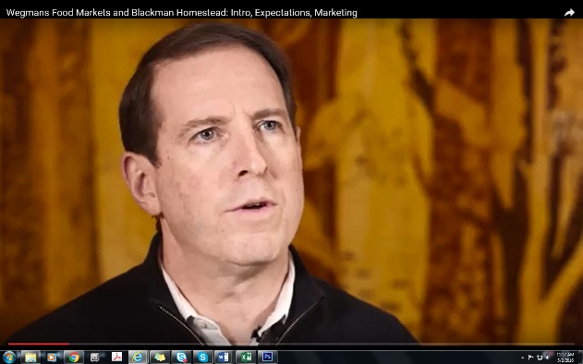
Wegmans Food Markets and Blackman Homestead: Intro, Expectations, Marketing
https://www.youtube.com/watch?v=U1jjC0wCJmM&feature=youtu.be

Wegmans Food Markets and Blackman Homestead: Communication
https://www.youtube.com/watch?v=CNt_8RKo9hA&feature=youtu.be

Wegmans Food Markets and Blackman Homestead: Food Safety
https://www.youtube.com/watch?v=vAZ2HXuTQHM&feature=youtu.be

Wegmans Food Markets and Blackman Homestead: Advice for Growers New to Wholesale
https://www.youtube.com/watch?v=6hmbH1-PJCs&feature=youtu.be

Headwater Food Hub and Fisher Hill Farm: 4 CLIPS
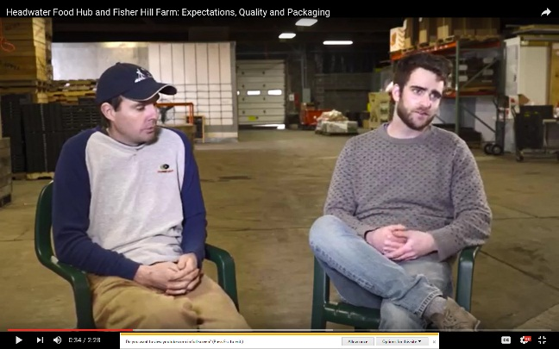
Headwater Food Hub and Fisher Hill Farm: Intro and Advantages of Wholesale
https://www.youtube.com/watch?v=965npUivHRo&feature=youtu.be

Headwater Food Hub and Fisher Hill Farm: Expectations, Quality and Packaging
https://www.youtube.com/watch?v=GWMKBF7ExO0&feature=youtu.be

Headwater Food Hub and Fisher Hill Farm: Food Safety
https://www.youtube.com/watch?v=E4o8CDNreIs&feature=youtu.be

Headwater Food Hub and Fisher Hill Farm: Engaging New Farmers
https://www.youtube.com/watch?v=F3sZjYRAzhk&feature=youtu.be

