Seed Transmission and Management of the White Leaf Spot and Light Leaf Spot Pathogens of Brassicas in the Pacific Northwest
WSARE Annual Report, January 2017
Shannon Carmody and Dr. Lindsey du Toit, Washington State University

Shannon Carmody is an MS student in the Department of Plant Pathology at Washington State University. This report summarizes progress Shannon has made on her MS thesis project since submitting an annual report in January 2016 for the Western SARE Fellowship supporting her MS project. Shannon’s advisor, Dr. Lindsey du Toit, Professor and Extension Plant Pathologist at the WSU Mount Vernon NWREC, runs an applied research and extension program focused on seed pathology and vegetable pathology. Shannon is completing her studies in this program in order to build a technical foundation in seed pathology, with a focus on organic seed pathology, because of the importance of seedborne pathogens in agriculture, including in the worldwide movement of seed.

Thesis Research Project Overview
Shannon’s research project is framed around two emerging plant diseases in brassica crops in the Pacific Northwest, light leaf spot and white leaf spot. In 2014, during a survey related to an outbreak of black leg of brassicas caused by the seedborne fungus Phoma lingam (which has the teleomorph stages Leptosphaeria maculans and L. biglobosa) in the Willamette Valley of Oregon, another two brassica diseases to the Pacific Northwest were detected in the Willamette Valley: white leaf spot (WLS), caused by Pseudocercosporella capsellae; and light leaf spot (LLS), caused by Pyrenopeziza brassicae. WLS had been found rarely in the Pacific Northwest before 2014, and LLS had not been documented anywhere in North America prior to 2014. All three fungal brassica-infecting pathogens found in the initial outbreaks in 2014 have been reported to be seedborne and seed transmitted, although information on the seedborne and seed transmitted aspects of the LLS and WLS pathogens is vary sparse. In fact, damaging epidemics of black leg in Midwestern and east coast states in the 1970s were tied back to P. lingam-infected seed lots grown in the Pacific Northwest, which had severe consequences on the brassica vegetable seed industry in this region. Understanding these important pathogens will help organic brassica growers, including seed growers, reduce the impact of these fungi on crop production, detect inoculum on seed, and implement effective disease management programs.

The overarching goal of Shannon Carmody’s project is to provide farmers and seed companies that produce brassica crops in this region with awareness and tools to detect and manage LLS and WLS in brassica fields and seed lots. Specific objectives outlined in the 2015 progress report, with progress made in 2016 towards meeting those objectives, are listed below:

- Produce brassica seed lots infested with the LLS and WLS fungi by inoculating developing pods on plants of several types of brassicas to facilitate natural infection of seed. Details of the plant inoculation process were provided in the 2015 annual report. Seed was harvested from these inoculated plants in late summer and fall of 2015. A seed lot of mustard (Brassica juncea) and a seed lot of cabbage (B. oleracea var. capitata), were each infested successfully with P. brassicae, demonstrating that the pathogen can be seedborne. This infested seed lot has been used to accomplish the other research objectives described below. Infection of seed lots with the WLS pathogen, P. capsellae, was not accomplished despite multiple inoculations of numerous plants of both Brassica species. Foliar symptoms of WLS developed on these plants, but not pod symptoms.

- Develop seed health assay(s) to detect and quantify the LLS and WLS pathogens in infested seed lots. The LLS pathogen is new to North America and the seedborne phase of the pathogen is not well understood. Therefore, a method for detecting this pathogen on infected seed needed to be developed. Various methods of plating seed onto agar media, blotters, etc. were tested. Ultimately, the LLS fungus was detected on the greatest incidence of mustard and cabbage seed lots by plating the seed onto NP-10 agar medium, incubating the seed at 4°C in the dark for six weeks to facilitate development of the very slow-growing pathogen at a cold temperature that inhibits most other (faster-growing) fungi that can occur on brassica seed, and examining the seed microscopically four, five, and six weeks after plating the seed. Preliminary results showed P. brassicae was detected on 12.5% of the mustard seed lot generated as part of Objective 1, and 0.4% of the cabbage seed lot. Repeating the seed health assays with both lots produced similar results. P. capsellae was not detected on the mustard or cabbage seed lots with any of the protocols evaluated, so no further work was done on the seedborne aspects of that pathogen.

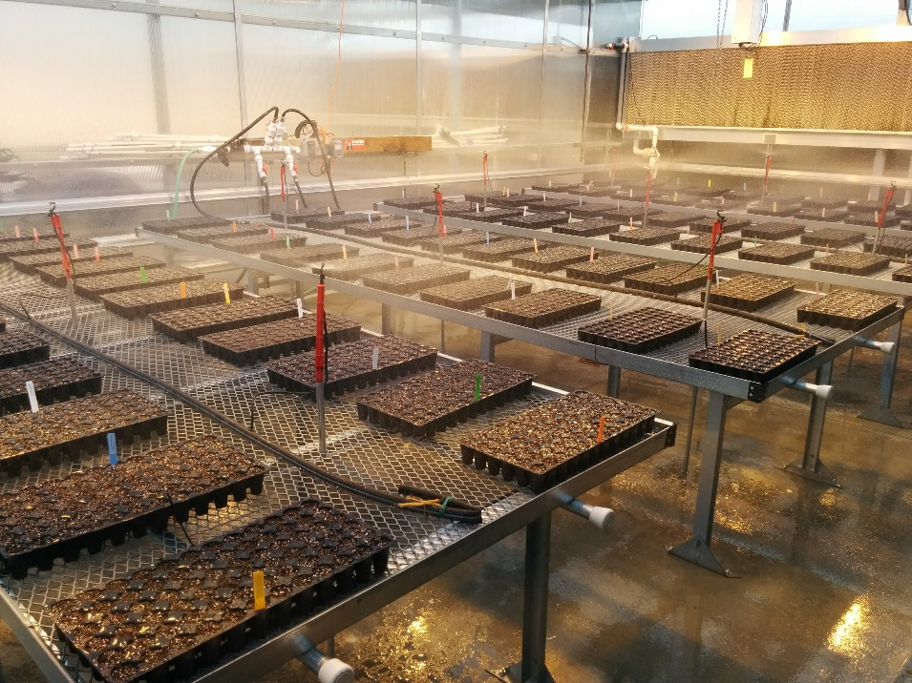
- Assess the rate of seed transmission of the LLS pathogen from infested seed lots planted under conditions conducive to LLS. Seed transmission trials were carried out in greenhouses at the WSU Mount Vernon Northwestern Washington Research & Extension Center (NWREC). The infected mustard and cabbage seed lots were planted in a greenhouse under misters to mimic growing brassica plants under overhead irrigation with high relative humidity and extended durations of leaf wetness. Seed of the mustard lot were planted into 15 72-cell flats, with each set of three flats representing one replication of 216 seed planted, and five replications planted. Seed of the cabbage lot were planted into each of 5 200-cell flats, with each flat representing one replication. Once plants started emerging, micro-sprinklers were staked between the flats and set on a timer to mist the flats for 10 s every 30 min for the first week after emergence, and 10 s every 45 min for the subsequent 35 days (Figure 1). These damp conditions ensured a conducive environment for development of P. brassicae.

Figure 1. Assay to test the rate of seed transmission of the light leaf spot fungus, Pyrenopeziza brassicae, from an infested mustard seed lot.

The LLS fungus developed on 1.6% of the seedlings that developed from 1,080 seeds planted under these conditions, which represented a 20% seed transmission rate from the 12.5% infested seed in that lot (Figure 2). In contrast, P. brassicae was detected on only 1 of 1,000 seedlings grown from the infected cabbage seed lot. However, this represented a 25% seed transmission rate from the 0.4% infested seed in that lot.
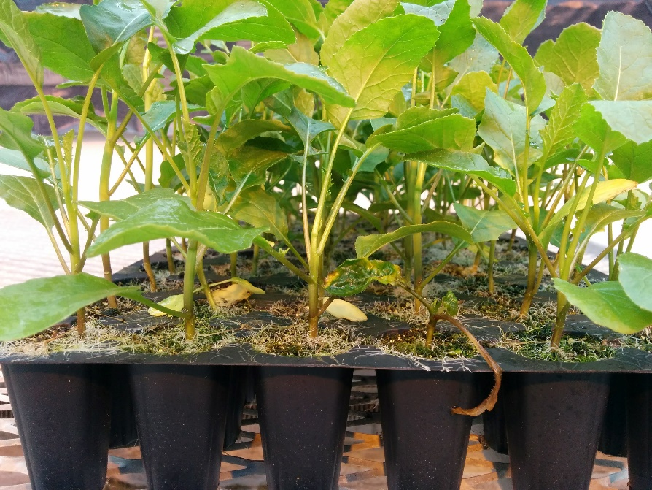
Figure 2. Seed transmission of Pyrenopeziza brassicae from an infested mustard seed lot. The second plant from the right, circled in red, developed venial browning and chlorosis typical of light leaf spot, followed by stunting and collapse of the seedling.

Most seed transmission studies focus on detecting the pathogen or symptoms of the disease on cotyledons as a measure of direct seed transmission. The LLS fungus, and symptoms of LLS, were very difficult to detect on mustard cotyledons as the symptoms typical of LLS, including venial browning and foliar chlorosis, were not distinct on cotyledons (cotyledons do not have distinct veins and senesce rapidly once true leaves start to form). Therefore, initial seed transmission tests necessitated focusing on symptoms of secondary infection, i.e., infection of the true leaves (Figure 2). The seed transmission trials demonstrated that P. brassicae readily is transmitted from infested seed to emerging seedlings. However, subsequent seed transmission trials completed in a different greenhouse, as part of the seed treatment Objective 4 described below, resulted in development of fairly distinct LLS symptoms on cotyledons prior to the first true leaves maturing, which provided a more direct measure of seed transmission and enabled seed transmission assays to be completed within 4 weeks. Even a very low incidence of seed transmission (<1%) can translate into a significant disease outbreak under conducive environmental conditions, given that >100,000 seed might be planted in some brassica crops (e.g., cover crops). The results reiterate the importance of growing or purchasing high quality, pathogen-free seed, particularly for organic production because of limited options for disease management once infection has occurred in a crop.

- Assess seed treatments to reduce or prevent seed transmission of the LLS fungus. Using the P. brassicae infested seed lot generated as part of Objective 1, four types of seed treatments are being assessed for reduction or prevention of seed transmission of this pathogen. This objective combines the protocols developed in Objectives 2 and 3 because of the three steps necessary to determine the efficacy of seed treatments: 1) a seed germination test (four replications of 100 seeds tested/treatment), 2) a seed health assay (four replications of 100 seeds tested/treatment), and 3) a seed transmission assay (four replications of 216 seeds tested/treatment) (Figure 1). The three types of organic seed treatments tested in fall/winter of 2016-17 included the following, each of which was evaluated in repeated trials, with four replications of each treatment tested in each assay in both the first trial and the repeat trial, using randomized complete block designs:
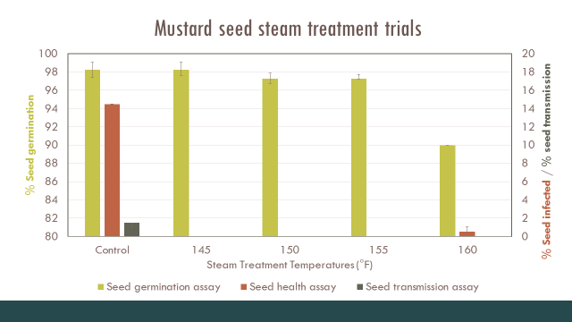
  - Steam treatments (Figure 3): In collaboration with Tom Stearns at the High Mowing Seed Co. facility in Vermont, samples of ~2,500 seeds of the infested mustard seed lot were treated with a proprietary steam treatment for 90 seconds at each of four temperatures: 145, 150, 155, and 160ºF compared to non-steamed control seed. A second set of samples of the seed lot was subjected to the same four seed treatments and a non-steamed control treatment for the repeat trial. All steam treatments were completed at High Mowing Seed Co., each seed sample was dried thoroughly immediately after treatment, and the seed samples shipped back to Mount Vernon, WA. Results from the first trial are shown in Figure 3, and the repeat trial produced similar results.
Figure 3. Results from steam treatment trials with mustard seed infected with Pyrenopeziza brassicae.
  - Hot water treatments: For each of the four replications of each duration (15 minutes and 30 minutes) of hot water treatment, a mesh tea strainer containing 500 seed of the P. brassicae infested mustard lot was immersed in deionized water that had been heated to 50°C for 15 min or 30 min, in a programmable circulating hot water bath. The seed subjected to the two hot water treatment durations were then triple-rinsed in sterilized, deionized water at room temperature, dried in sterilized conditions in a laminar flow hood, and stored for testing. Seed not subjected to hot water treatment served as the control treatment. The trial was repeated using the same procedures.
  - 1.2% NaOCl: For each replication of each of four durations of chlorine treatment, 10, 20, 30, and 40 minutes, a mesh tea strainer containing 500 seed of the P. brassicae infested mustard lot was immersed in a 250 ml glass beaker containing 100 ml of 1.2% NaOCl. The beaker was covered with Parafilm and placed on a gyrotary shaker at 220 rpm for 10, 20, 30, or 40 min. Immediately after the relevant duration of treatment, the seed was triple-rinsed in sterilized, deionized water at room temperature, dried in a laminar flow hood, and stored for testing. Seed not treated with bleach served as the control treatment. The entire trial was repeated.
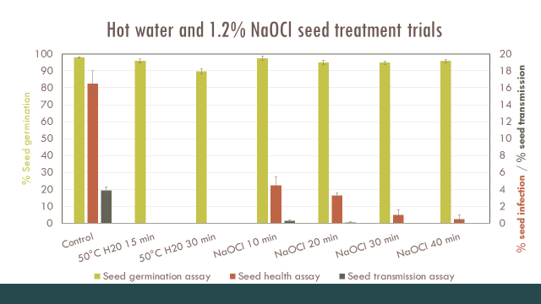
  - Fungicide seed treatments: Fungicide seed treatments that currently are registered for use on canola and/or other brassica crops are being evaluated for the potential to eradicate or reduce the incidence of seed with viable inoculum of the LLS pathogen, and to prevent or reduce the rate of seed transmission of the pathogen. Seed germination, health, and seed transmission trials are being carried out, and the entire experiment repeated, for 11 seed fungicide seed treatments as well as control seed, using similar protocols to those described above. These assays are in progress (Nov. 2016 to Feb. 2017).
Figure 4. Results from hot water and bleach (NaOCl) treatment trials using mustard seed infected with Pyrenopeziza brassicae.

Preliminary data analyses indicated that the four steam treatments and two hot water treatments were very effective at killing the LLS fungus on the infested mustard seed, as the pathogen was not detected in the seed health assay or on any seedlings in the seed transmission trial that developed from seeds subjected to these treatments, except for one seed subjected to one of the steam treatments on which the LLS fungus was detected in the seed health assay (Figures 3 and 4). Although all of the durations of 1.2% NaOCl treatment significantly reduced the incidence of seed on which the LLS fungus was detected (Figure 4), this disinfectant was not as effective as the steam or hot water treatments at preventing development of P. brassicae on mustard seed and seedlings. The ability to recover this pathogen on seed treated with 1.2% NaOCl for 40 minutes suggests that the infection is not just on the surface of the seed coat, but appears to be within the seed coat and possibly even in the embryo. The germination assay and seed transmission assay revealed that the hottest steam treatment (160ºF) was phytotoxic as the mustard seed germination was delayed and reduced, with stunting of the seedlings that developed from seed steamed at this temperature. The same phytotoxicity was observed for this steam temperature in the repeat trial. In the first trial with the two hot water seed treatments, the seed was first warmed up for 10 minutes at 25ºC prior to the 50ºC treatment. With this protocol, the 30 minute duration of hot water treatment was slightly phytotoxic to the mustard seed as the incidence of normal seed germination was reduced slightly in both the seed germination assay (Figure 4) and the seed transmission assay (data not shown). However, when this warming step was removed from the protocol in the repeat trial, the 30 minute duration of hot water treatment no longer was phytotoxic. Otherwise, results for the hot water, bleach, and steam seed treatment trials were similar in the repeat trials. Results for the fungicide seed treatment trials are being collected.

- Provide farmers, seed company representatives, consultants, extension educators, and other relevant stakeholders with educational materials and training opportunities on detection and management of the LLS and WLS pathogens, including the importance of purchasing high quality seed lots. A popular press article for farmers was written and published in the Washington Tilth Producers’ Quarterly: Carmody, S., and du Toit, L.J. 2016. Light leaf spot and white leaf spot – two new fungal diseases of brassicas in the PNW. Tilth Producers’ Quarterly 26 (4):5,18,20. Shannon gave a presentation on 29 January 2016 on this project at the annual meeting of the Puget Sound Seed Growers’ Association in Mount Vernon, WA. Lindsey du Toit has presented updates on this project to the Vegetable Technical Subcommittee of the American Seed Trade Association during three conference calls in 2016 and again on Jan. 4, 2017. Seed company plant pathologists have requested regular updates because of the potential significance of these diseases.
In early April 2016, Shannon found LLS to be widespread on wild bird’s rape mustard (B. rapa) and mustard cover crops (B. juncea) in Skagit, Whatcom, and Snohomish Counties of northwestern Washington State (Figure 5). WLS also was detected in B. juncea cover crops and on bird’s rape mustard plants growing along the edges of fields in Skagit and Whatcom Counties. Neither disease had previously been found in Washington State, so this represents an important record for the region. Both LLS and WLS fungi can infect a wide range of genera and species in Brassicaceae, although their impact on diverse types of brassica crops grown in the Pacific Northwest remains to be determined. In the U.K., LLS has become the main cause of yield losses in winter rapeseed production. In the E.U., Canada, Australia, and the southeastern U.S., WLS has been demonstrated to impact the quality and value of fresh market brassica crops. The finding of both of these pathogens in western Washington lead to an additional objective for Shannon’s MS research project.

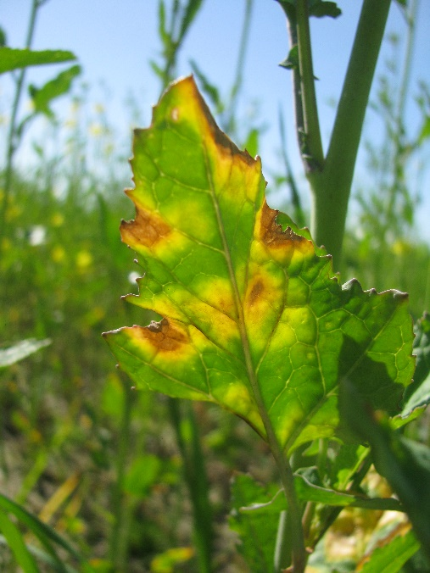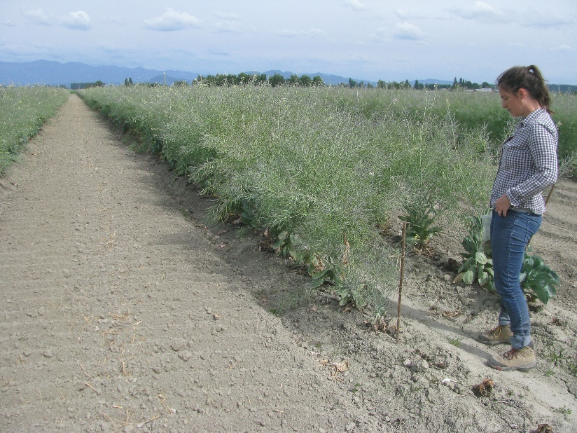
Figure 5. Light leaf spot symptoms observed in a mustard cover crop in April in the Skagit Valley (left), and Shannon surveying a cabbage seed crop in the Skagit Valley in July 2016 for light leaf spot and white leaf spot (right).

- Conduct a survey for LLS and WLS in northwestern Washington. A limited survey in spring-summer of 2016 of brassica cover crops, weeds, and biennial seed crops revealed the presence of both the LLS and WLS pathogens in mustard cover crops and in bird’s rape mustard weeds growing alongside roads, ditches, and dikes in Skagit, Whatcom, and Snohomish Counties. Neither pathogen was found in surveys of a dozen cabbage seed crops in the summer of 2017. The survey was continued in November 2016 after planting and establishment of fall-sown cover crops and initiation of the fall rainy season, to assess when symptoms first appear in these cover crops and stands of bird’s rape mustard. Symptoms of LLS were observed on cover crops and birds’ rape mustard weeds in Skagit Co. in Nov. 2016, and additional isolates of the fungus collected from samples. Pathogenicity testing of isolates of P. brassicae and P. capsellae has been completed for all samples collected in spring 2016. Pathogenicity testing for isolates collected in western Washington entailed collecting symptomatic leaves or whole plants, isolating from the lesions, and developing single-spore isolates for long-term storage and further analyses. The single-spore isolates were inoculated onto healthy plants of mustard and/or turnip in a greenhouse to observe symptoms typical of each disease, and re-isolations completed from symptoms that developed. In addition, molecular (DNA-based) methods of species identification were used on each isolate, i.e., PCR assays with published primers to amplify the internal transcribed spacer (ITS) region of ribosomal DNA (rDNA) and the beta-tubulin DNA, which confirmed the genus and species identity of the original isolates and re-isolates from the pathogenicity tests. Interestingly, the ITS rDNA sequences only had 95% sequence similarity with the few ITS rDNA sequences available in GenBank for this species (mostly of isolates from the EU and UK), which typically is considered below the level of similarity for isolates of the same species.

- Use the seed health assay developed in Objective 2 to survey brassica cover crop seed lots obtained from growers and seed companies that are planted in the Skagit Valley. To date samples of five brassica cover crop seed lots have been received and tested that were planted in Skagit Co., WA in 2016. We have detected the LLS pathogen on one seed lot of white mustard (Sinapis alba) cultivar Nemagon (at <1% incidence), but not on the four other seed lots assessed to date. The Nemagon seed lot was grown in the Willamette Valley of western Oregon, where the LLS spot pathogen was first documented to occur in North America in 2014, while the other seed lots were grown in eastern Washington where the pathogen has not been detected. This revealed the potential for movement of the LLS fungus on infested seed lots and, therefore, introduction of the pathogen into regions on cover crop seed.

- Partnering with researchers at Rothamsted, UK working with P. brassicae to examine genetic differences in isolates from the USA (Oregon and Washington) vs. isolates from the UK, EU, and New Zealand, to learn about the potential origin and population genetics of the pathogen in North America. Shannon completed sequencing of the ITS rDNA as well as the beta tubulin, and translation elongation factor (TEF) regions of the LLS isolates she has collected to date from Oregon and Washington, and is in the process of obtaining the RPB2 gene sequences. These sequences will be used to complete a multi-locus sequence analysis (MLSA) of isolates of the LLS fungus obtained from infected plants in Oregon and Washington compared with isolates from the UK, EU, and new Zealand obtained from Drs. Jon West and Kevin King at Rothamsted Experimental Station in the UK. Drs. West and King have also examined the mating type genes of the US isolates we sent to them from Shannon’s collection, compared with UK, EU, and New Zealand isolates. They have established that both mating types of P. brassicae, MAT1-1 and MAT1-2, are present in western Washington and Oregon, and the North American isolates are distinct genetically from the UK, EU, and New Zealand isolates. Their results suggest a different population of the LLS fungus was introduced into the Pacific Northwest USA than the UK, EU, and NZ isolates. The MLSA results will be combined with the mating type sequence analyses to be published in 2017. Based on the interesting find of a different genetic grouping of isolates from the US, a grant proposal is being prepared to seek funding for further work in collaboration with Drs. West and King as well as researchers at Oregon State University.
Lastly, a side project has developed during Shannon’s MS degree after she detected another fungal plant pathogen, Plectosphaerella cucumerina, on a turnip seed lot of the cultivar Barkant that was harvested from a seed crop grown in the Willamette Valley or OR in 2015. The seed crop had severe infections of LLS, WLS, and black leg in 2014-15. P. cucumerina was not considered a common pathogen of brassicas or to be seedborne in brassicas, even though the fungus is ubiquitous in many environments, can colonize plants endophytically, and has even been evaluated as a potential biocontrol agent for some fungi and nematodes. P. cucumerina was detected on >20% of the Barkant turnip seed lot, and Shannon demonstrated the fungus could be seed transmitted from that lot when planted under misters in a greenhouse using the seed transmission protocol described above. However, an average of only one in five isolates of P. cucumerina obtained from the Barkant seed lot was pathogenic when inoculated onto turnip foliage. Hannah Rivedahl, an MS student in Dr. Ken Johnson’s lab at Oregon State University, is studying isolates of this pathogen that she has obtained from wilted cucurbit plants (particularly squash) in the Willamette Valley. In her research on the host range of this fungus, Hannah isolated P. cucumerina from root and crown lesions of brassica crops. Shannon is collaborating with Hannah to test pathogenicity of cucurbit isolates of this fungus using both foliar inoculation methods and soil inoculation methods. To date, Shannon has found four isolates to be pathogenic on turnip using the foliar inoculation method, and has used PCR assays followed by sequencing of the ITS rDNA to confirm the genus and species identity of the P. cucumerina isolates. Interestingly, the ITS rDNA sequence of the isolates that are pathogenic on brassica foliage differs slightly from the sequences of the isolates that are not pathogenic on brassica foliage. Shannon will be comparing these with sequences of the Oregon cucurbit isolates from Hannah’s collection.

Academics and Outreach
Coursework completed by Shannon Carmody in spring and summer semester of 2016 included: Advanced Fungal Biology (PL P 526), Epidemiology (PL P 551), Seminar (PL P 515), and Field Plant Pathology (PL P 525). Shannon attended three conferences in 2016: the Organic Seed Growers’ Conference in Corvallis, OR on 4-6 February; the American Phytopathological Society (APS) Pacific Division Meeting in La Conner, WA on 28-30 June; and the Student Organic Seed Symposium in Waterville, ME on 4-9 August.

Additionally, Shannon gave the following workshops and presentations in 2016:
  - Presentation on 29 January 2016 and 13 January 2017 at the annual meeting of the Puget Sound Seed Growers’ Association in Mount Vernon, WA;
  - WSU Department of Plant Pathology seminar (for PL P 515) titled “The Wicked Problem of Cucumber Green Mottle Mosaic Virus: Research and Perspectives in Seed Pathology” on 18 April in Pullman, WA;
  - WSU Department of Plant Pathology seminar (for PL P 526) titled “The Mysterious Case of the Pointy-Headed Morel” on 27 April by videoconference from Mount Vernon to Pullman, WA;
  - Presentation and abstract at the American Phytopathological Society Pacific Division meeting on 28-30 June [Carmody, S.M., Ocamb, C.M, and du Toit, L.J. 2016. Potential for seed transmission of Pyrenopeziza brassicae and Mycosphaerella capsellae on brassicas in the Pacific Northwest. Phytopathology 106:S4.196 (Abstr.) ;
  - Webinar for E-Organics and the Organic Seed Alliance on seedborne diseases on 16 August 2016;
  - “Plant Disease 101” workshop for beginning farmers enrolled in the WSU Cultivating Success Beginning Ranching and Sustainable Farming course on 20 October 2016;
  - Workshop in October 2016 for the WSU Mount Vernon NWREC Student Harvest Festival, in which Shannon taught 80 third graders from the Mount Vernon School District how to save tomato seeds.

Shannon’s thesis research will be presented at the national meeting of the American Phytopathological Society in San Antonio, TX in August 2017. In addition, her defense seminar to the WSU Department of Plant Pathology is scheduled currently for April 2017. We anticipate Shannon will publish three scientific journal articles from her thesis, to be submitted in spring-summer 2017.

