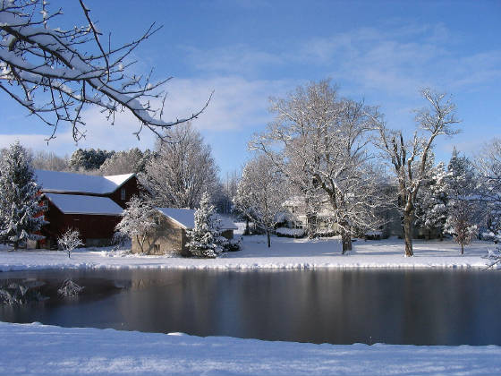
On Farm Problem-Solving Case Study

Lou Lego, Elderberry Pond Farm

Auburn, New York
Background
Lou Lego and his wife have been farming near Auburn, NY for thirty-five years. They have about 100 acres, including vegetables, pasture, forest, herbs, cut flowers, and apple trees. They raise heritage pigs and chickens. Elderberry Pond Farm’s most unique feature is not a crop, however—it’s their restaurant! Their son Christopher trained as a chef and came back to the farm to start a now beloved farm-to-table restaurant that features meat and vegetables produced on-site. Running a restaurant changed the way Lou farms—because the food is needed so often and for so long, succession planting is essential. Approximately 70% of the food produced on the farm goes to the restaurant!
Initial Problem: Detection & information gathering
Elderberry Pond farm had been growing cucumbers for years, with small amounts of downy mildew, but they were always able to harvest the crop. Things changed in 2008, when it seemed to be particularly aggressive, killing the plants so quickly the entire crop was lost. Lou did some research online and discovered that NC State was investigating a new strain of downy mildew that was devastating crops in south.
Testing a quick and easy first solution
Downy mildew spreads by airborne spores, so Lou tried using row cover. This delayed infection by a few days, but still, the cucumber plants died. Lou did further research on the spores to get to the bottom of things. He discovered they were 1.3 microns in diameter, and he began to think, “I wonder if there is a filter that can capture them?” Indeed, he found that there are hypoallergenic filters for furnaces that are affordable.
Back to the drawing board: Trial of a second solution
Lou wrote and received a SARE grant to test his idea that furnace filters could be used to capture the spores if the cucumbers were grown under cover. He built a low tunnel with furnace filters for intake of air. There were covered beds and uncovered control beds nearby. The low tunnel worked perfectly—zero plants were lost to downy mildew. The adjacent beds, both uncovered and covered with row cover, were killed by downy mildew infestation.
Re-assessment & next steps
Getting into the low tunnel to harvest was difficult, and Lou was concerned about temperature getting too hot. Lou wanted a larger solution but was concerned about the possibility of contamination. Could a high tunnel work? What about opening the doors—would spores get in? Based on his previous work in clean rooms, he knew that one could create a positive air pressure inside a room, so that when a door is open, air flows out rather than in.
Testing an improved tunnel system
Lou wrote a larger SARE grant, which was funded, and built a 100ft x 25ft high tunnel. All air intake passes through fifteen furnace filters at one end of the structure. Positive pressure is maintained so that anyone entering the high tunnel does not bring outside air with them. They planted both cucumbers and tomatoes inside, to prevent tomato late blight. This system works well and continues to be in use today!
Insights: You, too, can become an innovator/expert problem-solver!
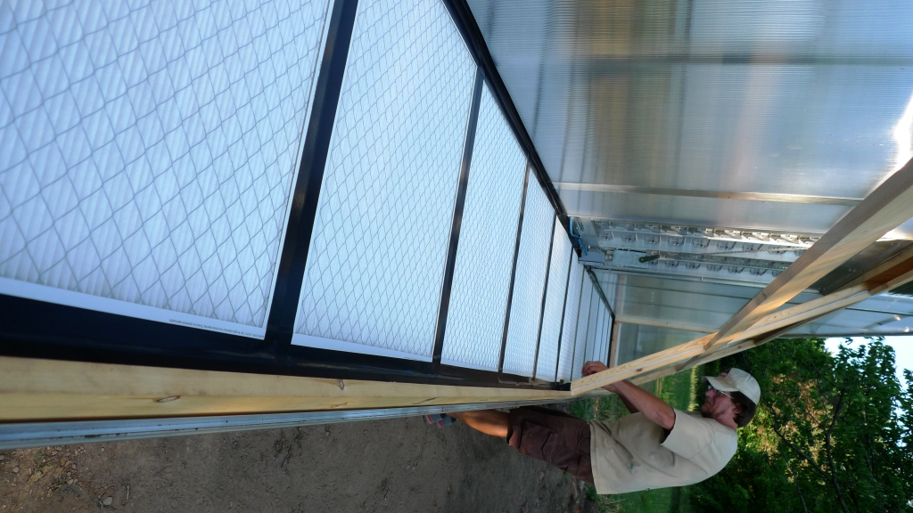
Keep detailed notes in a journal. Highlight any unusual observations on the farm.
Bring in knowledge from other life/work experiences! It was Lou’s work in clean rooms in his pre-farming life that gave him the idea to use positive air pressure.
Replicating treatments is frequently not practical on a working farm. To compensate for the lack of replication, Lou minimizes differences between his control and the experimental treatment by using the same varieties and keeping other management practices such as planting date the same in the control plot and his tunnel.
Be prepared for other domino effects—in this case, because so many plants were under tunnels, there was increased need for irrigation.
Grants are helpful both for the financial resources to make changes, as well as the validation that an idea is worthwhile and perhaps useful to a broader audience.
Outreach/discovery sharing
Lou has shared this discovery a conferences, at SARE workshops, and through farmers coming to visit the farm and see his setup.

