Economic Breakdown of Bokashi Use
Material | Cost | Cost/Unit | Units needed | Cost/Material
Bran | $10/25 lb bag | $0.71/lb | 12 | $8.52
EM-1 | $22.99/ 32 oz bottle | $0.40/oz | 3 | $1.20
Molasses | $7.00/32 oz bottle | $0.20/oz | 3 | $0.60
Table 1. Materials costs to make 12 lb of bokashi bran
Total Cost to make 12 lb of bokashi bran= $10.32
Cost/lb= $0.86

Approximately 1 lb of bran is used per gallon of bokashi. Each gallon varies in weight, but most of my buckets weighed around 20 lb. I was able to make 200 lb of bokashi with this 12 lb batch of bran. So, figuring in labor costs:

Time to prepare bran: 30min
Time to prepare bokashi buckets: 1.5 hours
Total preparation time = 2 hours @ $10/hour = $20.00
Total cost to prepare 200 lb of bokashi= $32.82 = $0.17/ lb

So, comparing that with Vermicompost and Thermophilic Compost applications:
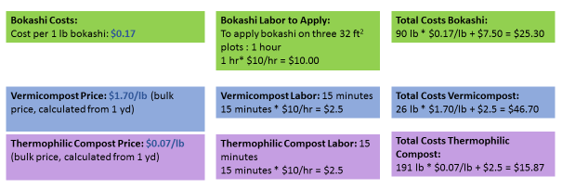
And now comparing yields across treatments:
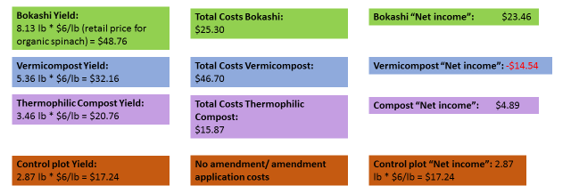
Reference: Spinach yields are around 5-7 t/acre, which would equate to about 7-10 lb from this size plot (32 sq ft).

