Establishing a Beehive
Cooperative Extension•Delaware State University
A Program
Beehive boxes and frames
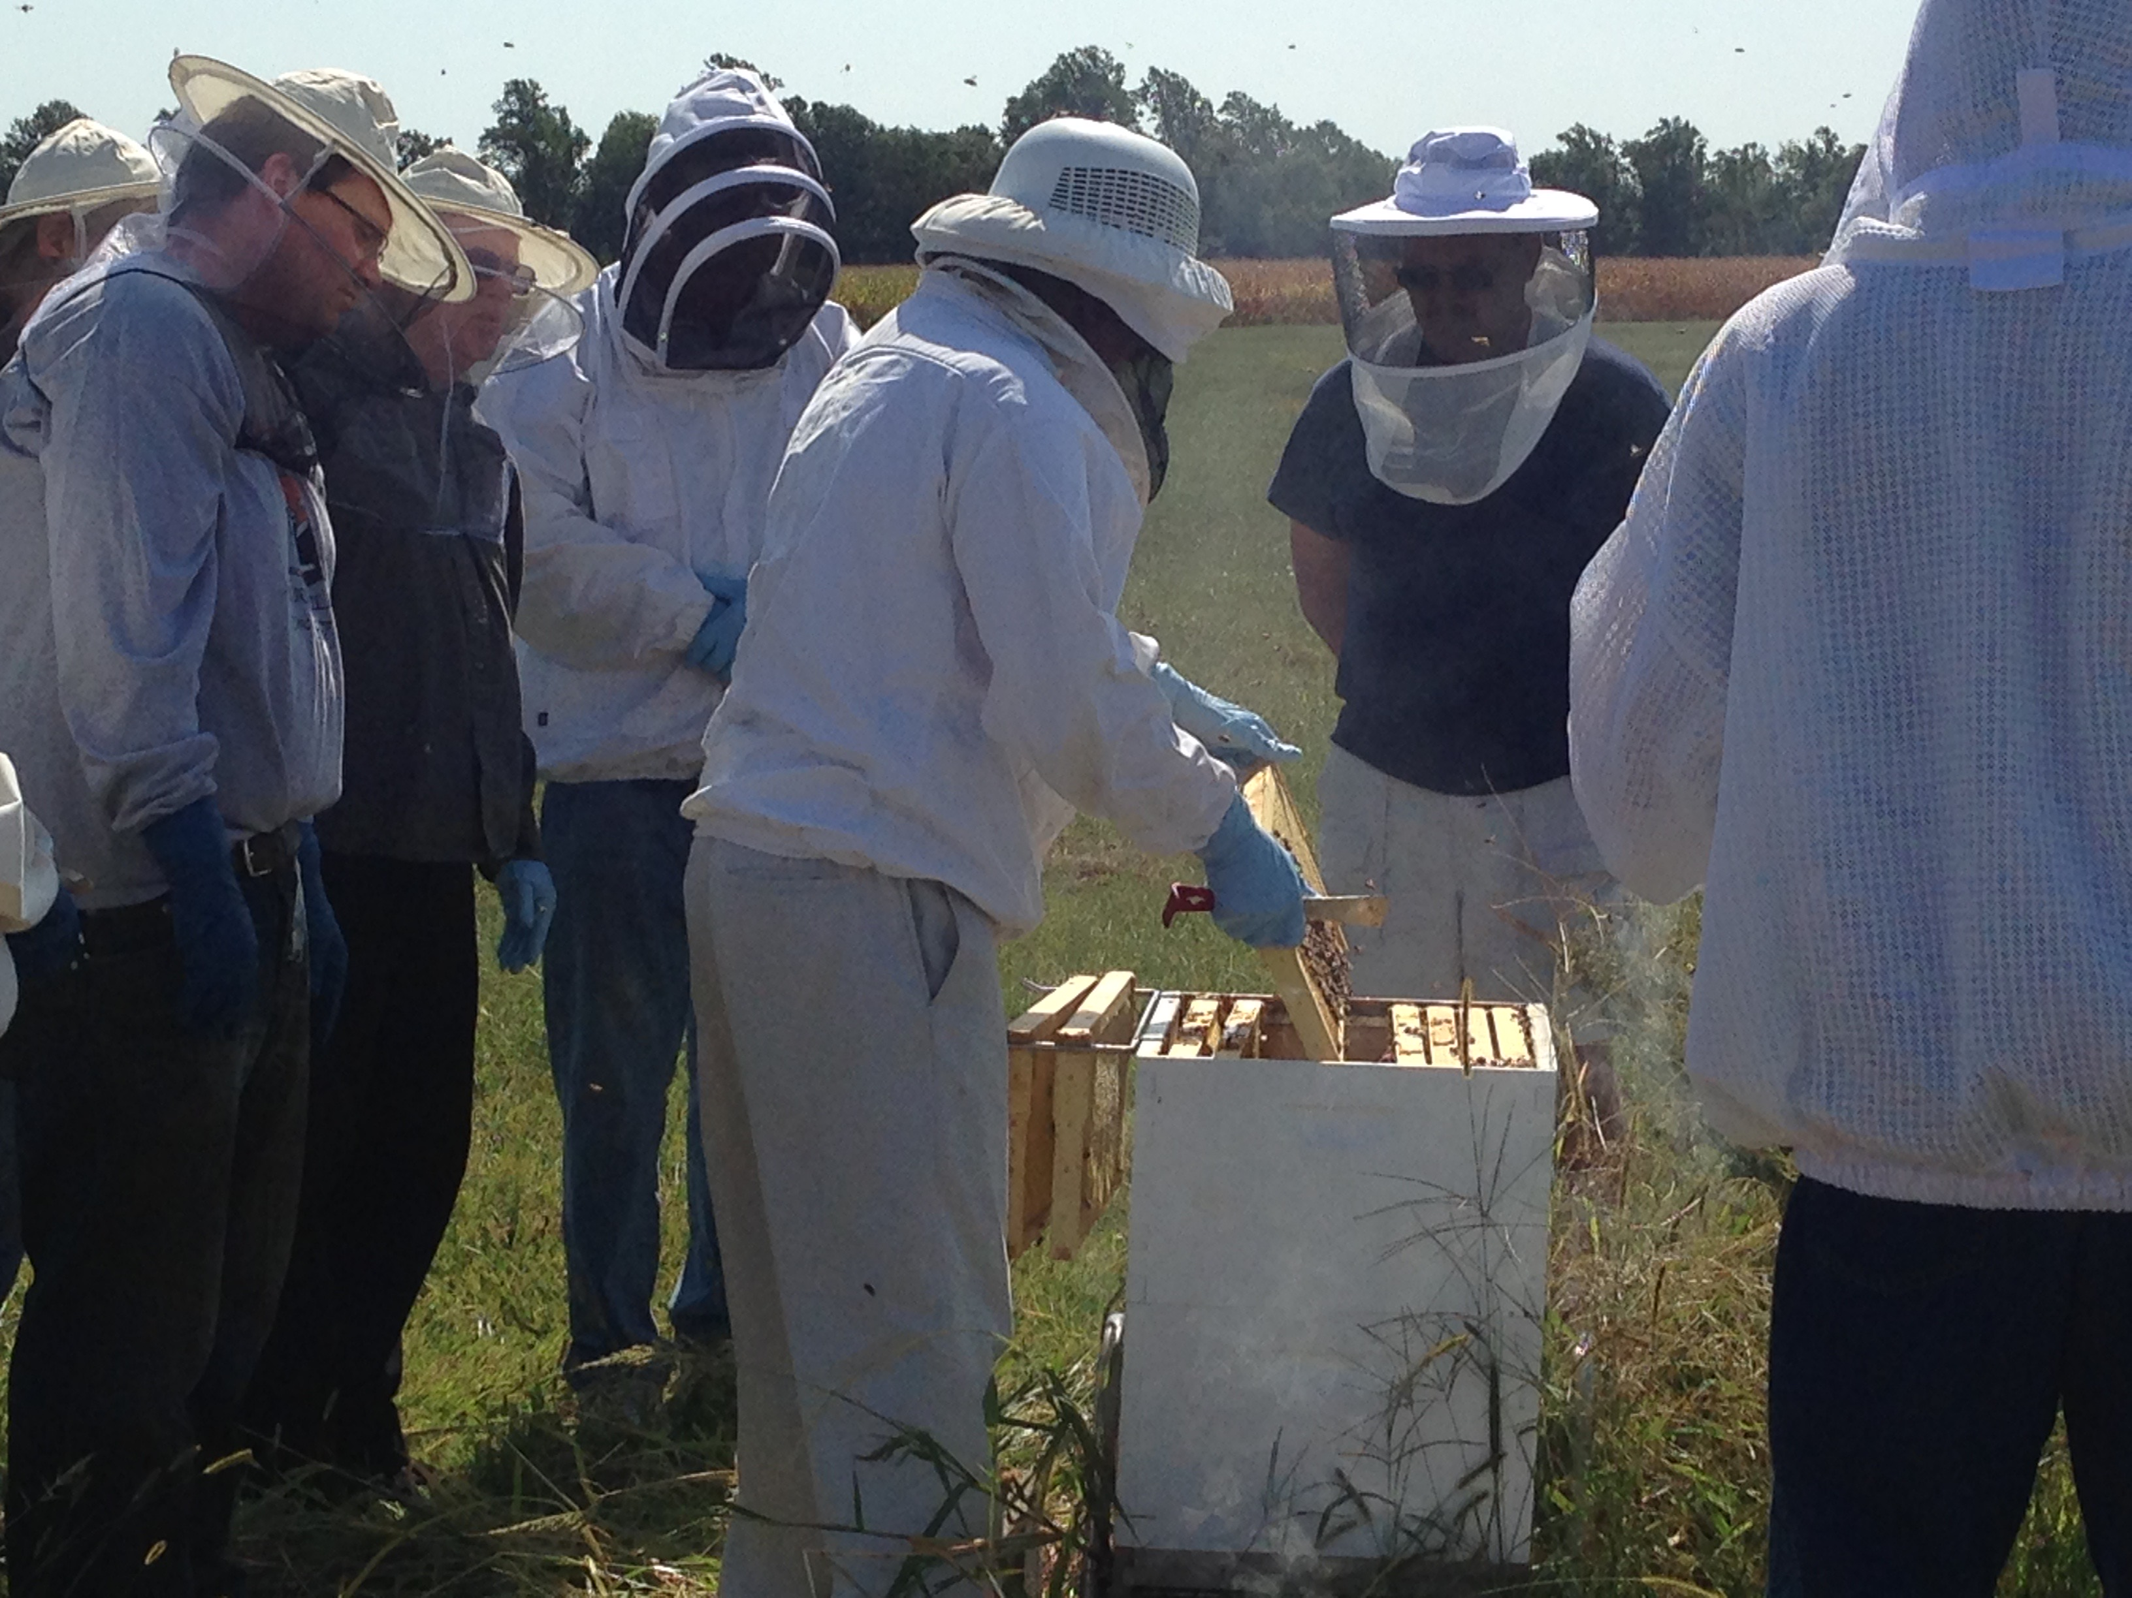
This is your first decision. It is generally agreed that you should start with at least two, but there are many different types of boxes varying in depth and the number of frames it holds. Shallow boxes to deep ones, 8-frame, 10-frame; it can be confusing when you start. Your best bet is to consult with experienced beekeepers and you can find them at the Delaware Beekeepers Association: http://www.delawarebeekeepers.com.

Hive Stand
Hive stands can elevate the stands a few inches to protect from small predators, such as mice.
Bees and queen
Obviously you need bees for your hive. There are many sources to get bees, but a common opinion is to get them locally. Known as nucs, they come on frames with a queen, brood in all stages, honey, and pollen. These will be put in the center of the hive and surrounded by empty frames for them to fill. Again, a great resource for recommendations is the Delaware Beekeepers Association.
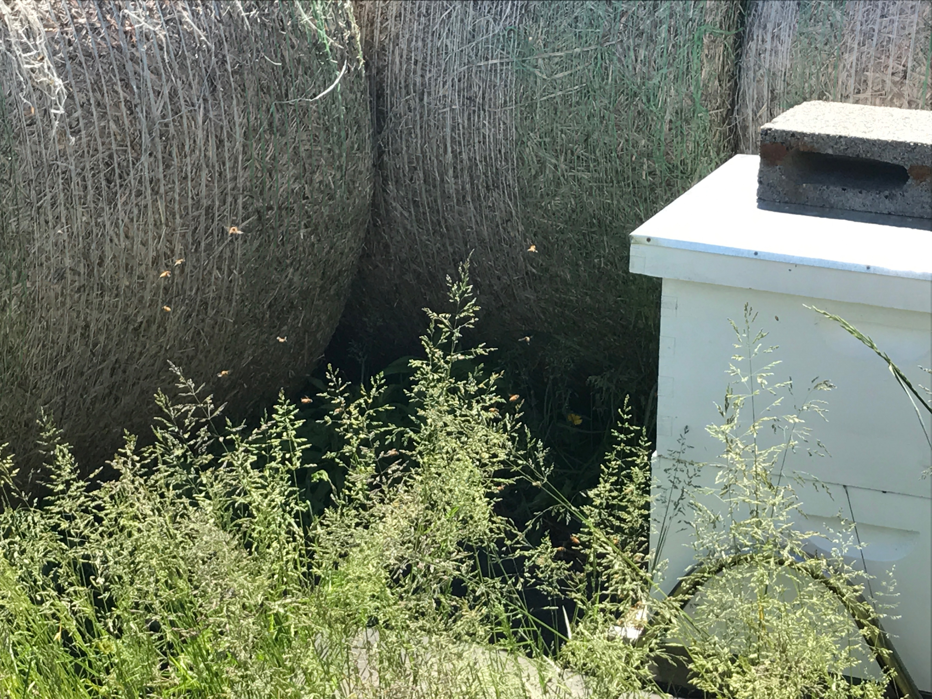
Location
Bees can travel for miles, but they need a constant source of water, and face south-southeast. The ground should be level and have good drainage so they do not get wet. A heavy weight on top can protect the hives in strong winds and they may need a windbreak, such as hay bales, during the winter if they are exposed to cold winds.
Veil/suit and gloves
It is not necessary to have a full suit, but it can make beginning beekeepers feel more comfortable. At the very least, a veil and gloves are needed, to go along with pants, closed-toed shoes, and a jacket. Different hives have varying levels of aggressiveness, so you can adjust what you think you need as you get used to them.

Smoker and fuel
Smokers are inexpensive and very effective. Different beekeepers have different preferences for which types of fuel to use, but they are all generally efficient. It is still not known exactly why smoke makes it less likely for the bees to sting, but it definitely works and is necessary when you are pulling out frames to inspect or to extract honey.
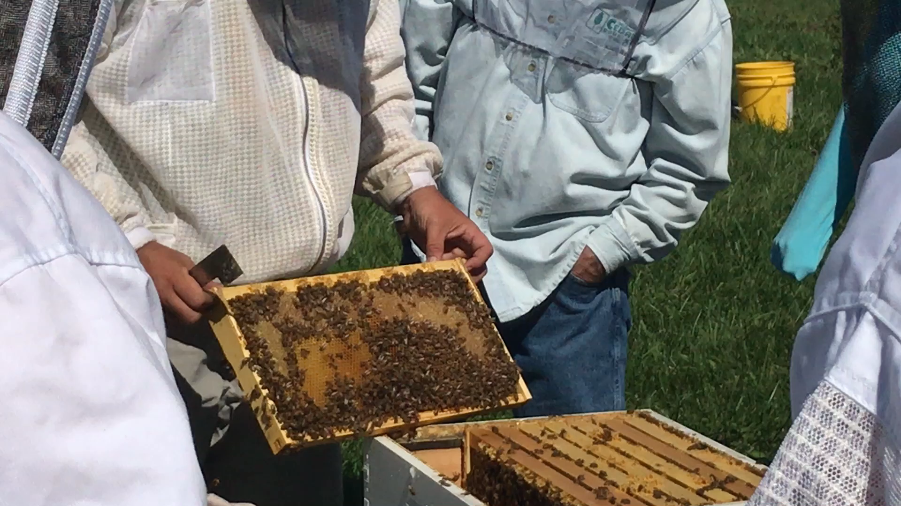
Hive Tool
The hive lid and frames will stick together once the bees start making honey. A good tool, often one with a flat side and one curved can make your work a lot easier.

Top feeders
A feeder filled with half sugar, half water, by weight, can really help new hives get established. Similar to a pet water dispenser, they can provide a constant supply of water and sugar for a few days. You will likely need two per hive and it will take you a few weeks to determine how often you need to refill them. After a couple years, you may be able to stop feeding them.

Extractor and Uncapping Tool
If you are planning on getting honey, you will need an extractor. The uncapping tool scrapes the caps off of the frame to expose the honey. Then frames are spun around in the extractor and the honey simply flies off and drains out. These can be hand spun or electric and come in varying sizes. When getting started, it might be a good idea to ask to use a fellow beekeeper’s. Alternatively, a 21-frame extractor is available to use for free at Delaware State University’s Outreach and Research Center in Smyrna, DE. Simply arrange a time with Jason Challandes, the Regional SARE Educator at jchallandes@desu.edu.
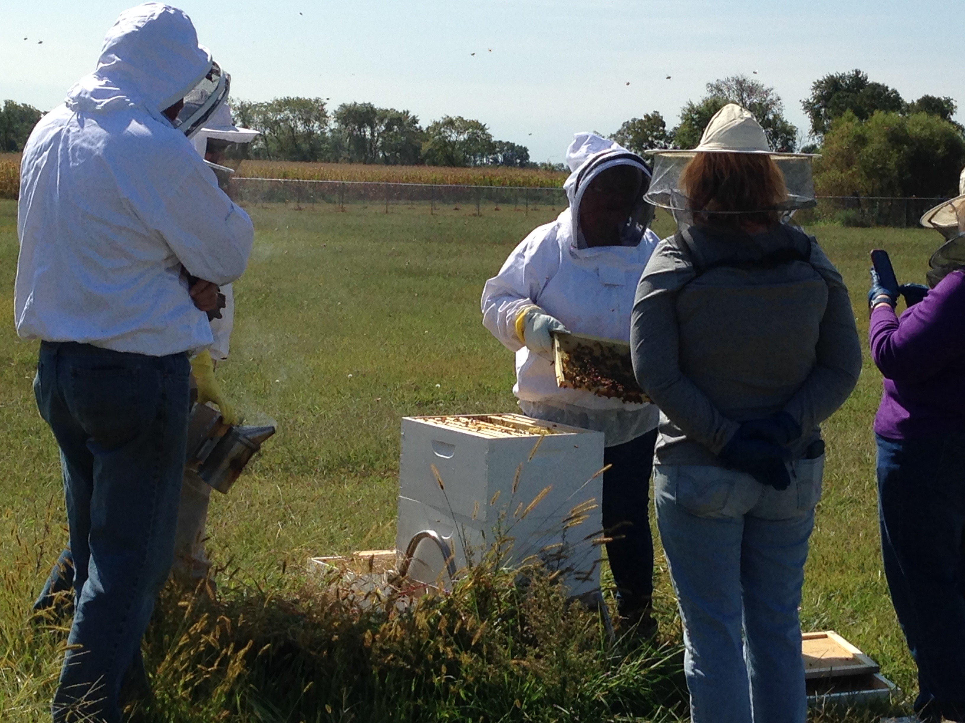

Cooperative Extension Education in Agriculture, 4-H and Home Economics, Delaware State University, University of Delaware and United States Department of Agriculture cooperating, Dr. Dyremple B. Marsh, Dean and Administrator. It is the policy of Delaware Cooperative Extension that no person shall be subjected to discrimination on the grounds of race, color, sex, disability, age, or national origin.

