So, You Want to Support Farms in Maine?

Join your Fellow UMaine Extension Colleagues for this Unique Opportunity

This professional development opportunity is designed to expand your skills and expertise to better support your beginning farmer clientele. The hands-on, two-day workshop will cover important business planning topics that farms need to be aware of to improve their chances at success.

Topics to be covered include:
- Whole Farm Planning
- Market Research
- Business and Financial Plan Development
- Business Regulations
- Evaluation of Farm Enterprises
- Land Acquisition and Evaluation
- Production Record Keeping

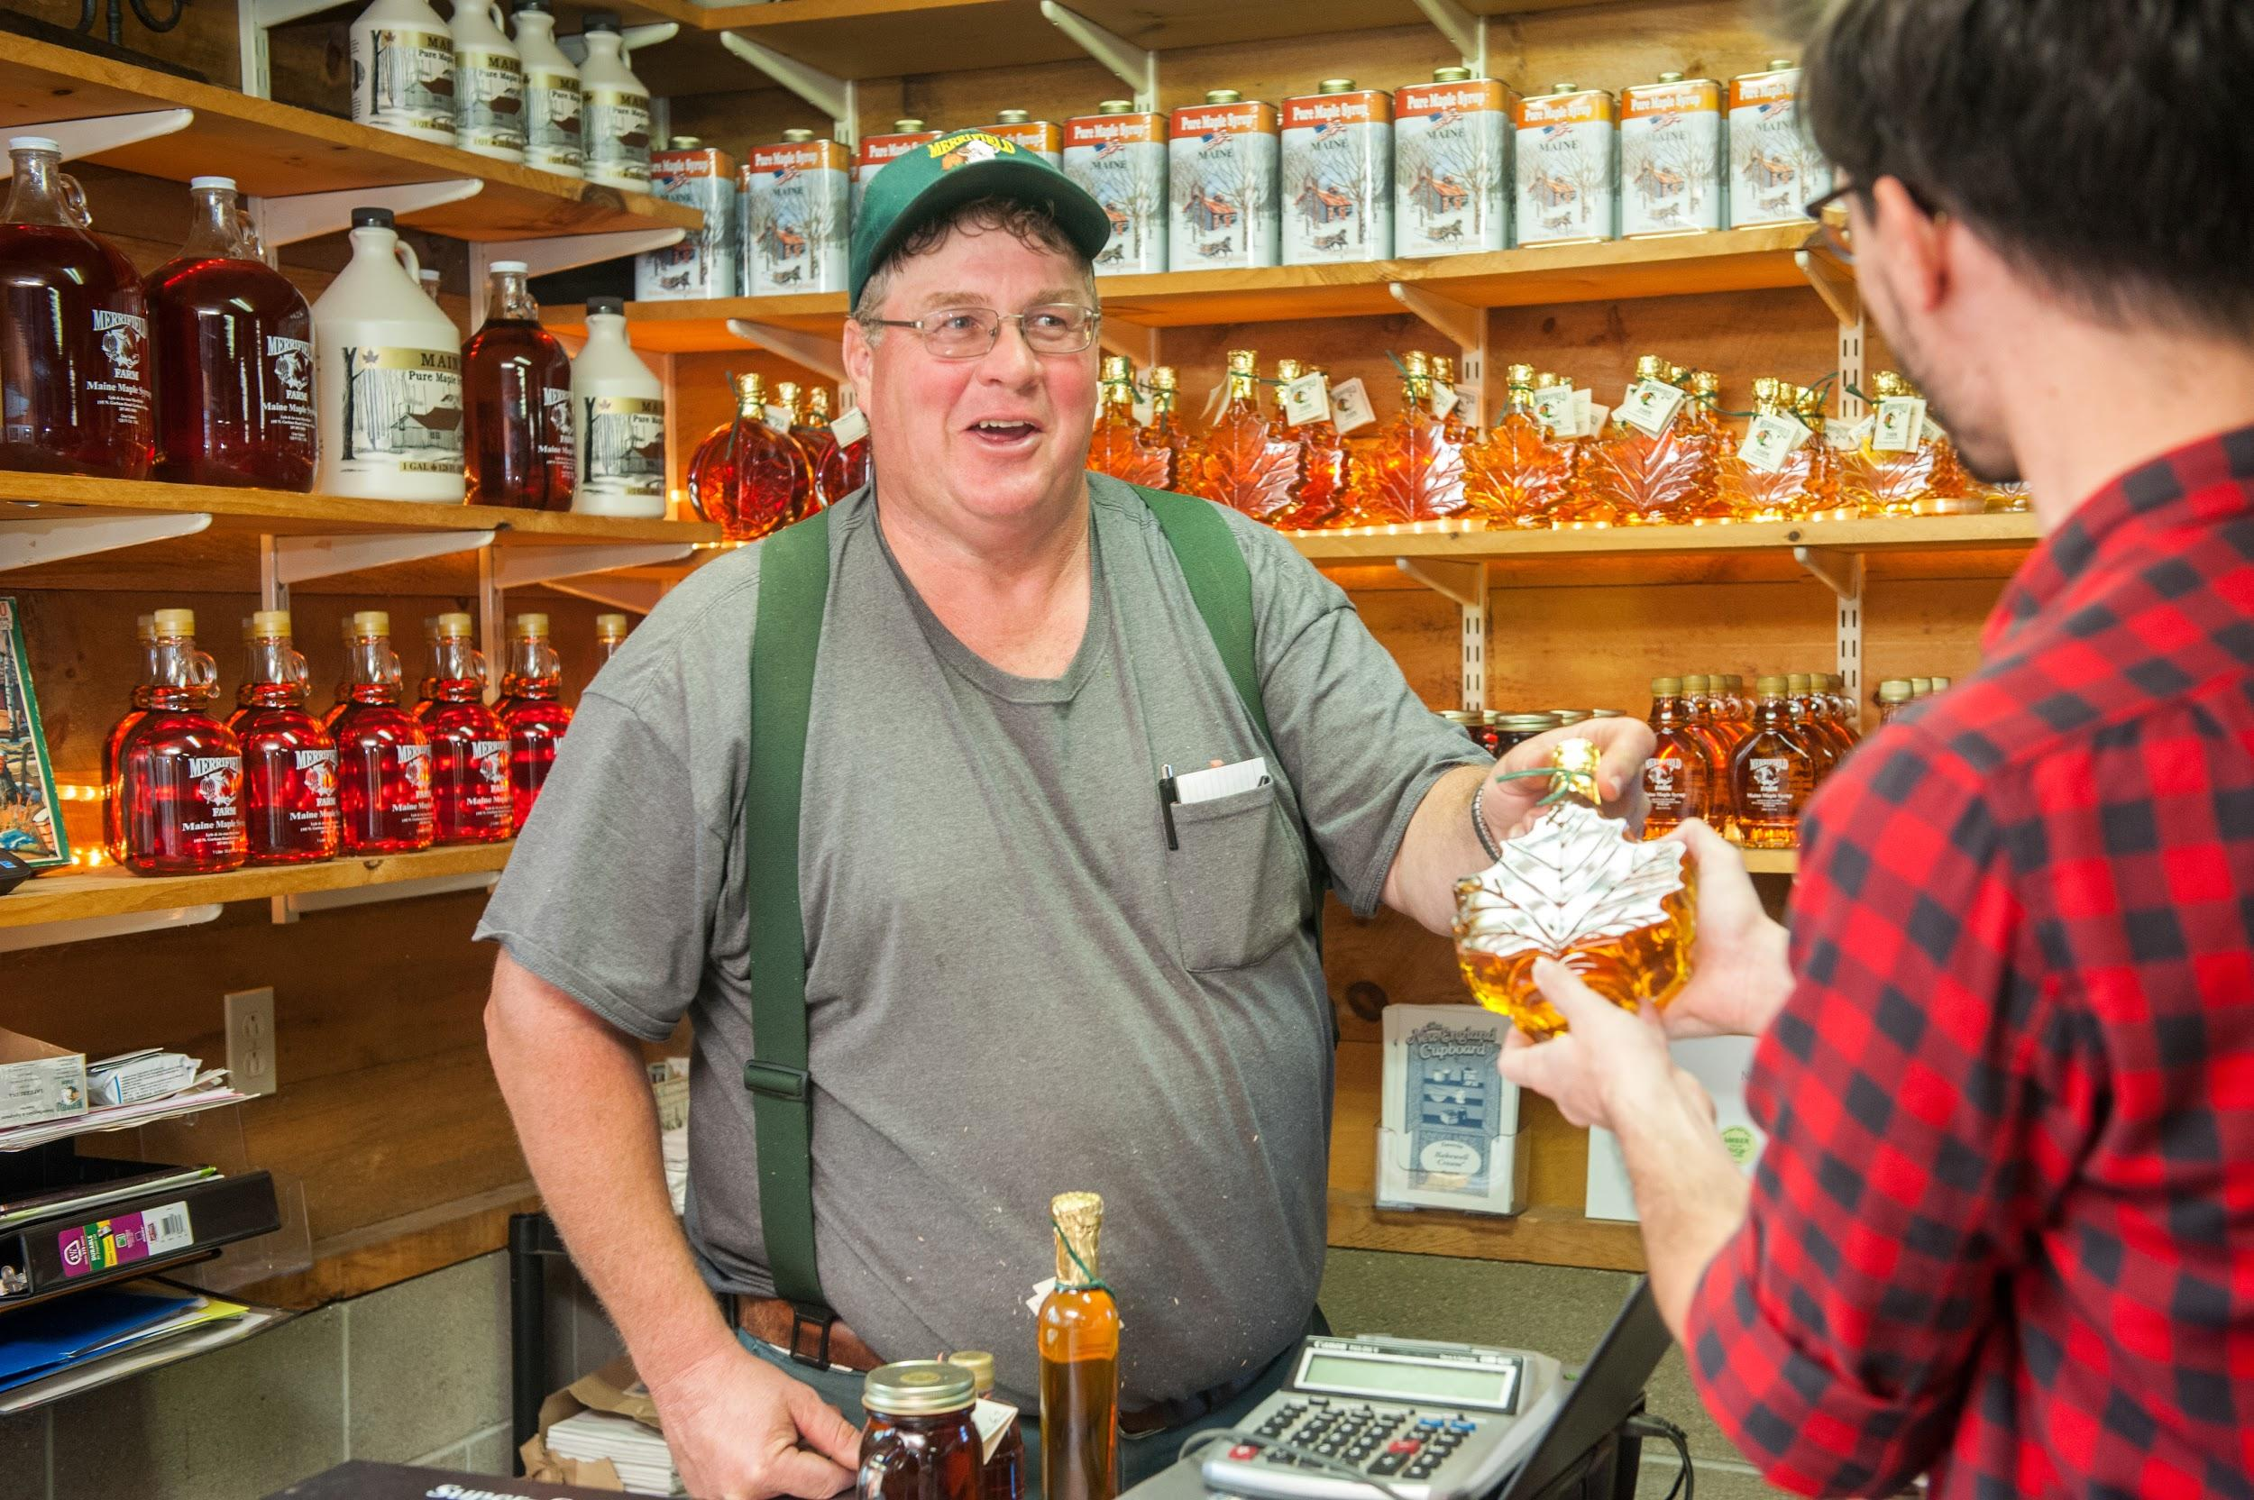
This two-day training program is designed to give an overview of each topic and to improve your ability to help farmers manage their farm businesses effectively. You will learn about additional resources and ag service provider professionals who specialize in each of these areas. This will also be an opportunity to network with your peers and to learn more about their work and lives. By the end of this training, you will be equipped to offer the So, You Want to Farm in Maine? curriculum in your county on your own or as part of a team.
Photo Credit: Remsberg

About the Project
The So, You Want to Farm in Maine? (SYWTFIM) workshop series helps beginning and experienced farmers to improve their business management skills and to learn about agricultural service providers and resources in Maine. The demand for one-on-one consultations and the 5-part workshop series has been high, keeping in-line with the increase in beginning farmers in the state. This SARE funded professional development project was developed to increase the confidence of UMaine Extension Aggies across the state to offer these programs.

The project will provide support people for regional teams to offer SYWTFIM series throughout the state and to offer one-on-one consultations to farmers in each county.

Course details
This two-day training will be held at the Merrell Farmhouse at beautiful Pineland Farm in New Gloucester, ME. The training will be held on Feb. 27th and 28th.

Accommodations will be available on the evenings of Monday the 26th, and Tuesday the 27th.

All expenses for the training will be paid through a Northeast SARE Professional Development Grant. Covered expenses include travel, room and board, and supplies and materials. Additionally, a program mentor group will support participants through communication on quarterly conference calls and via email.

Participants will be required to attend the two-day training session and commit to working with at least 1 farmer soon after the training to implement the knowledge and skills gained during the training.

Twenty participants will be accepted for this training

To register for the training or for more information, contact Jason Lilley at Jason.lilley@maine.edu or (207) 781-6099.

The planning team members look forward to learning with you.

Best,
Jason Lilley, Tori Jackson, Cathy Kloetzli, Frank Wertheim

