Farm Detective
Circle Yes OR No under each picture that you see at the farm.
Circle Good OR Bad if you think it is good for the plants or bad for the plants.
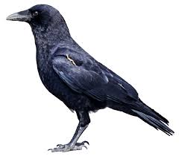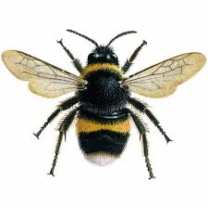
Do You See A Crow or Bird? Do You See A Bee?

Yes OR No Yes OR No

Good OR Bad Good OR Bad

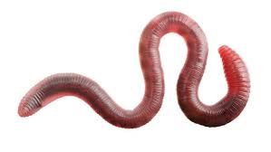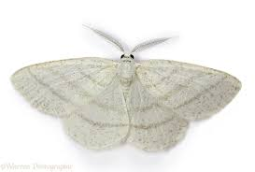
Do You See A Worm? Do You See A Moth?

Yes OR No Yes OR No

Good OR Bad Good OR Bad

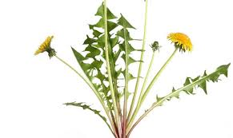
Do You See Weeds?

Yes OR No

Good OR Bad

