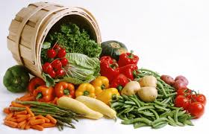
Farm Survey #2

1. What is your favorite vegetable? _________________________________

2. Do you eat vegetables at home? (circle one) YES OR NO

3. What kind of vegetables do you eat at home? ___________________________

4. Does your school have a garden? (circle one) YES OR NO

5. Do you eat vegetables at school? (circle one) YES OR NO

6. What kind of vegetables do you eat at school? ___________________________

7. Do you want to have a garden at home? YES OR NO

8. What do plants need to grow big and strong? (circle one or more words)

Water

Cookies

Sunlight

Vitamins

Milk

Food

9. Are vegetables good for your body? YES OR NO

10. Are vegetables a woe food, slow food or go food?

11. Name three plants you saw at the farm:

12. Do you like the taste of vegetables? YES OR NO

13. Do you want to grow vegetables at home? YES OR NO

