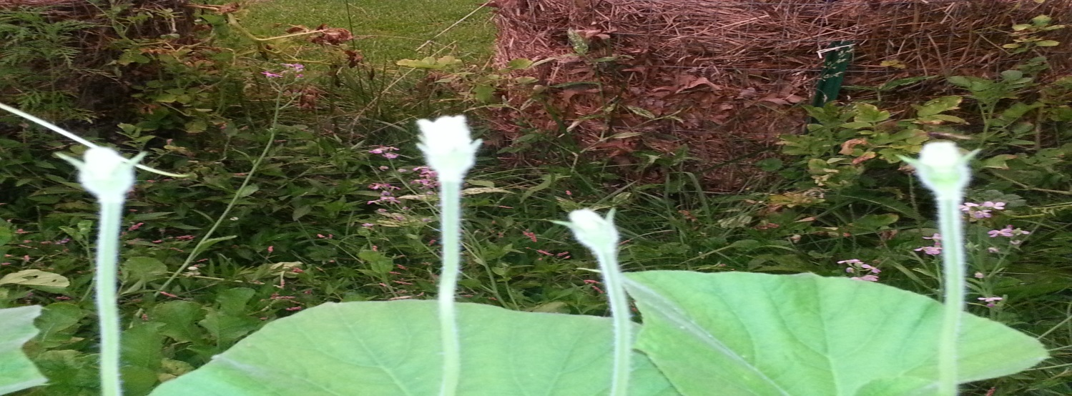
Farm to Table Dinner and Workshop
September 17, 2016 5:00 to 8:00 PM
Come out and enjoy the evening with us for a scrumptious dinner and appetizers. Everything will be prepared by Chef Chris from Pepper Berries Urban Farm and a couple of other local farms. A night to enjoy a bounty from local farms!!!
5:00 Meet & Greet Hour Time to hear our vision for the farm, who we are working with and meet some of them.
Serving: Pesto Delight using Kale, basil and tomatoes fresh from the garden.
Cucuzza lasagna rolls served with cucuzza squash, tomatoes, herbs, garlic and onions from the garden
Fruit Spritzer served with fresh fruit
6:00 Dinner and Entertainment Hour
Serving: Stuffed Chicken Breast or Pork Loin cook to perfection with spinach, kale and cardoon and feta cheese rolled in bread crumbs and served with a lemon butter sauce.
Grilled Medley sautéed on the grill with 3 vegetables, fingerling, majestic and red potatoes with onions and tomatoes,
Garden Salad served with a mixture of lettuce, fresh veggies and flowers served with a vinaigrette dressing made from a jam that we make.
Rolls, butter and jam
Ground Cherry ala mode or elderberry ala mode
Entertainment to be announced.
7:30 Workshop to be announced
$25.00 per adult $12.00 per child
Call and order your ticket today. All credit cards are accepted. Most be registered and paid by September 10, 2016. 816-230-0007 or preciouspetals64076@yahoo.com
