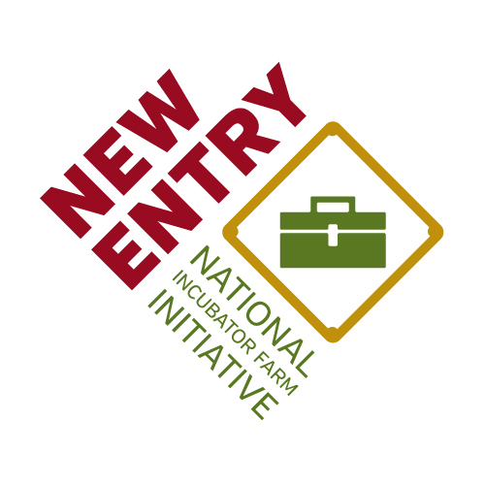

Northeast Incubator Farm Training Initiative
Field School

April 14-15th, 2016
Allentown, PA

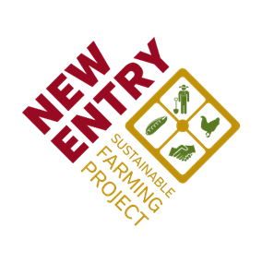
Brought to you by In partnership with With generous support from

Abundant thanks to the many organizations and individuals that came together to make this Field School possible. In particular, the New Entry Sustainable Farming project would like to thank:

NE SARE for generous funding in support of professional development opportunities for Incubator Farm Project staff.
www.nesare.org

Our fiscal sponsor Third Sector New England.
www.tsne.org

The Seed Farm, for serving as a local host, supporting the planning and implementation of this Field School, and for their commitment to growing new farmers in the Lehigh Valley.
www.theseedfarm.org

Lehigh County Ag Center for generous use of their conference space and kitchen.
www.extension.psu.edu/lehigh

Rodale Catering for their assistance in planning and crafting a delicious lunch, and their commitment to local, fresh and organic products.
www.rodalecatering.com

Agenda

April 14 | Activity | Location
10:00 | Registration, Light Breakfast | Lehigh County Ag Center
10:30 | Welcome & Introductions | 4184 Dorney Park Rd, Allentown, PA 18104
11:00 | Lender Perspectives on Access to Capital  Amanda Knackstedt, Farm Credit
12:00 | Kevin Lusch, FSA
1:00 | Lunch
1:30 | Experiences with Kiva Zip  Lindsey Parks, The Seed Farm
2:00 | Supporting Farmers in Accessing Capital  Lyn Franklin Kime, Penn State Extension
3:00 | Break
3:15 | Legal Dimensions of Access to Capital  Rachel Armstrong, Farm Commons
5:45 | Conclude & Return to Holiday Inn | 904 Hamilton St, Allentown, PA 18101
6:30 | Dinner at Fegley’s Allentown Brew Works | 812 Hamilton St, Allentown, PA 18101
April 15 | Activity | Location
8:30 | Breakfast | Lehigh County Ag Center
9:00 | Workshop M&E | 4184 Dorney Park Rd, Allentown, PA 18104
12:00 | Lunch
12:30 | Travel to The Seed Farm | 5854 Vera Cruz Rd, Emmaus, PA 18049
1:00 | Farm Tour
2:30 | Farmer Panel
4:00 | Closing & Farewell

Maps & Directions

From the Ag Center to the Holiday Inn
12 min (4.1 miles)

Head east on Dorney Park Rd toward Hillview Dr
0.2 mi

Turn right onto Lincoln Ave
0.2 mi

Turn left onto PA-222 N/Hamilton Blvd
Continue to follow Hamilton Blvd
Destination will be on the right
3.7 mi

904 Hamilton St
Allentown, PA 18101

From the Holiday Inn to Fegley’s Allentown Brew Works
Head east on Hamilton St toward S 9th St

Destination will be on the right
  - mi

Fegley's Allentown Brew Works
812 Hamilton Street, Allentown, PA 18101

From The Ag Center to The Seed Farm

Head east on Dorney Park Rd toward Hillview Dr
33 s (0.2 mi)

Continue on Lincoln Ave. Take S Cedar Crest Blvd to Vera Cruz Rd in Upper Milford
16 min (7.1 mi)

The Seed Farm
5854 Vera Cruz Road, Emmaus, PA 18049

