Overview:

- Land Size = 148 acres
- Planting was done with a JD 1590 no-till drill on two dates: West side of field May 11th, East side on May 15th
- First planting blend was:
  - 30# Hayes forage barley
  - 14# Forage Oats
  - 12# Forage Peas
  - 4# Common Vetch
  - 1# Purple-top Turnip

- On June 22nd 150 head of 600# heifers were placed on the first paddock (90,440# total)
- On June 28th an additional 63 head were merged into the herd (42,860# additional – 133,300# total).
- June 29 started grazing 6 – 8 acre paddocks to graze off tops of barley and oats to prevent heading.
- On July 1 the 40 acres in the NW corner was drilled with a warm-season blend of 12# forage wheat, 2.5# sorghum sudan, 2.5# millet, 1# forage radish.
- July 7 – moved back to light grazed areas for 2nd grazing so that we could plant warm-season blend following cattle.
- July 11 – planted 17 acres with new warm season blend: 15# forage wheat, 5# sorghum sudan, 5# millet, 1# forage radish.
- Warm season blend will be planted in increments as cattle move around the circle.

Soil Moisture Profile (LESA):

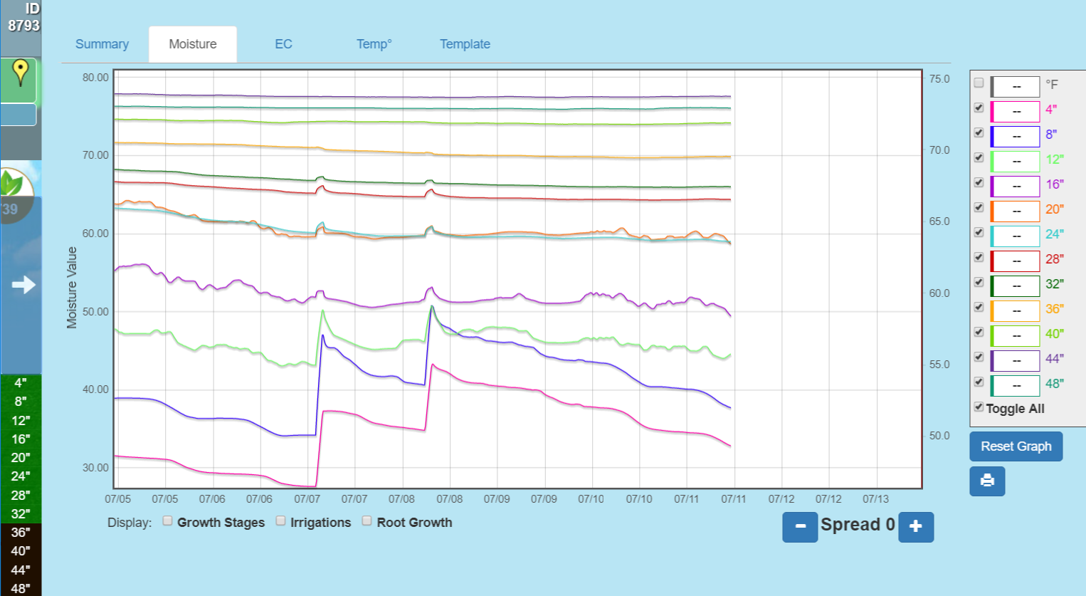
LESA Span Moisture profile. Note irrigation response down to 36” level.

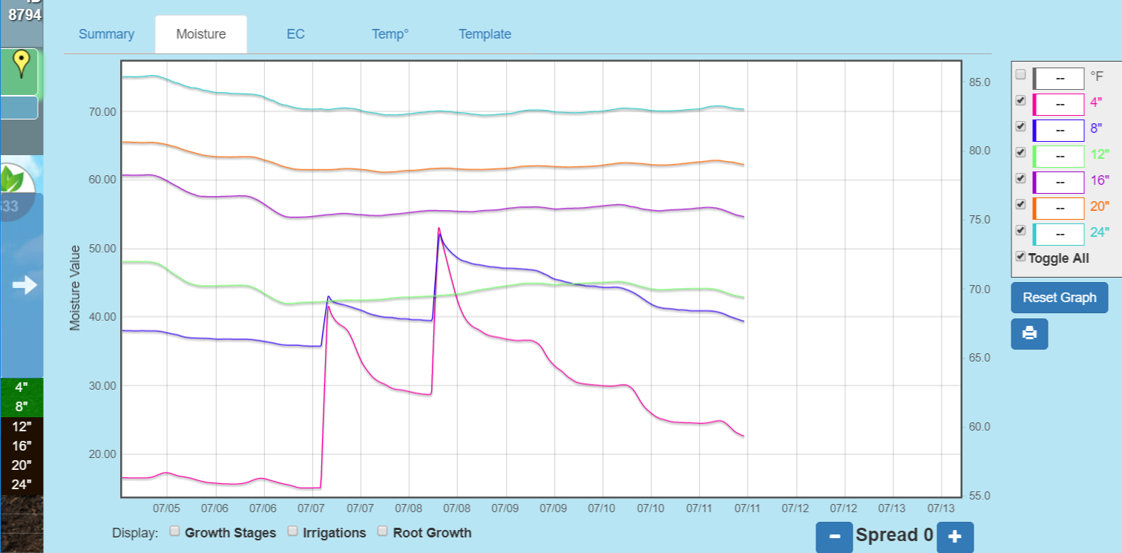
Rotator span moisture profile. Note that moisture response is only seen to 8” with some affect at 12”.

