Default Report
Cover Crop Survey
October 14th 2016, 11:46 am MDT
Q1 - What is the main type of cash crop on your farm? (if growing more than one, please indicate within your circle a 1 for greatest acreage, 2 for second most and so on)
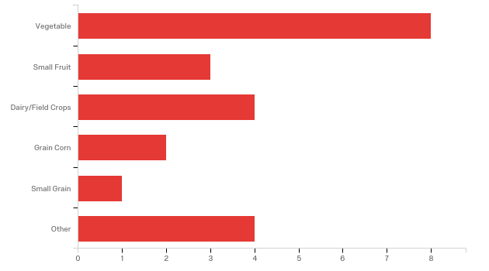

Answer | % | Count
Vegetable | 72.73% | 8
Small Fruit | 27.27% | 3
Dairy/Field Crops | 36.36% | 4
Grain Corn | 18.18% | 2
Small Grain | 9.09% | 1
Other | 36.36% | 4
Total | 100% | 11

Other
Other
beef
hay, timothy, alfalfa
Forage for livestock
Animals

Q2 - Please indicate the size of your current farming operation?
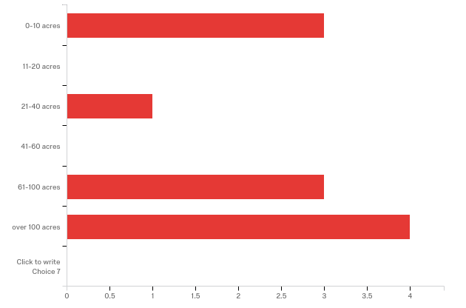

Answer | % | Count
0-10 acres | 27.27% | 3
11-20 acres | 0.00% | 0
21-40 acres | 9.09% | 1
41-60 acres | 0.00% | 0
61-100 acres | 27.27% | 3
over 100 acres | 36.36% | 4
Click to write Choice 7 | 0.00% | 0
Total | 100% | 11

Q3 - How often would you say you cover crop?
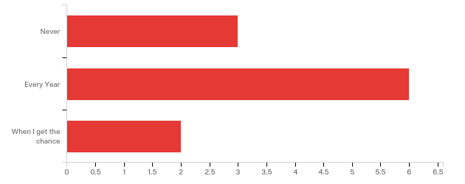

Answer | % | Count
Never | 27.27% | 3
Every Year | 54.55% | 6
When I get the chance | 18.18% | 2
Total | 100% | 11

Q4 - How often would you like to cover crop?
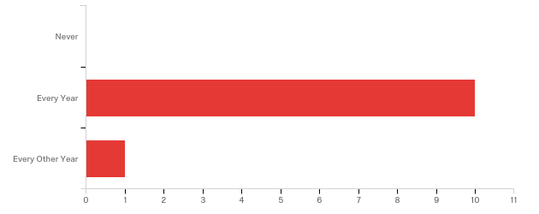

Answer | % | Count
Never | 0.00% | 0
Every Year | 90.91% | 10
Every Other Year | 9.09% | 1
Total | 100% | 11

Q5 - What percentage of acreage mentioned in question 2 do you try to cover crop?
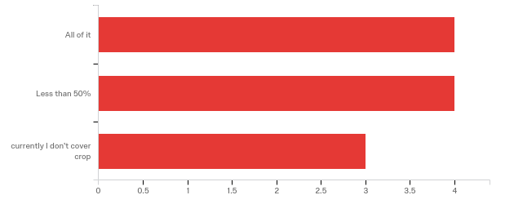

Answer | % | Count
All of it | 36.36% | 4
Less than 50% | 36.36% | 4
currently I don't cover crop | 27.27% | 3
Total | 100% | 11

Q6 - If you currently are cover cropping, which season do you plant most of your cover crop?
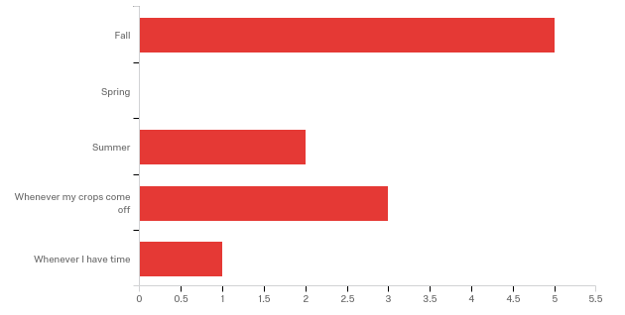

Answer | % | Count
Fall | 55.56% | 5
Spring | 0.00% | 0
Summer | 22.22% | 2
Whenever my crops come off | 33.33% | 3
Whenever I have time | 11.11% | 1
Total | 100% | 9

Q7 - If you had to pick one reason why you don't cover crop what would it be?
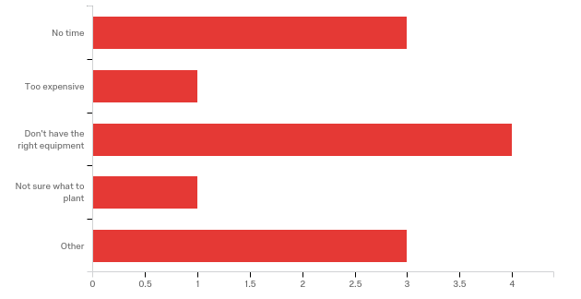

Answer | % | Count
No time | 33.33% | 3
Too expensive | 11.11% | 1
Don't have the right equipment | 44.44% | 4
Not sure what to plant | 11.11% | 1
Other | 33.33% | 3
Total | 100% | 9

Other
Other
dont plow
just getting started
Plastic Row

Q8 - How satisfied were you with the information provided at this meeting?
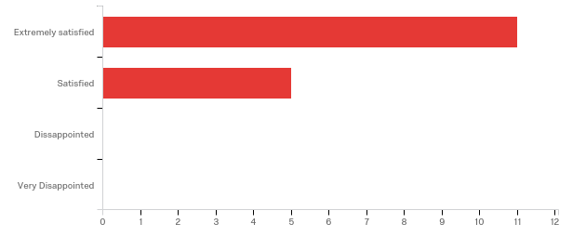

Answer | % | Count
Extremely satisfied | 68.75% | 11
Satisfied | 31.25% | 5
Dissappointed | 0.00% | 0
Very Disappointed | 0.00% | 0
Total | 100% | 16

Q9 - Click to write the question textWhich part of today’s meeting did you gain the most knowledge from?
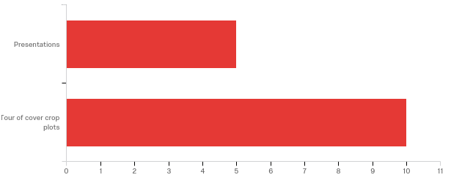

Answer | % | Count
Presentations | 35.71% | 5
Tour of cover crop plots | 71.43% | 10
Total | 100% | 14

Q10 - From the information presented at this meeting what changes might you try:
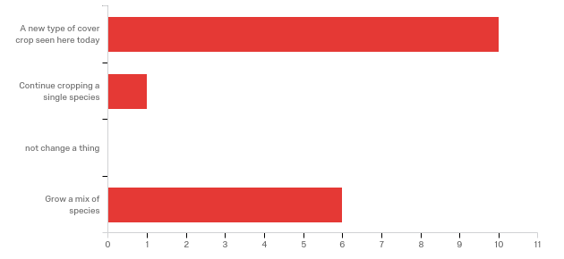

Answer | % | Count
A new type of cover crop seen here today | 66.67% | 10
Continue cropping a single species | 6.67% | 1
not change a thing | 0.00% | 0
Grow a mix of species | 40.00% | 6
Total | 100% | 15

Q11 - Will you try to increase the amount of cover cropping on your farm based on some of today’s information?
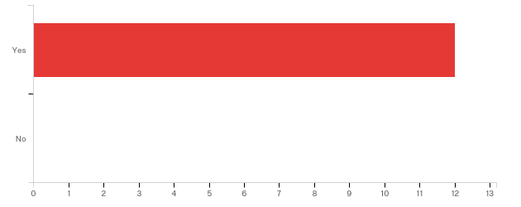

Answer | % | Count
Yes | 100.00% | 12
No | 0.00% | 0
Total | 100% | 12

Q12 - Was there information missing that you would have liked to have seen? If so, what is it?

Was there information missing that you would have liked to have seen? If s...
more equipment
planting techniques
small scale application
some organic management techniques
No

Q13 - Which cover crop(s) did you find the most interesting and would like to see more information on?

Which cover crop(s) did you find the most interesting and would like to see...
dwarf sudangrass
radish and mixes
peas and radishes
I would like to see more trials
everything but winter rye
brassicas
Not sure, Im new to this
Tritical
401 Rye

Q14 - Was this meeting what you expected?
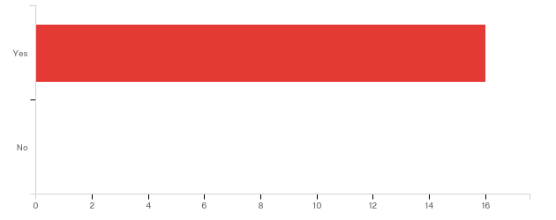

Answer | % | Count
Yes | 100.00% | 16
No | 0.00% | 0
Total | 100% | 16

Q15 - Would you attend a similar meeting in the future?

Answer | % | Count
Yes | 100.00% | 16
No | 0.00% | 0
Total | 100% | 16

Q16 - Did this meeting impact your operation at home?
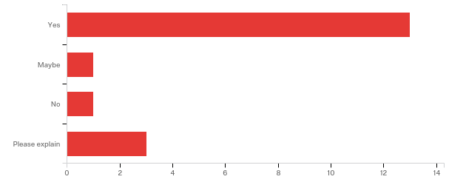

Answer | % | Count
Yes | 86.67% | 13
Maybe | 6.67% | 1
No | 6.67% | 1
Please explain | 20.00% | 3
Total | 100% | 15

Please explain
Please explain
encouragement to try new covers and possible intercropping
I'll be trying new ones
Inspiring!

