Fig. 17 Interseeding pictures Schohaire Valley Farm
Corn planted 6/18/17 , Interseeding 7/17/17 Photo 10/27/17
seeding rate based on weighing before and after seeding

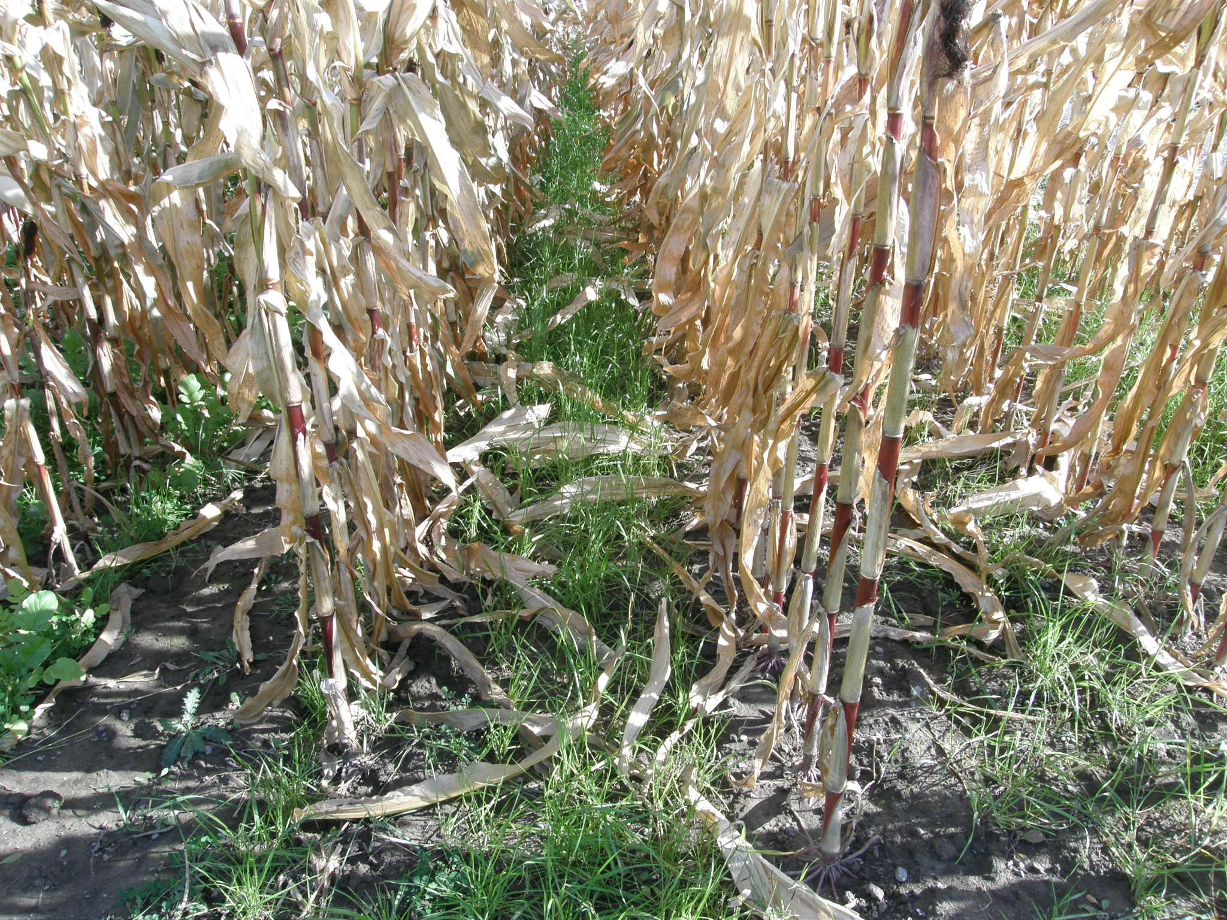
Annual ryegrass (25 lb/ac)
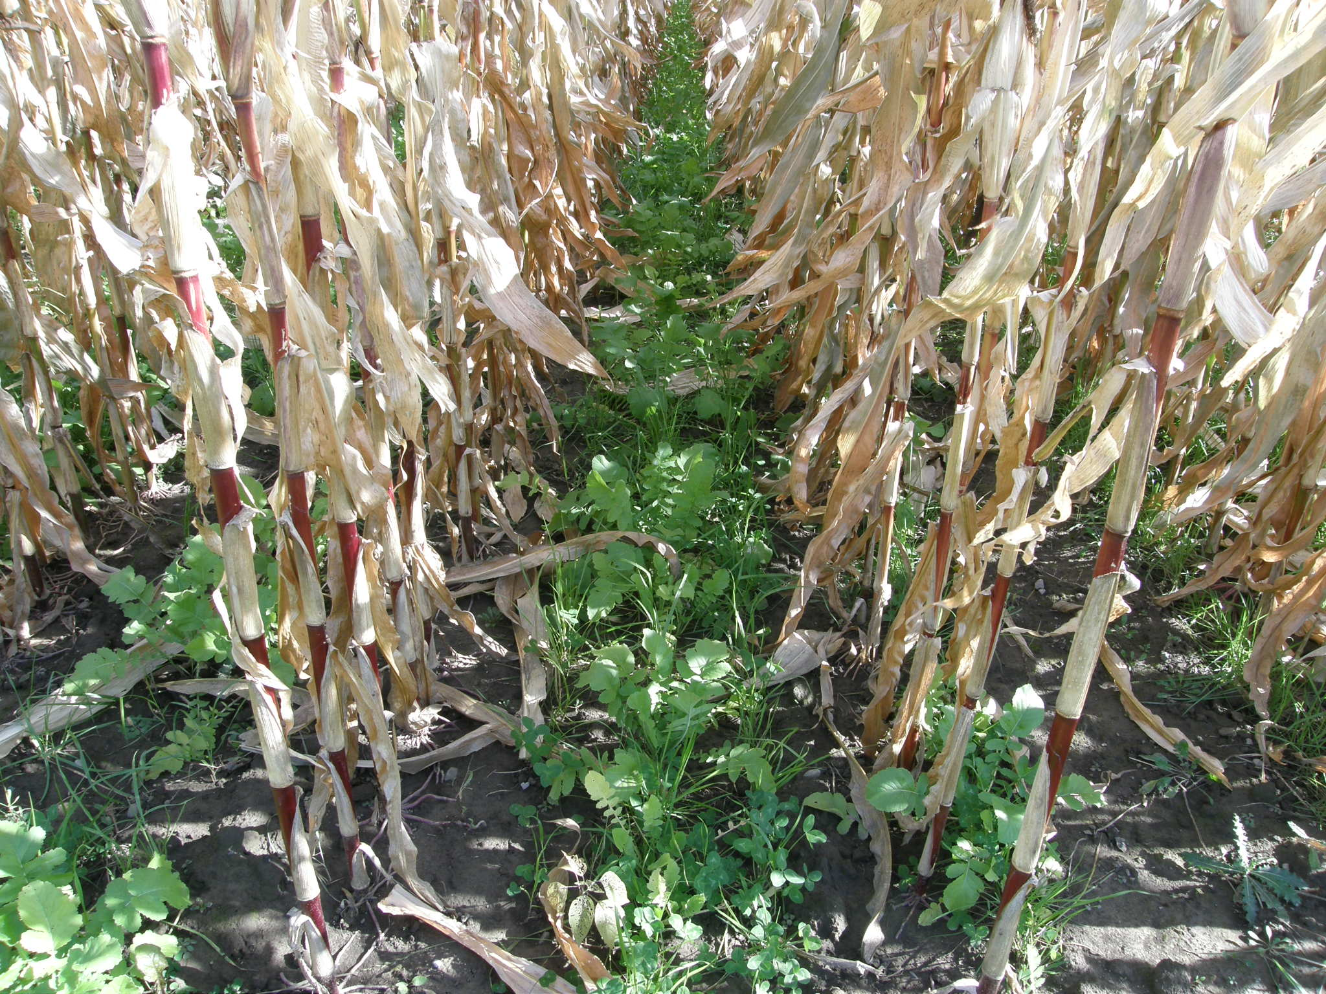
Annual Ryegrass, Red Clover and Radish (25 lb/ac)
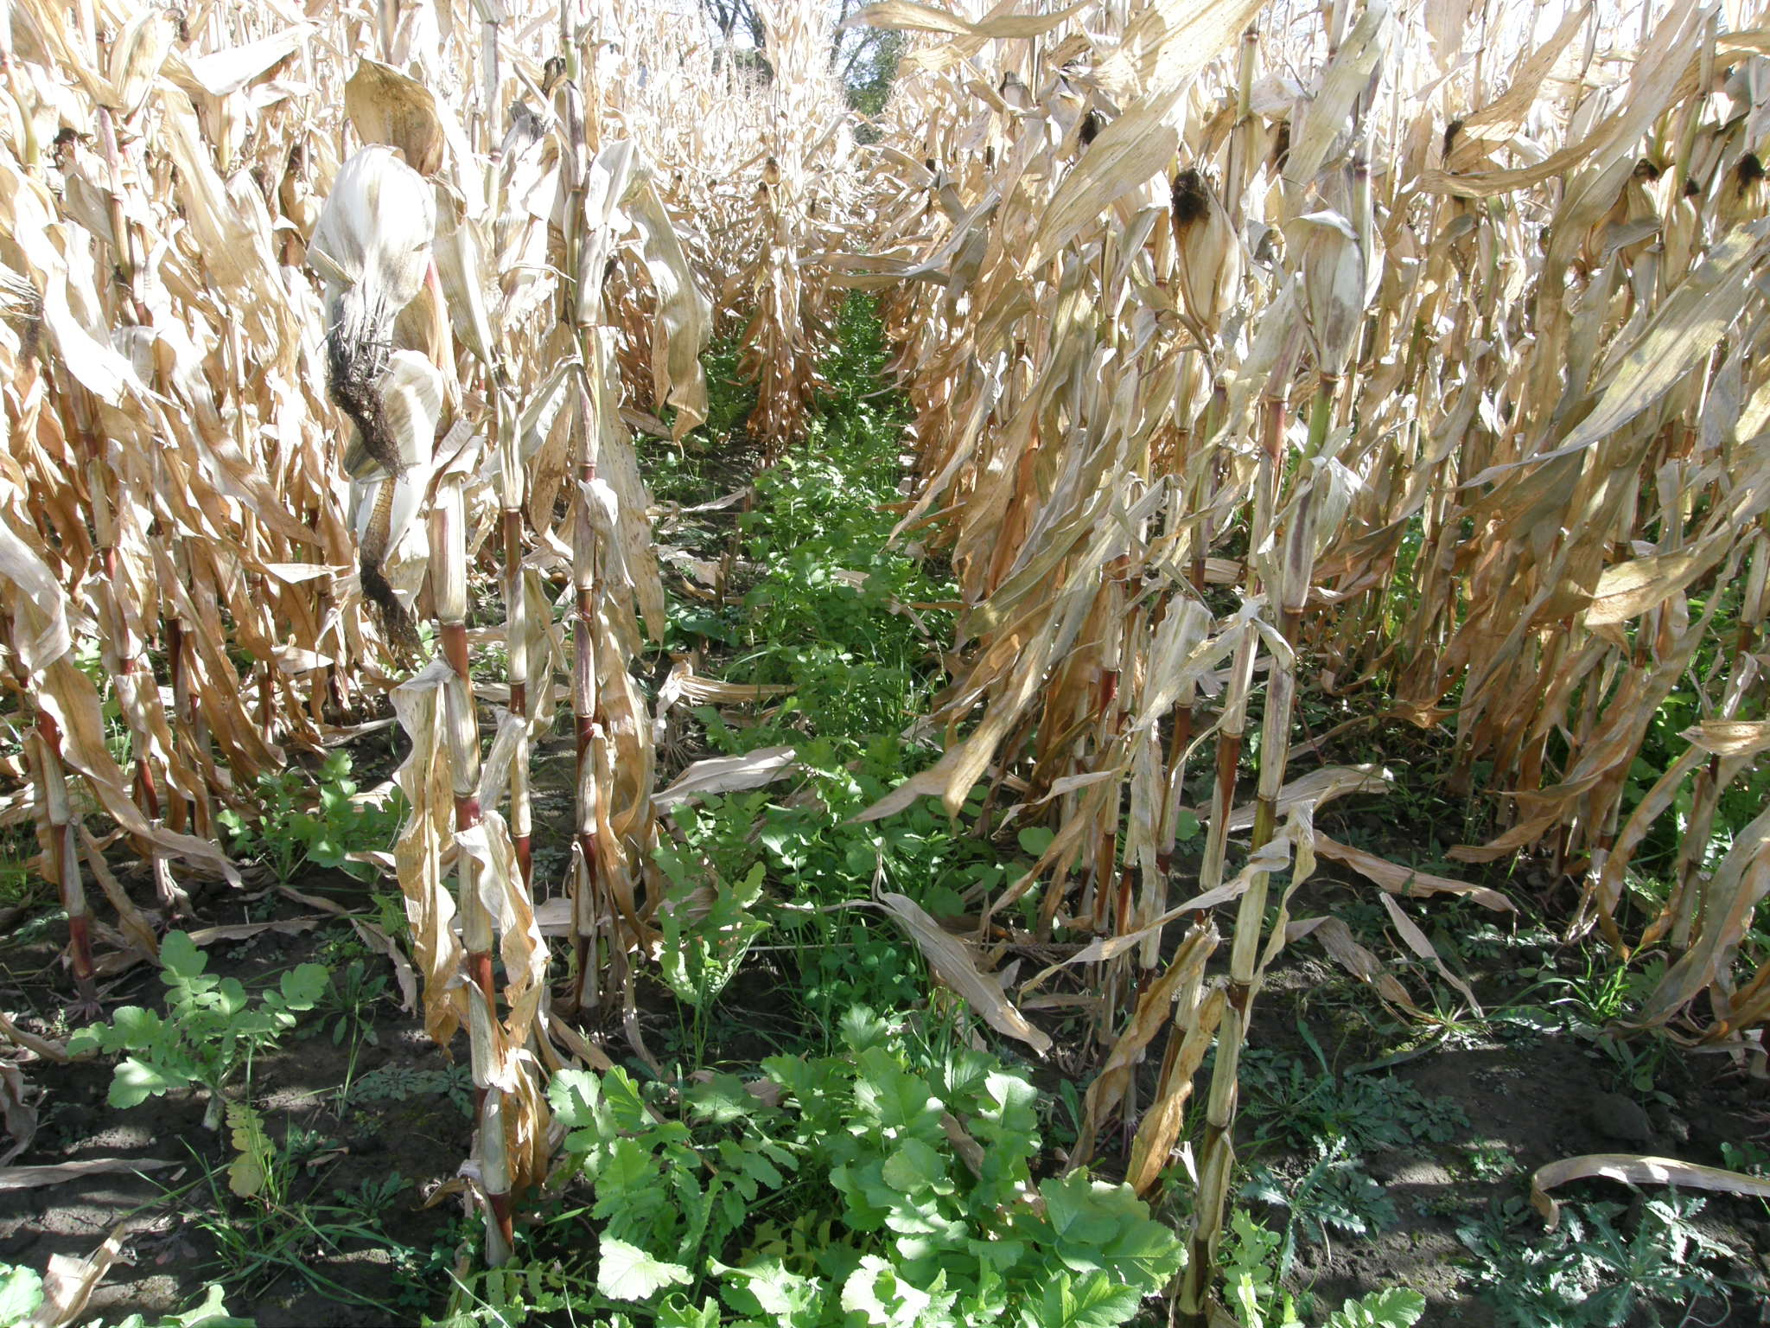
Broadcaster Mix from Kings (30 lb/ac)
Annual ryegrass (40%), Crimson clover (30%), Red clover (15%) Daikon radish (10%) ands Yellow blossom sweet clover (45%)
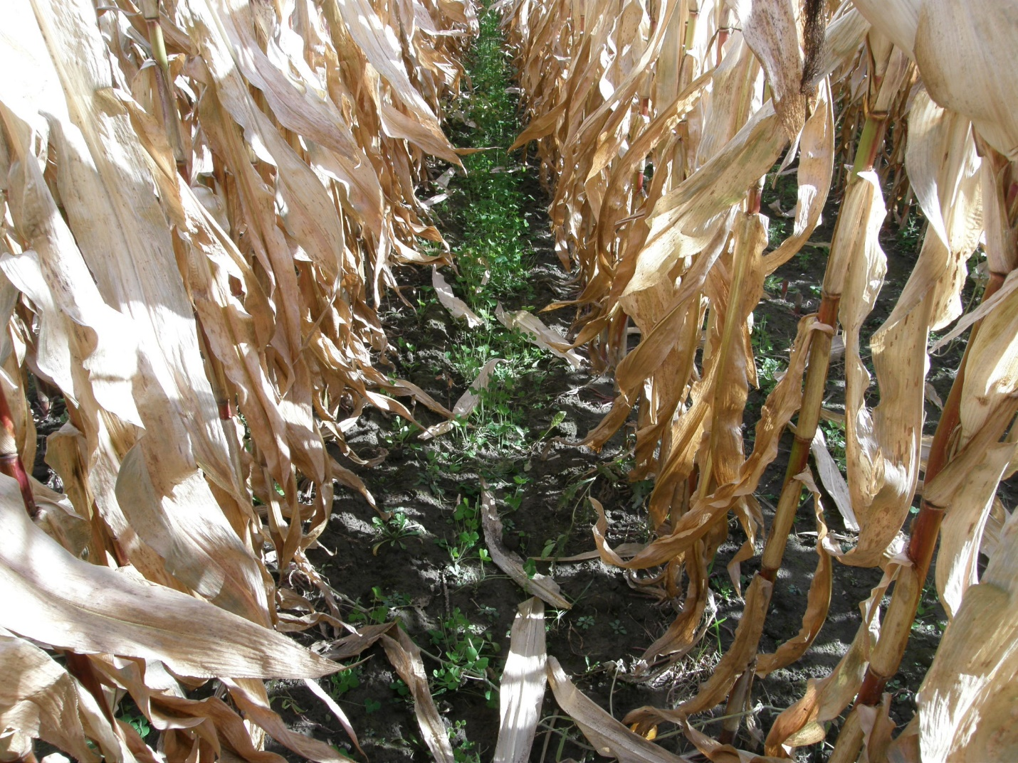

Crimson Clover (5 lb/ac)
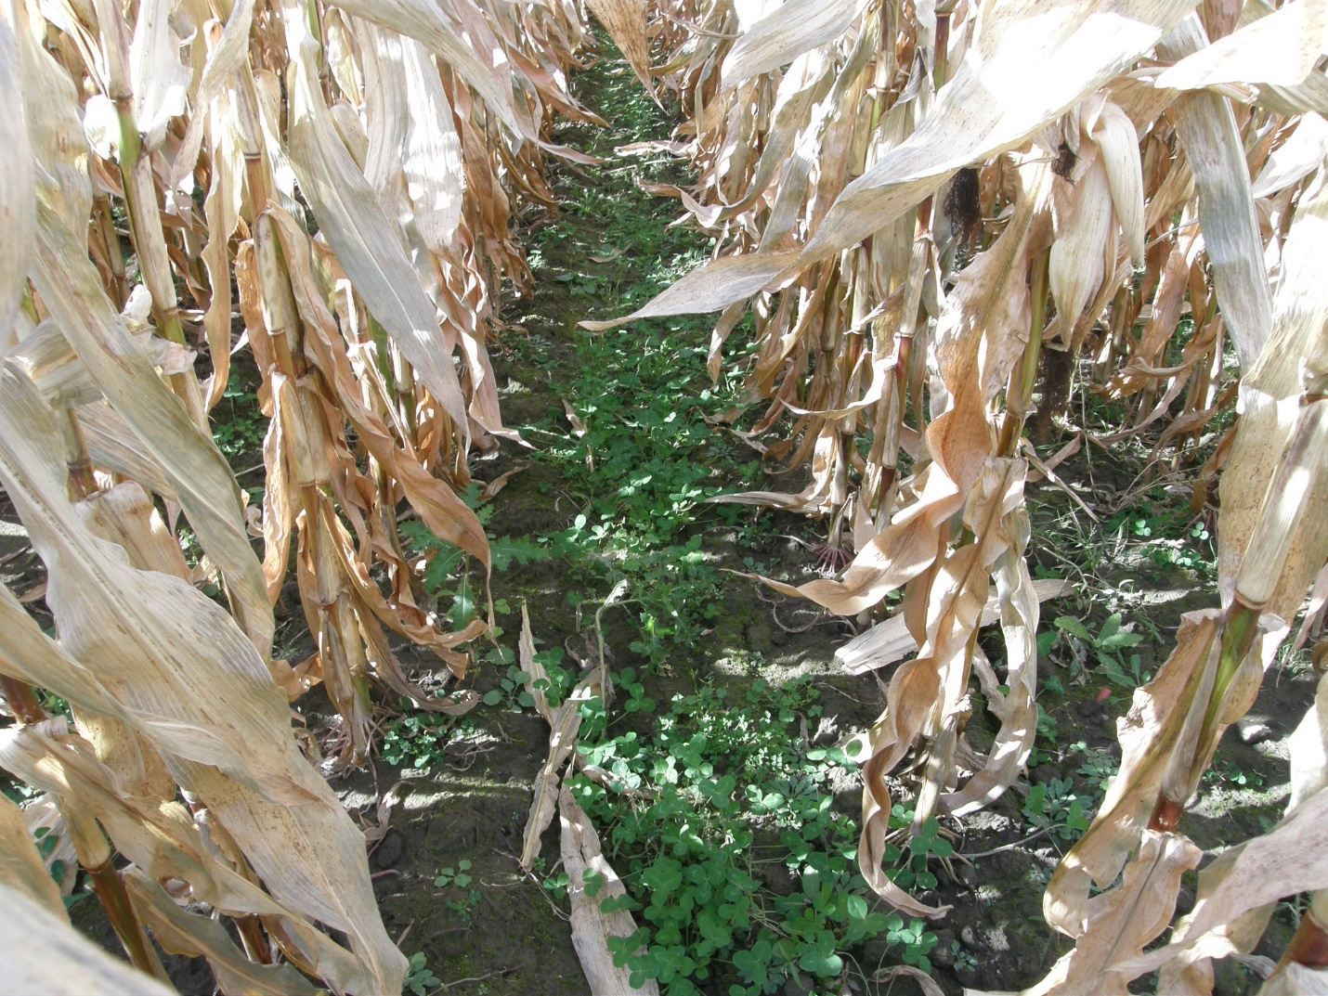
Red Clover (5 lb/ac)
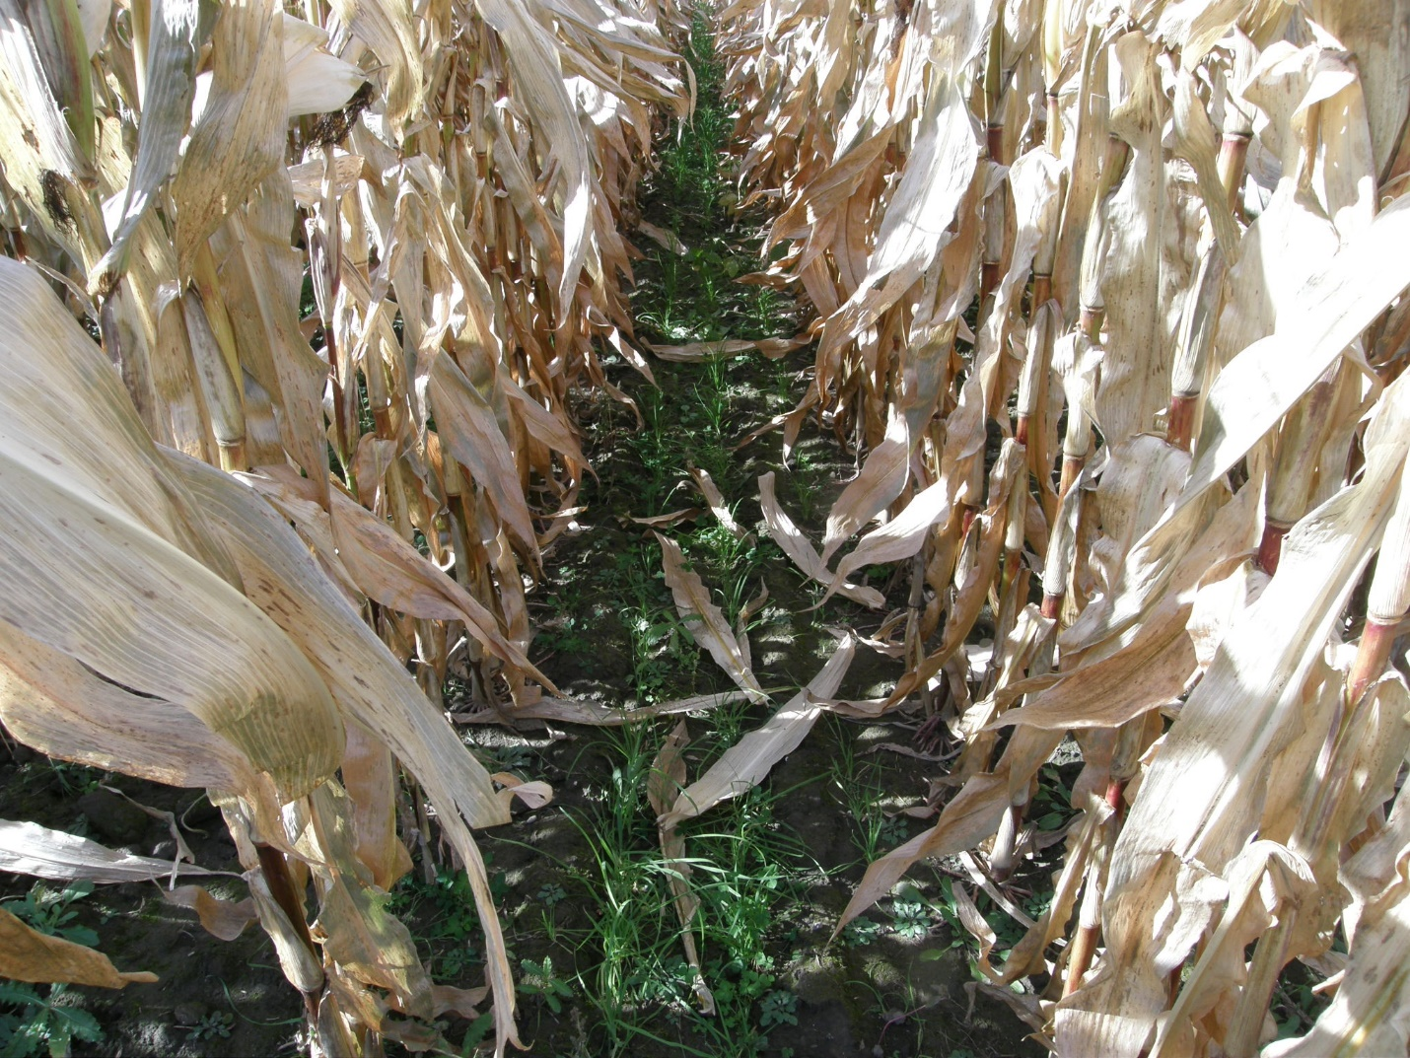
Orchardgrass and White Clover (17.3 lb/ac)

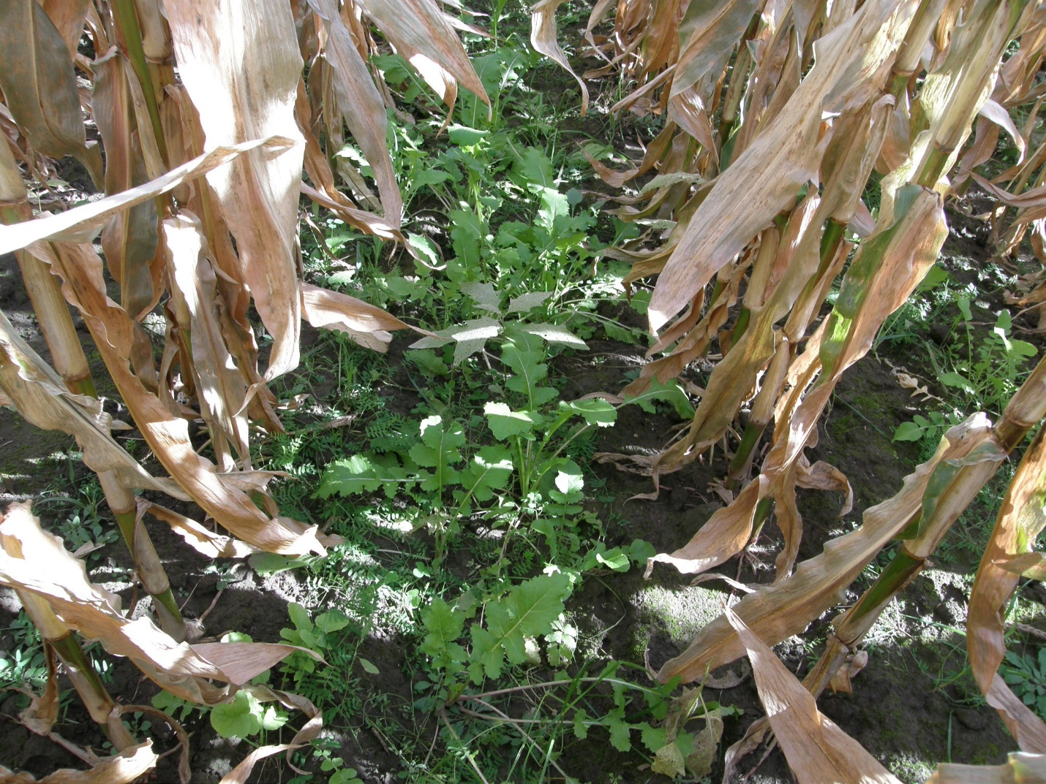
Rays Crazy Mix (37 lb/ac)
Austrian winter pea (23.6%), Oats (19.9%), Triticale (19.8%), Hairy Vetch ( 12.4%), Crimson Clover (10.0%), Annual ryegrass (7.1%), Daikon radish (3.7%), and Barkant turnip (2.5%)

