Fig. 18 Photos of Warm and Cools Season Species and Mixes Showing Establishment, Weed suppression and percent Cover
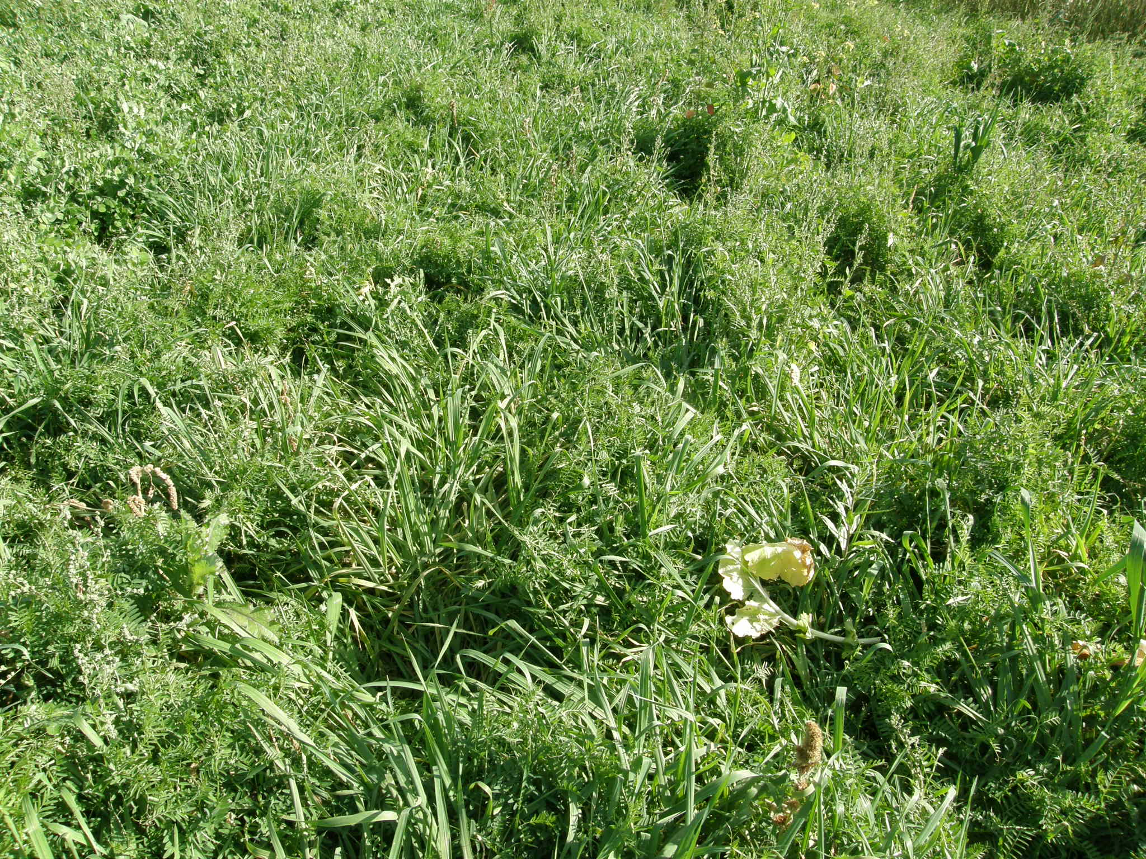
Barley and Hairy Vetch photo Planted 8/2/18 Photo 10/27/17
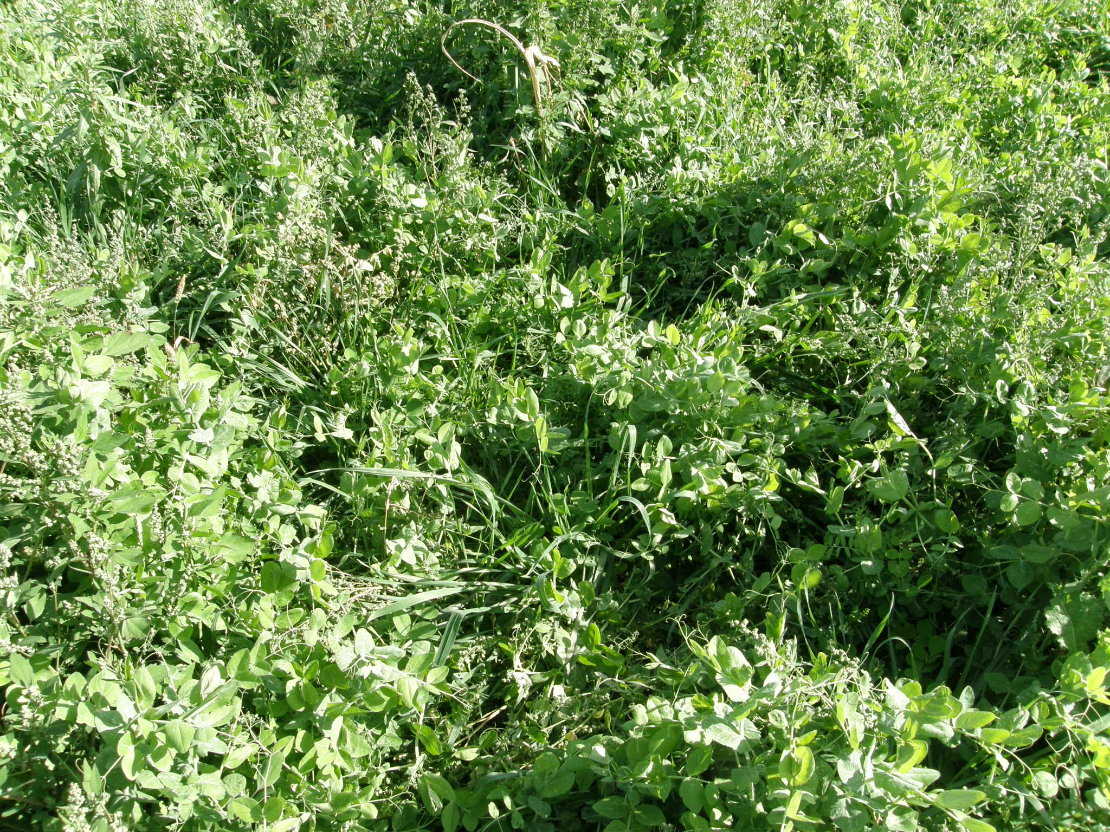
Triticale, Austrian Winter Pea and Crimson Clover; Planted 8/15/17 Photo 10/27/17
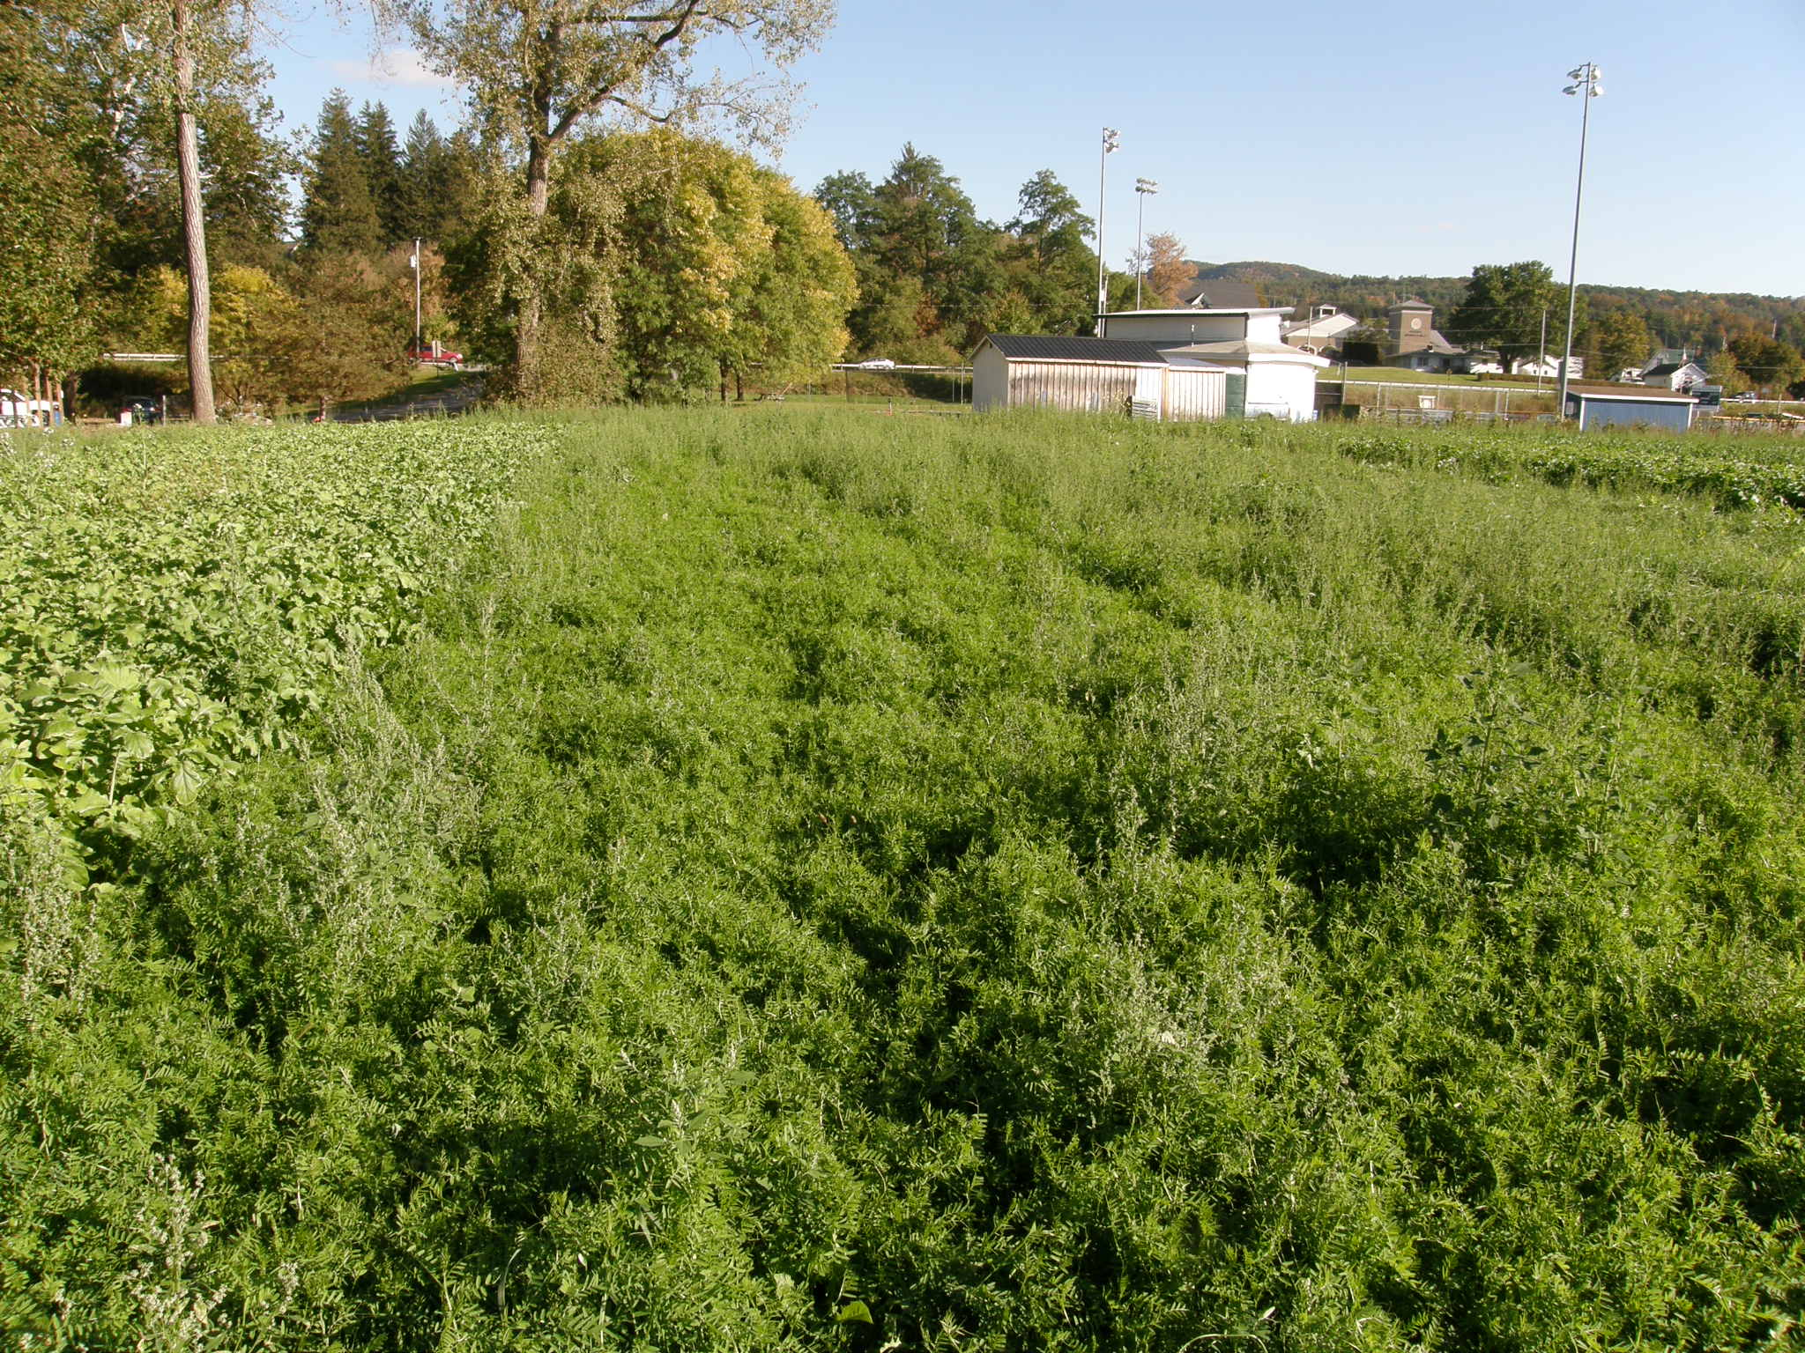
Left Radish Center Hairy Vetch Planted 8/15/17 Photo 10/12/17.

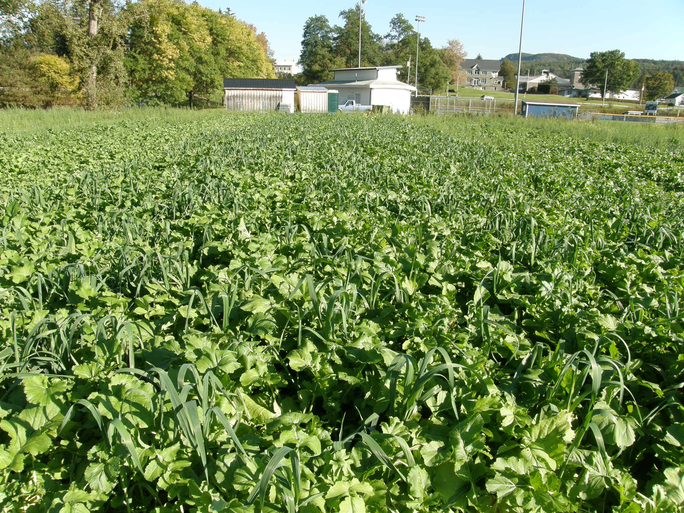
Left: Rays Crazy fall Mix, Center: Soil Builder plus, Right: Cargo planted 8/15/17 Photo 10/12/17
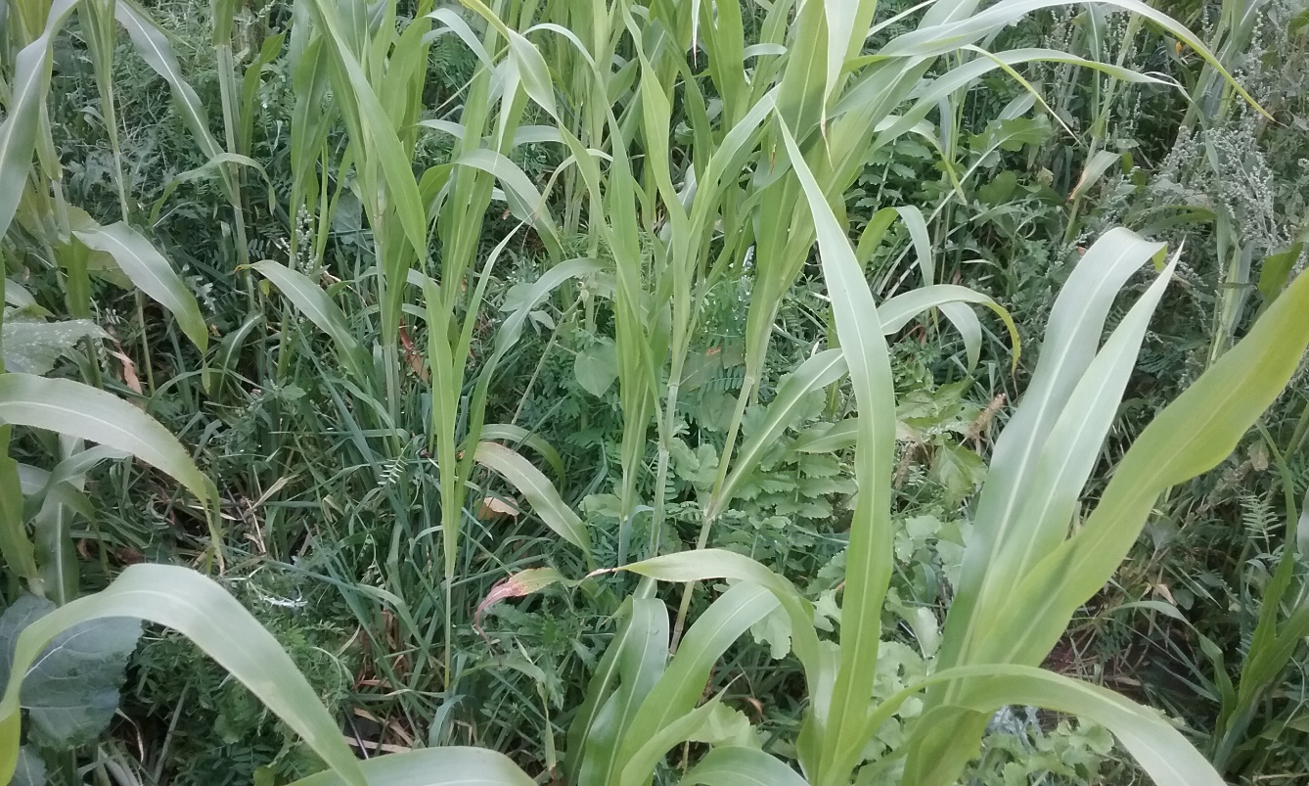
Sorghum X Sudangrass, Hairy Vetch, Barley, Radish and Canola; Planted 8/15/17 Photo 10/12/17
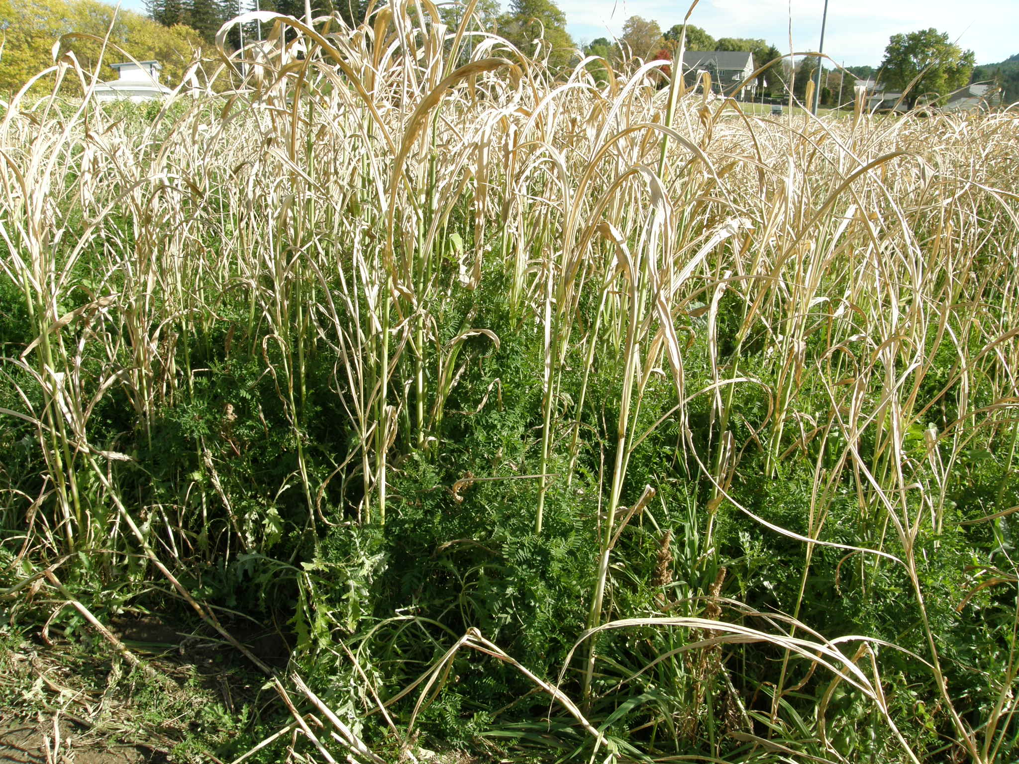
Sorghum Sudangrass, Hairy Vetch,Bbarley, Radish and Canola; Planted 8/2/17 Photo 10/27/17
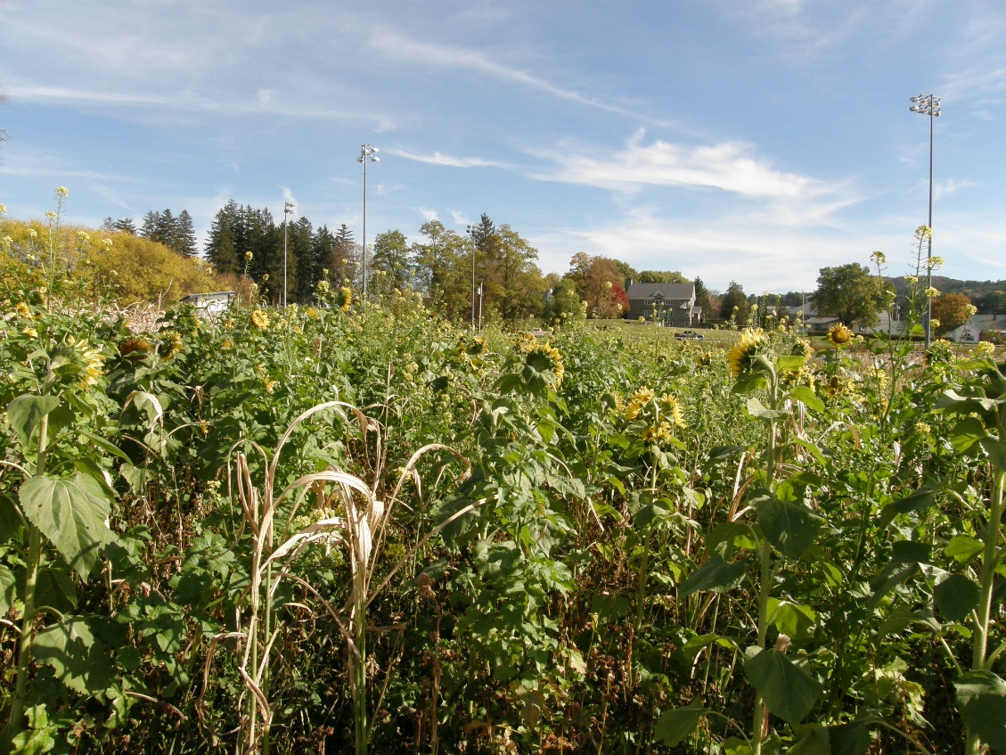
Sunflower, Cowpea, Sorghum x Sudangrass, Buckwheat; Planted 8/2/17 Photo 10/27/17

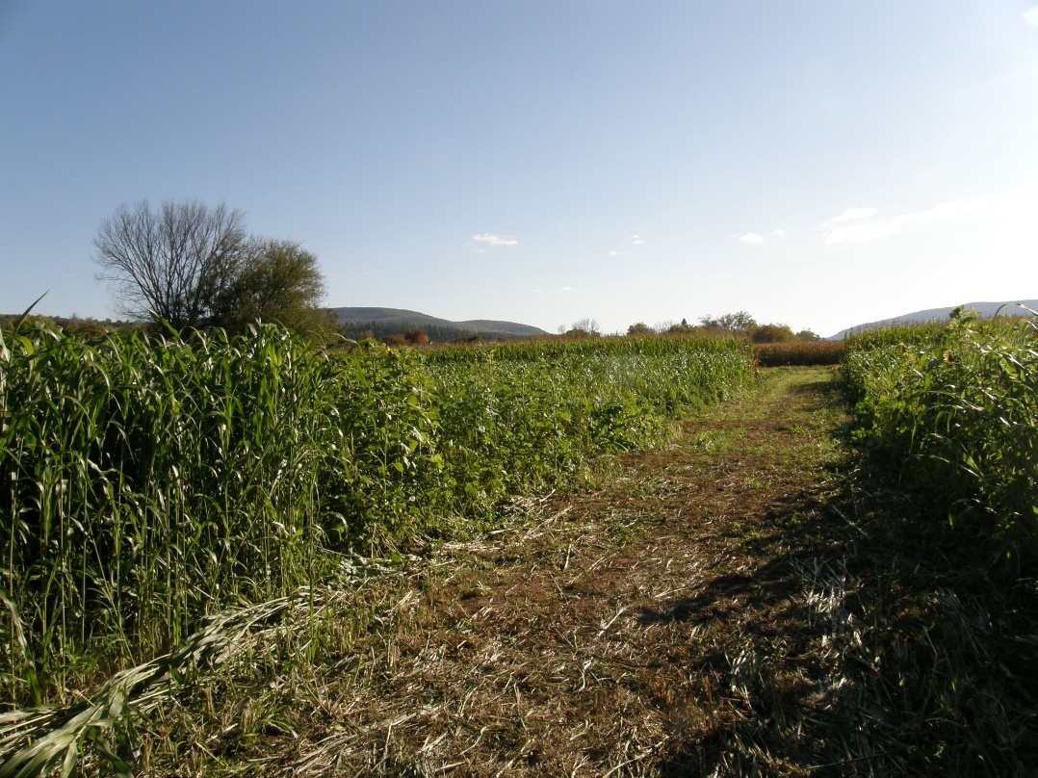

Overview of Warm Season Plots Planted 8/2/17 Photo 10/12/17

