Fig. 5 Pictures of Dave Magos post harvest cereal rye establishment demonstration. Seeded on 9/30/16 at 120 lb/ac with photos taken on 10/28/16.
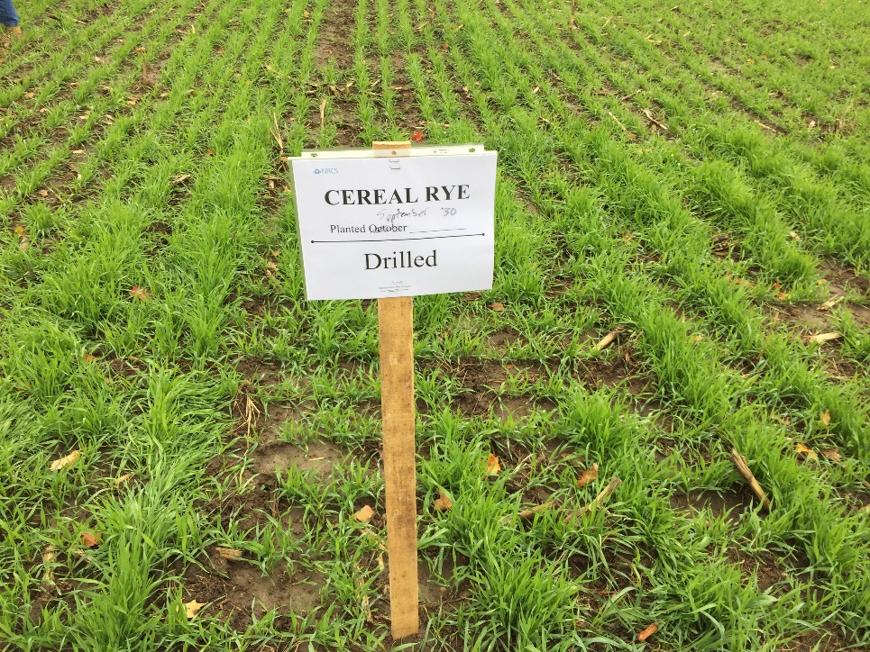
Cereal rye no-tilled drilled

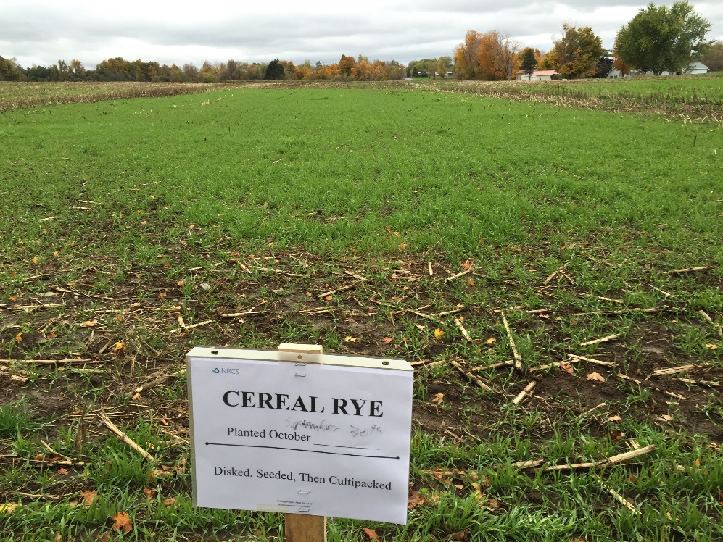
Cereal rye seeded then cultimulched
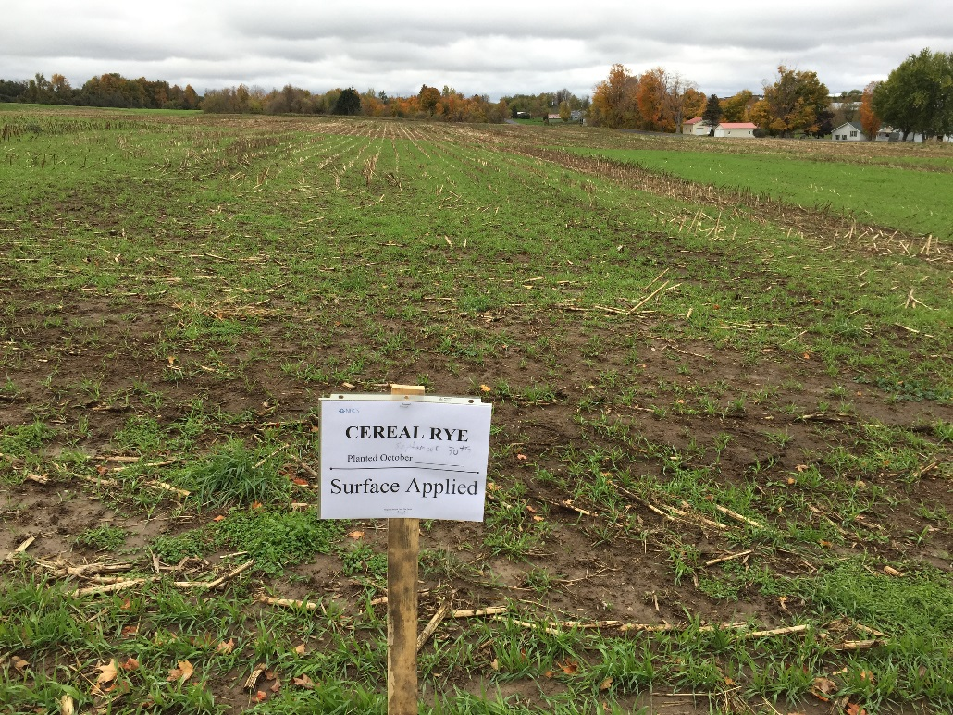
Cereal rye broadcast with no surface disturbance

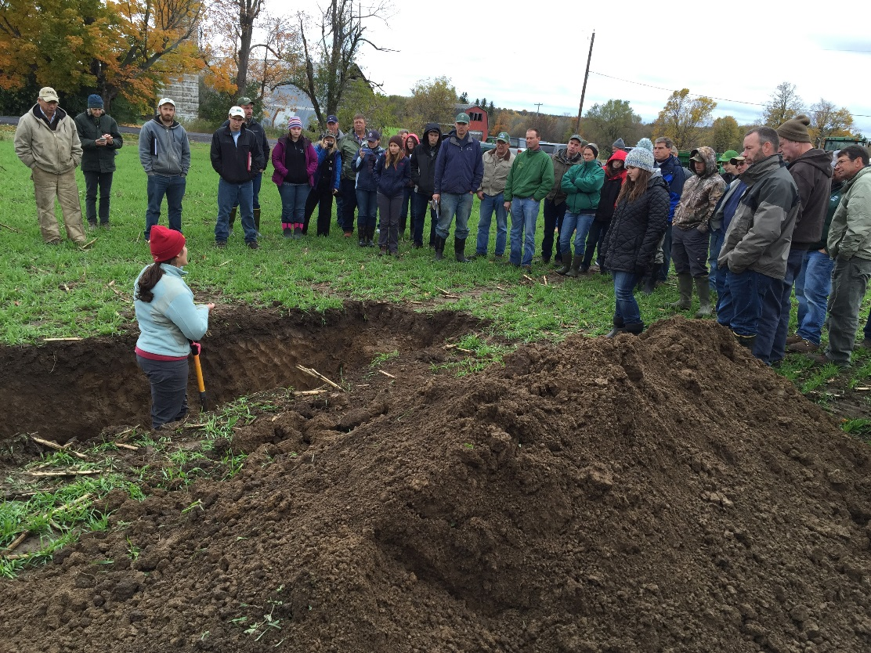
Amy Langner discussing soil characteristics in soil pit by the cover crop demo
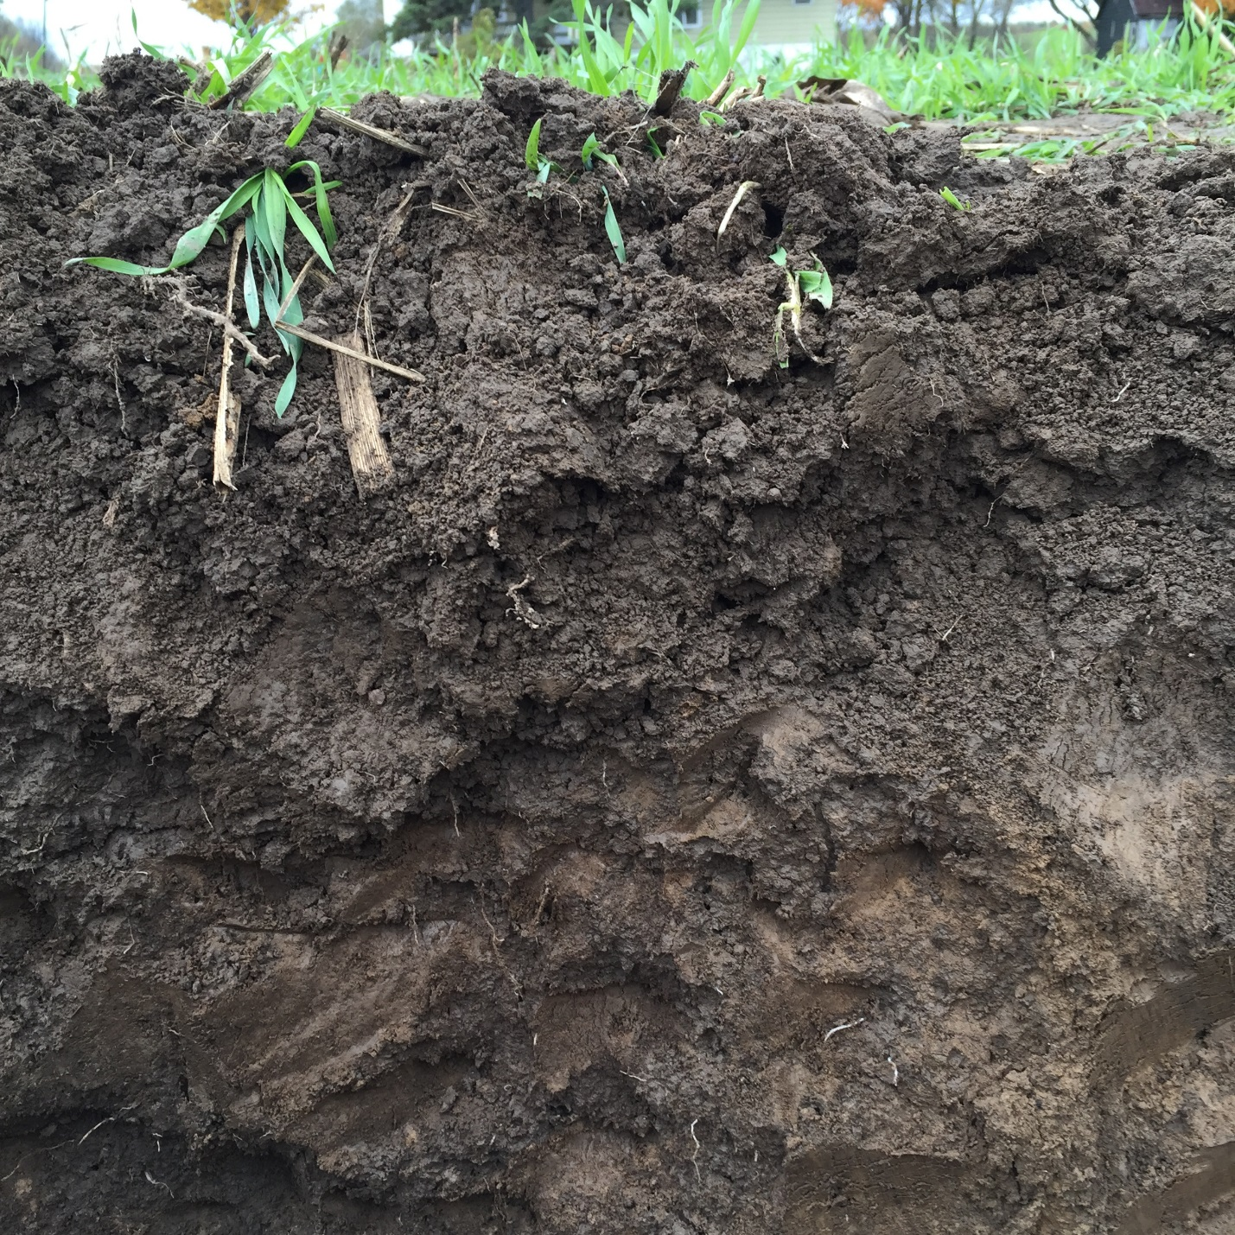
Picture of soil pit showing good soil aggregation and deep cover crop roots

