Fig. 6 Mike Northrups Interseeding, Annual Ryegrass 12 lb/ac, Red clover 8 lb/ac and Daikon radish 3 lb/ac. Seeded June 24th, Corn Harvested Late September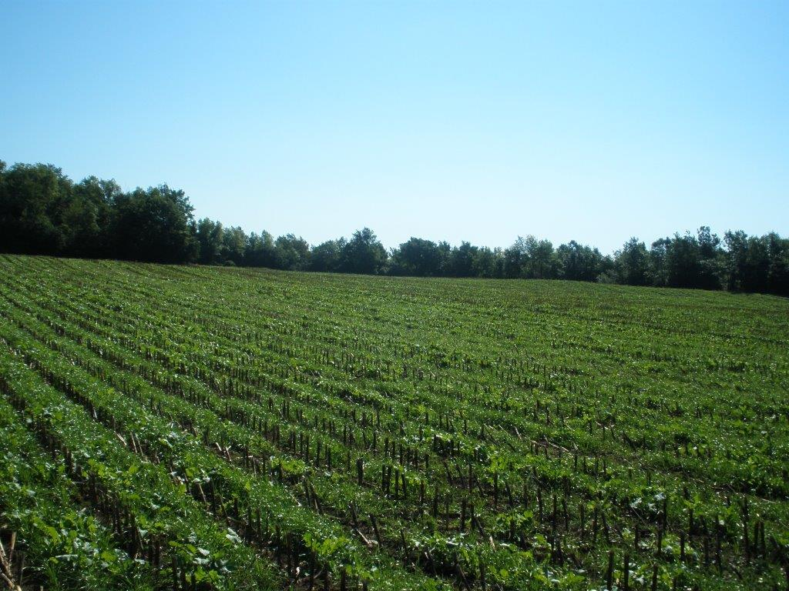
Overview of seeding just following silage corn harvest in Late September
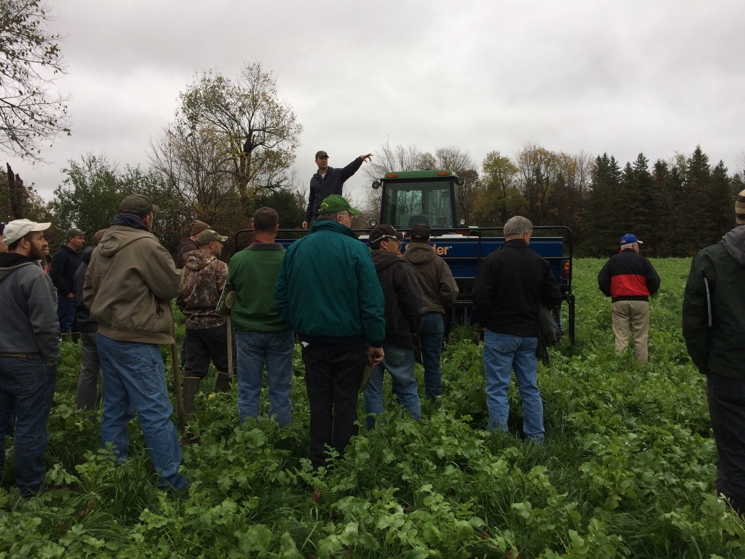
Discussion by Dave Komorowski of no-till interseeder on 10/28/16 at workshop

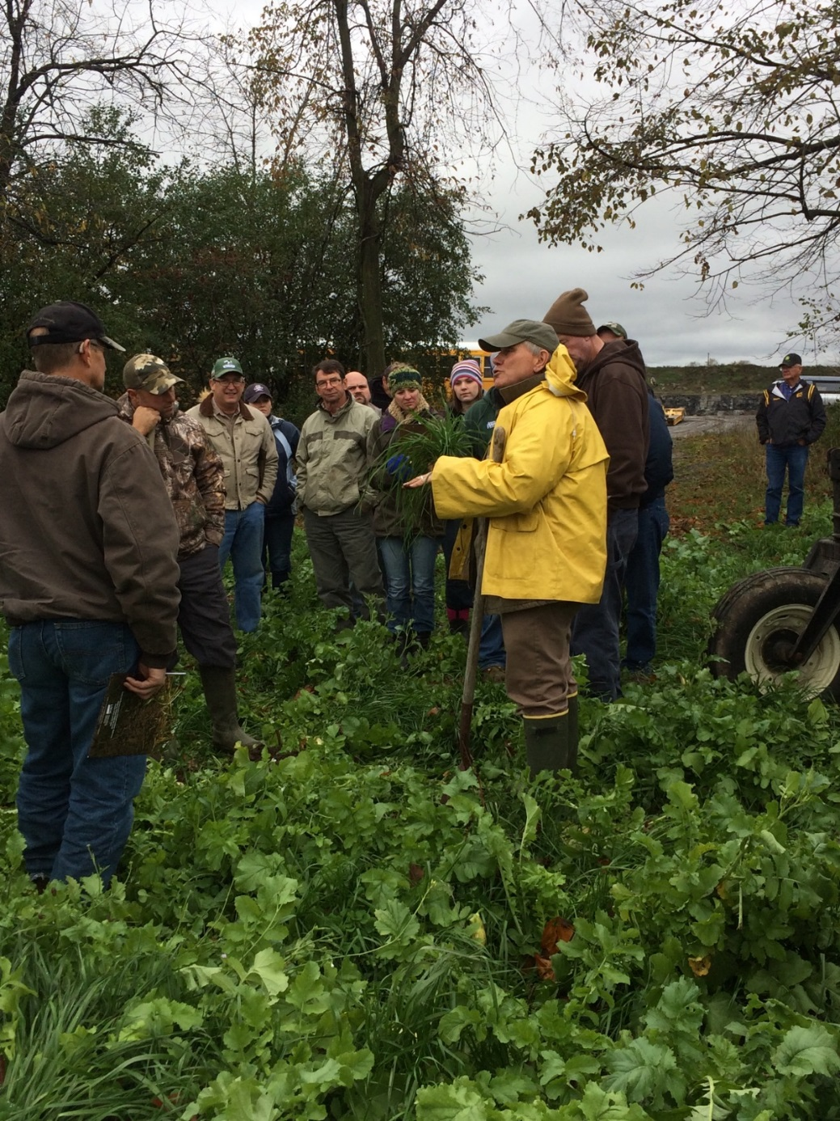
Discussion by Paul Salon of the interseeding: The interaction of cover crop species in the mixture and their soil interactions at the workshop on 10/28/16

