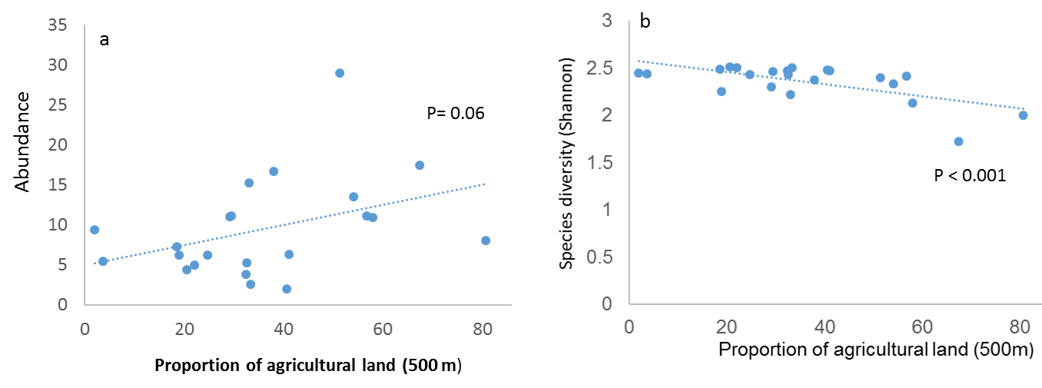
Fig 7. Predator abundance along a gradient of landscape simplification (a). Predator diversity along a gradient of landscape simplification (b).

