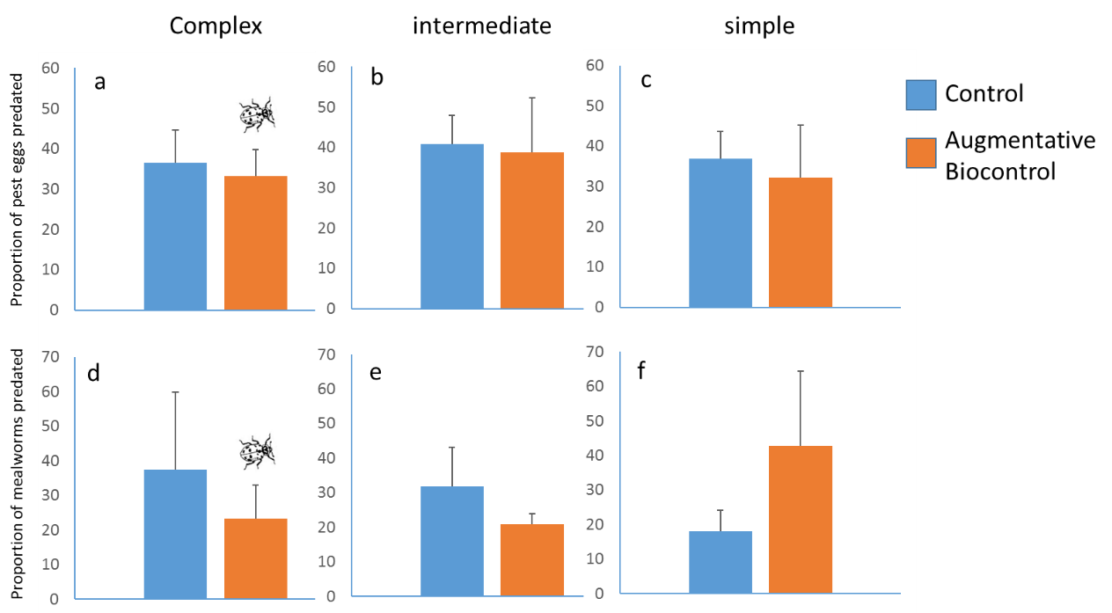
Fig 8. Predation on sentinel preys. Predation on T. ni eggs (a, b, and c), and predation on mealworms across the landscape complexity gradient (d, e, and f). Error bars are mean ±1 SE.

