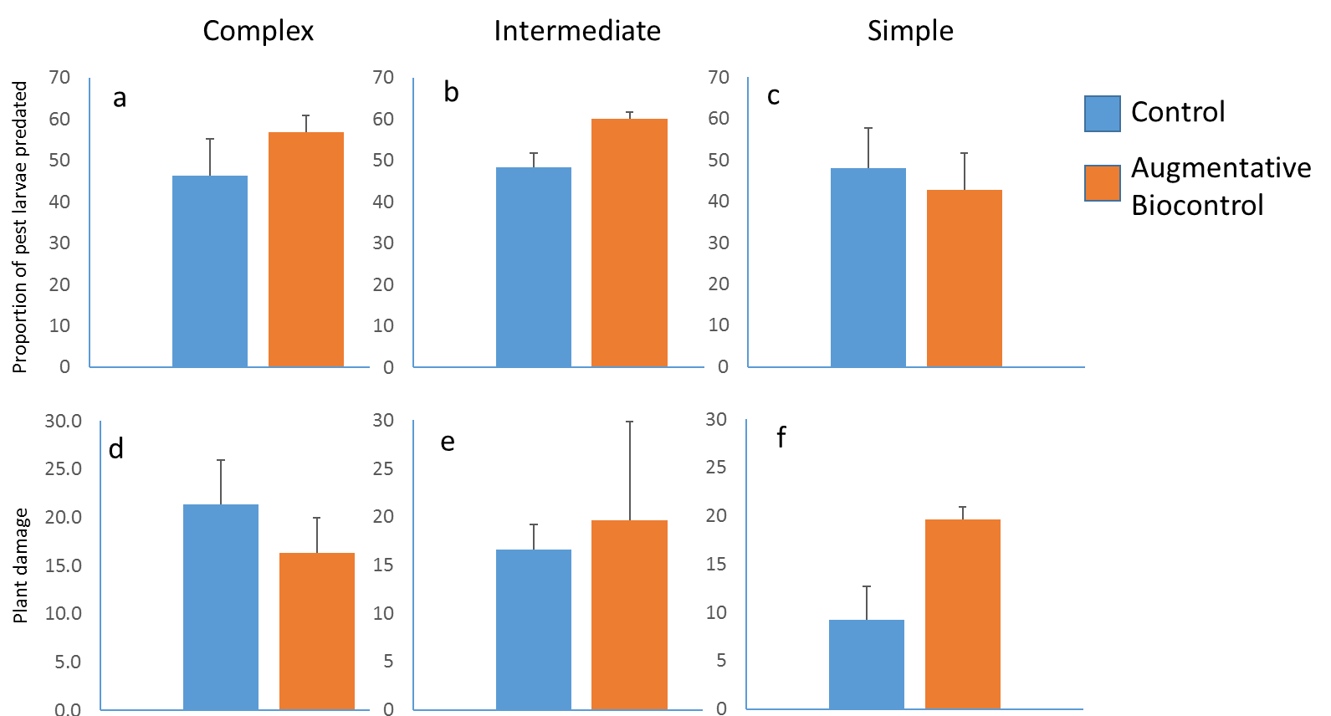
Fig. 9. Predation on sentinel preys and plant damage. Predation on T.ni larvae (a, b, and c). Percentage of plant damage (c, d, and f) across the landscape complexity gradient. Error bars are mean ±1 SE.

