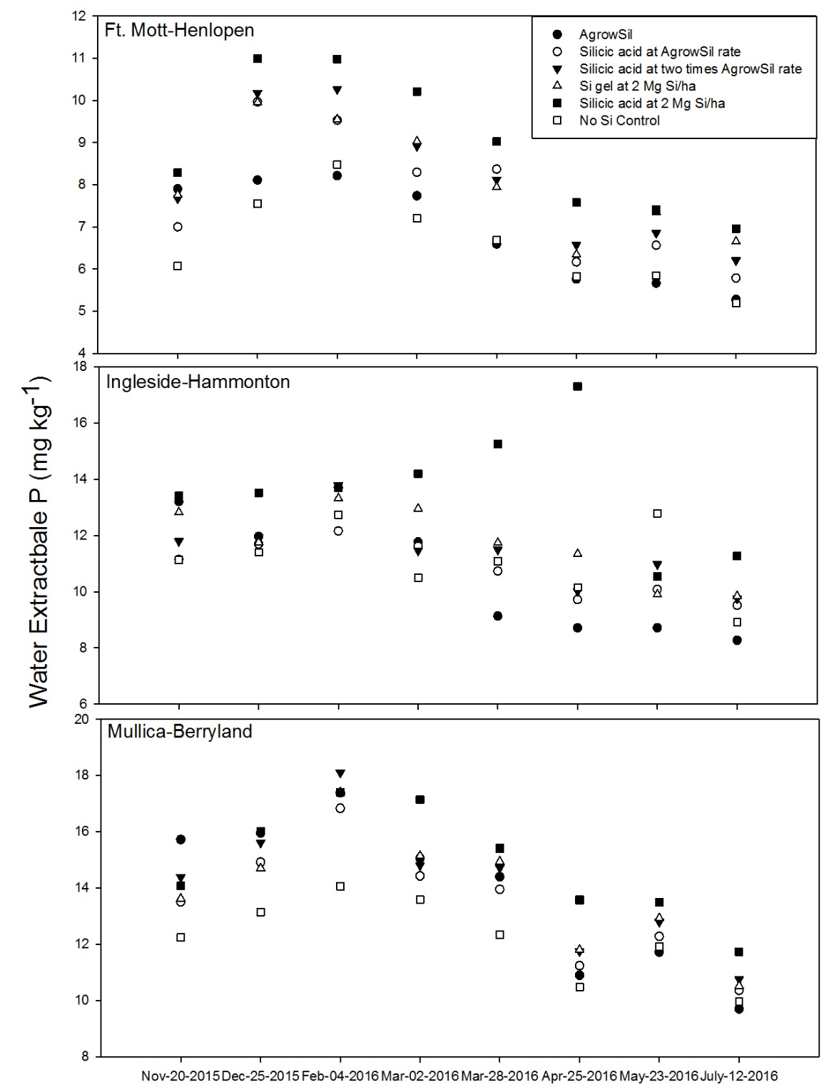
Figure 1. Effect of Si treatment on water extractable P over one growing season of winter wheat in three legacy P sites in Delmarva.

