Results

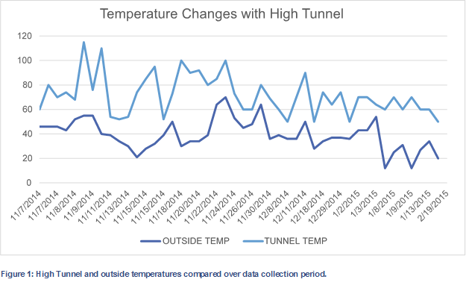

Figure 2: Yield trends in pounds by crop from November thru April in the Model High Tunnel.

Figure 3: Sales by crop for winter and spring crops