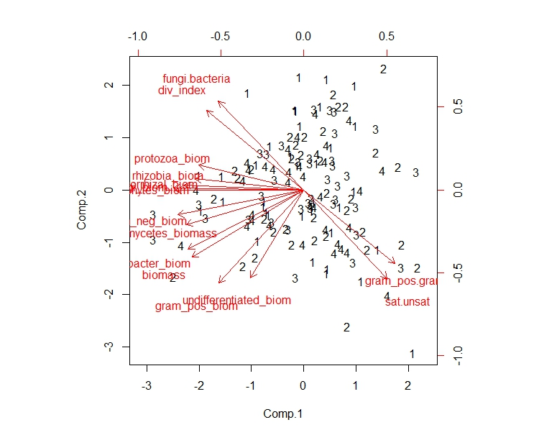

Block

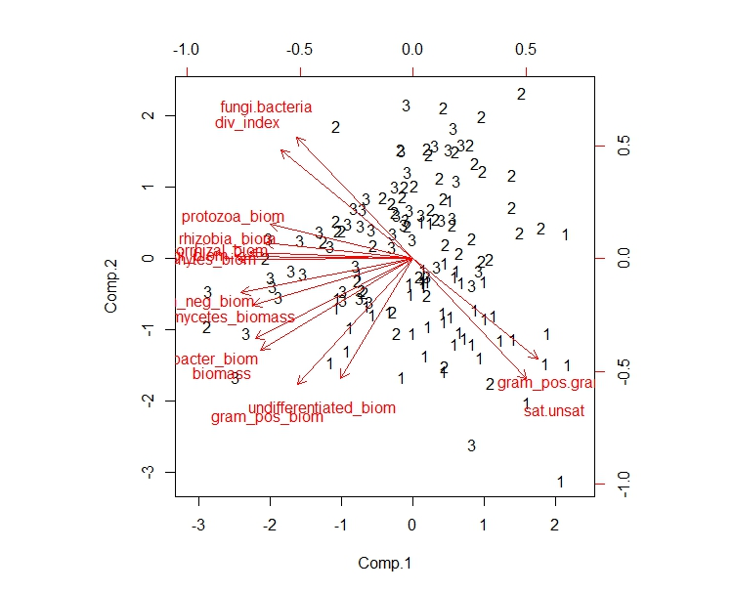

Sample Time

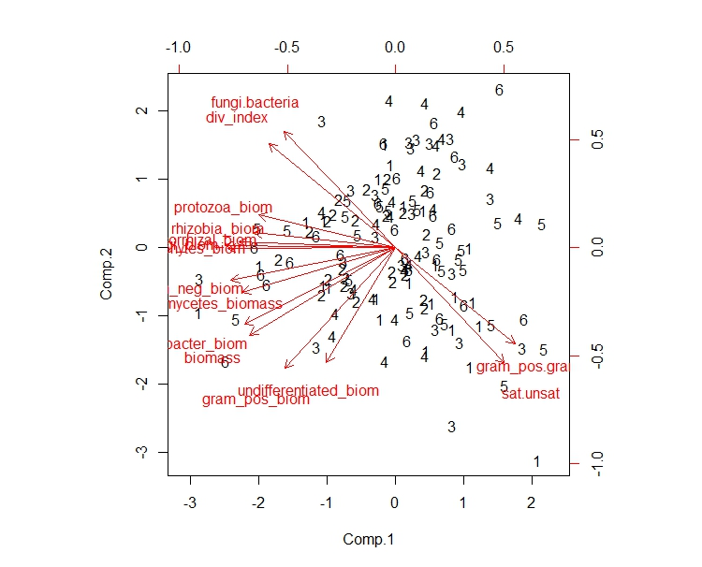

Site

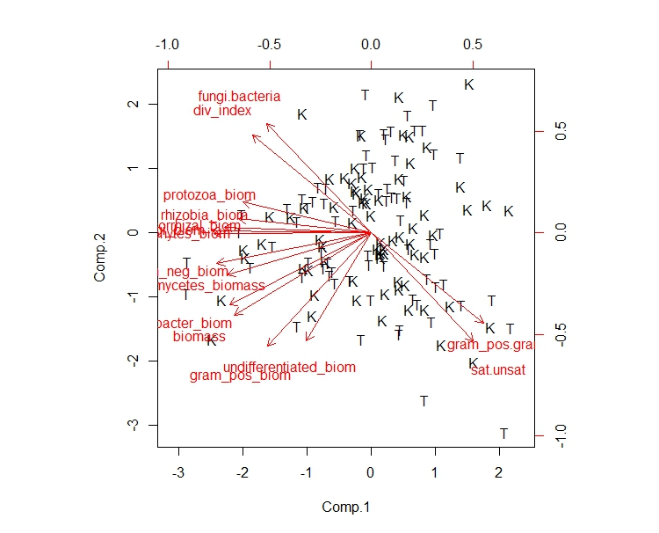

Crop Type

**Figure 10:** Principle component scores 1 and 2 for the principle component analysis of the indicator markers from the soil microbe PLFA analysis. Sample time represents the time of sample with 1 being spring of 2015, 2 being fall of 2014, and 3 being fall of 2015. Site is the location of the garden from rural to urban (1=Kuipers to 6=Garfield). Block is the blocking factor of the sites. Crop type is the crop type of the pot the samples were taken from with K=kale and T=tomato. The circles on the sample time plot are the grouping of spring (1) and fall (2,3) sample times.