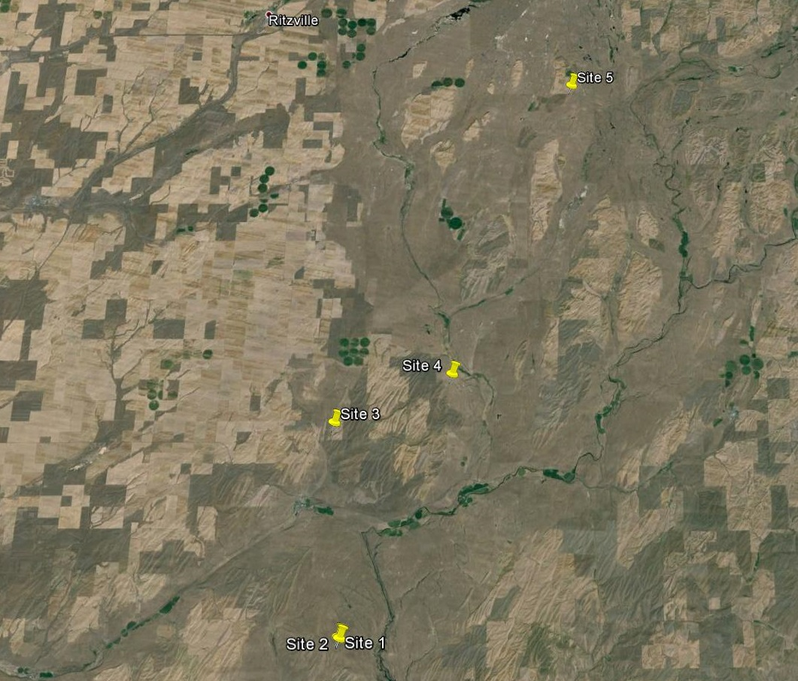
Figure 1. Sites for replicated and demonstration plots on 5 ranches across a 25 mile transect of the Channel Scablands. Selection of these sites was to evaluate multiple factors such as climate, soil types, competing vegetation and other environmental conditions.

