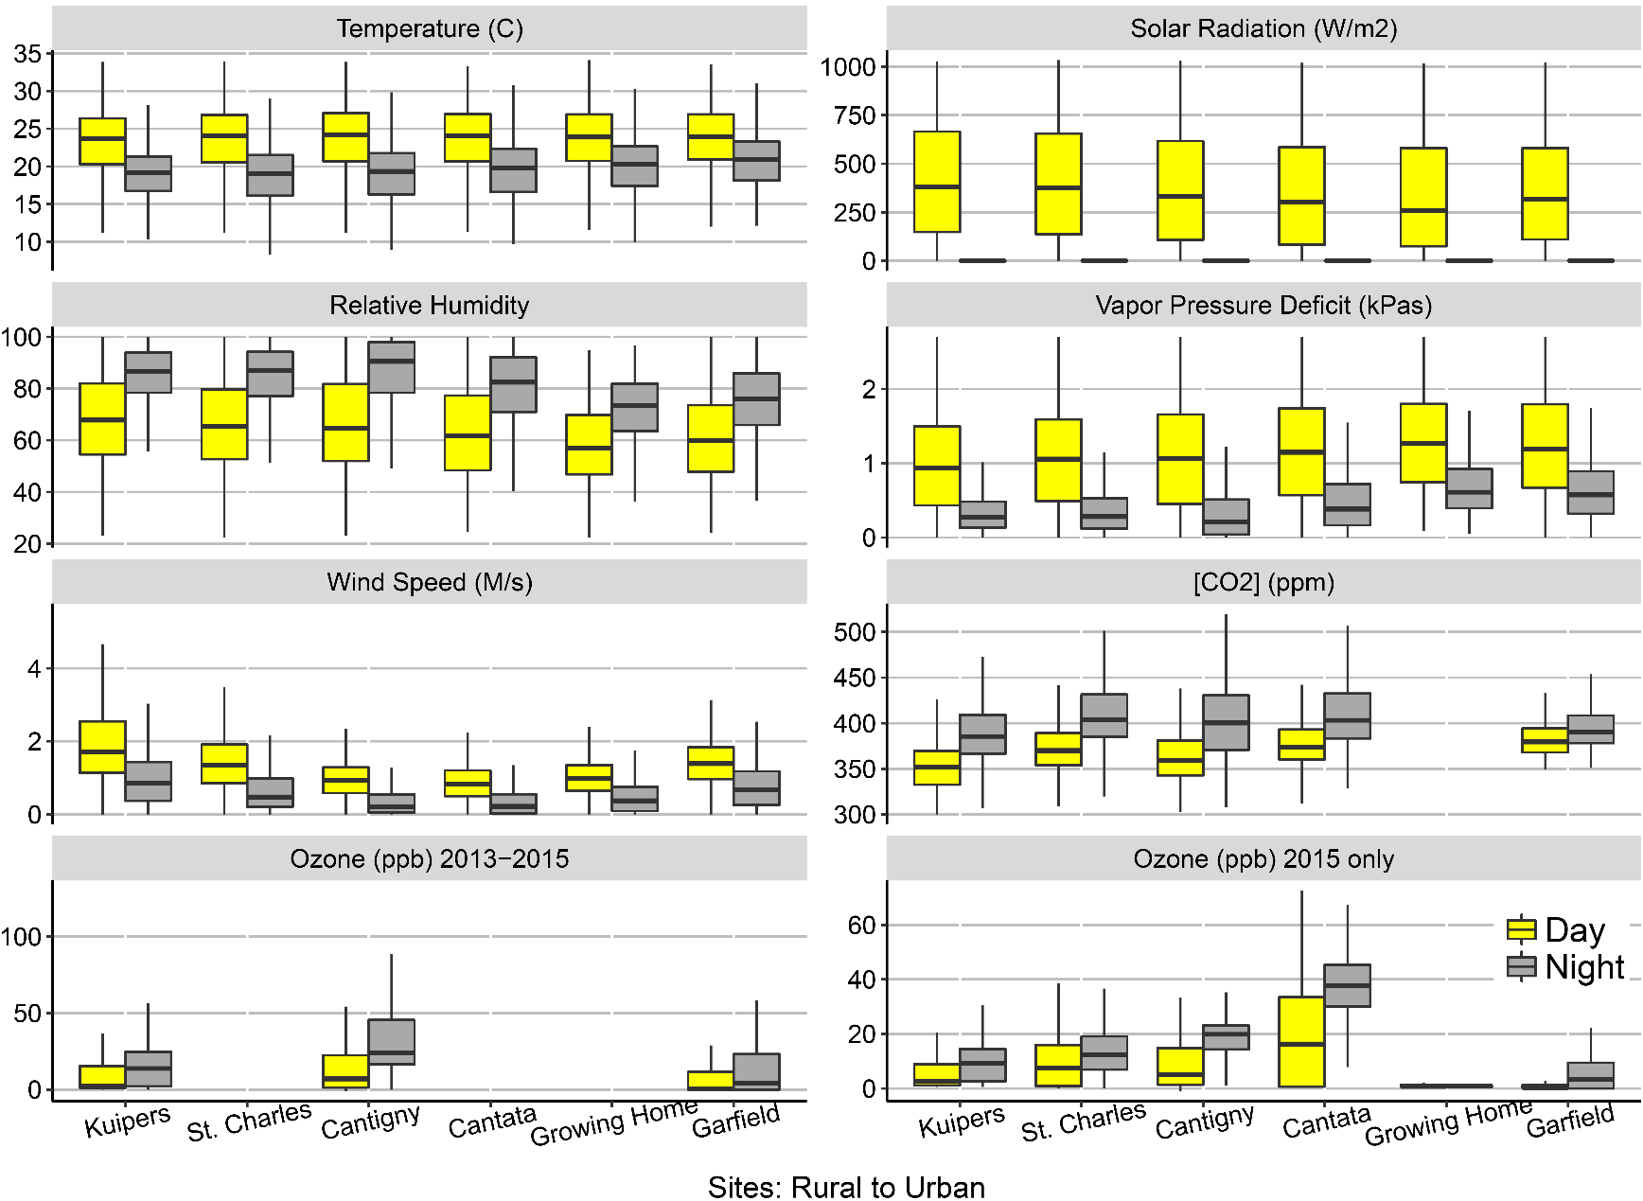

**Figure 2**: Boxplots for summer micrometeorological measures from towers adjacent to the research sites. These panels are hourly averages from June 15th to September 1st of a culmination of 2013, 2014, and 2015. The horizontal axis is the research sites from the rural to urban. Scales of each vertical axis are given in the title in parentheses. Yellow boxes represent daytime hours from 0530 to 1930 and grey boxes are nighttime hours. Three ozone monitors were installed in 2013 and 2014 and all six sites had ozone monitors in 2015. A CO2 IRGA was not installed at the urban Growing Home site.