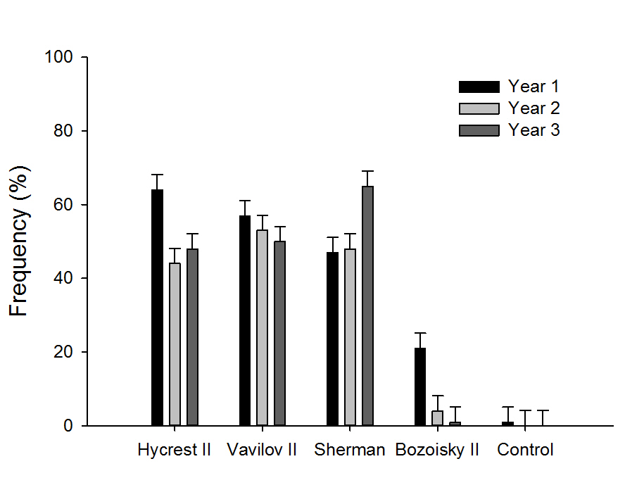
Figure 2: Frequency of seeded grasses the first three years after seeding. Note the failure of the Bozoisky II plots and rapid re-invasion of annual grasses (weeds) represented in this figure and table 2.

