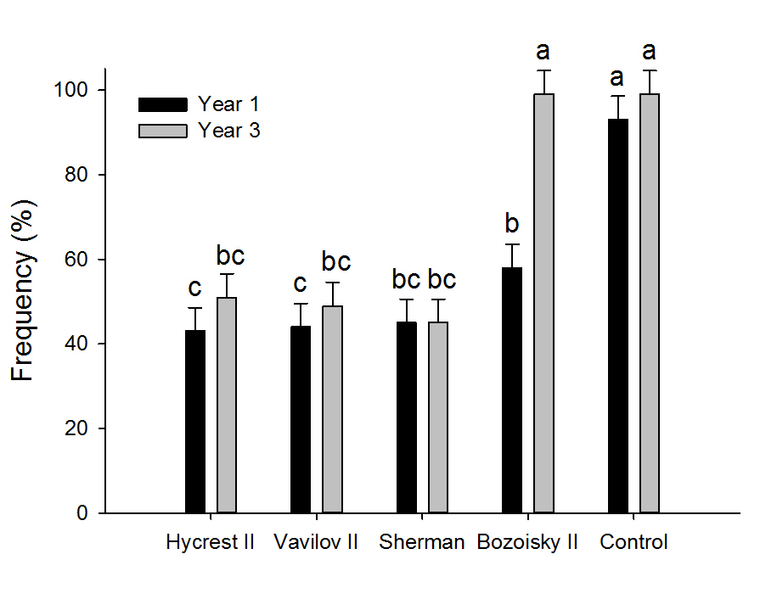
Figure 3: Frequency of weeds within plots for year 1 and Year 3. Bars not labeled with the same letter differ (P < 0.05). Notice the weeds in year 3 of the failed Bozoisky II plot compared with the other grasses and control plot.

