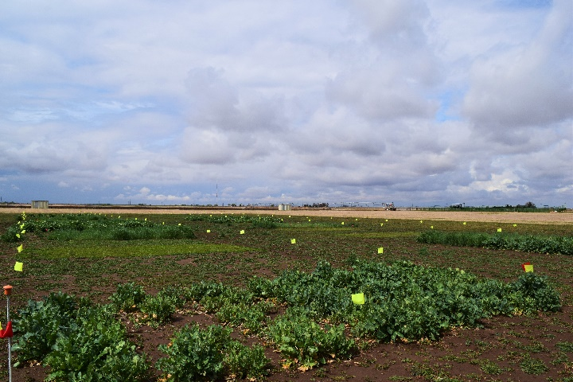
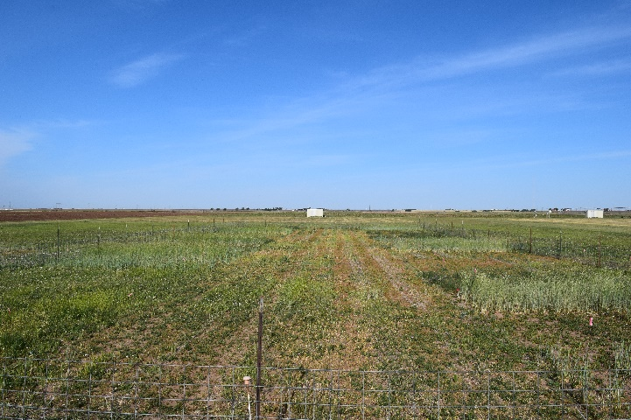
Figure 3. View of cover crops in Year 1 (Spring 2016; left) and Year 2 (Spring 2017; right). Yields were visibly greater in Year 1.

