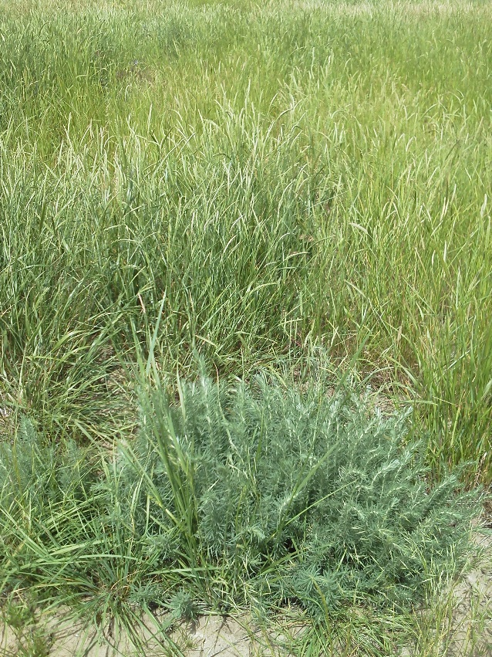
Figure 4. A Sahro forage kochia plant within a well established stand of Vavlov II.

