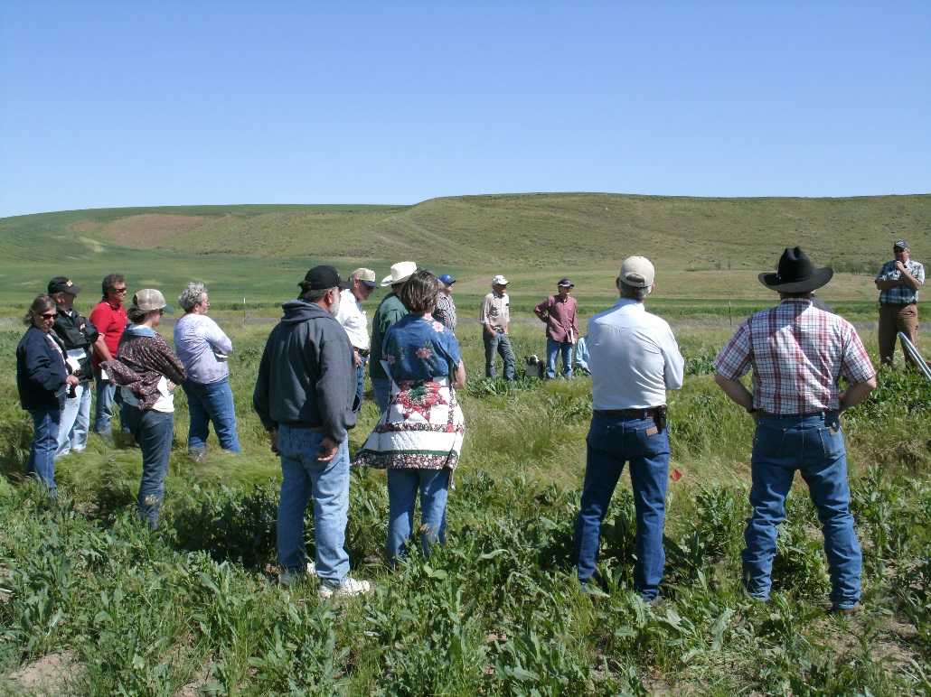
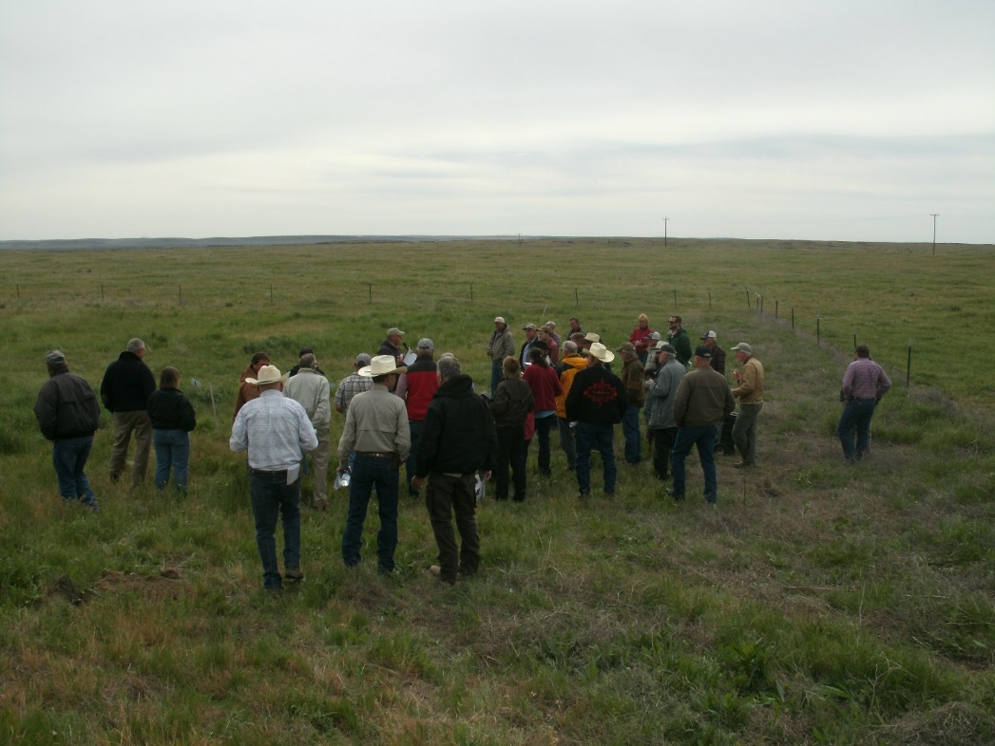
Figure 5. Field day held May of 2015 for stakeholders . Top Photo: Dr. Kevin Jensen discusses the design of the plots and explains how the plots were prepared and seeded. Bottom Photo: Ranchers and producers look at the plots and interact with scientists and technicians.

