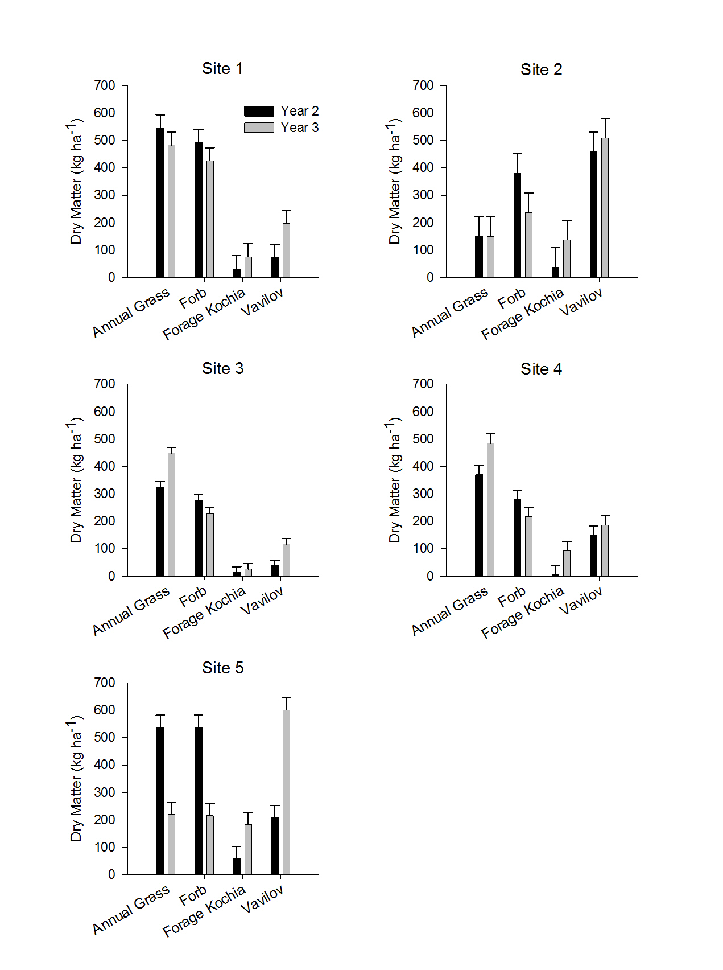
Figure 6: Comparison of forage dry matter across all five sites on year 2 and 3. There was a clear site difference.

