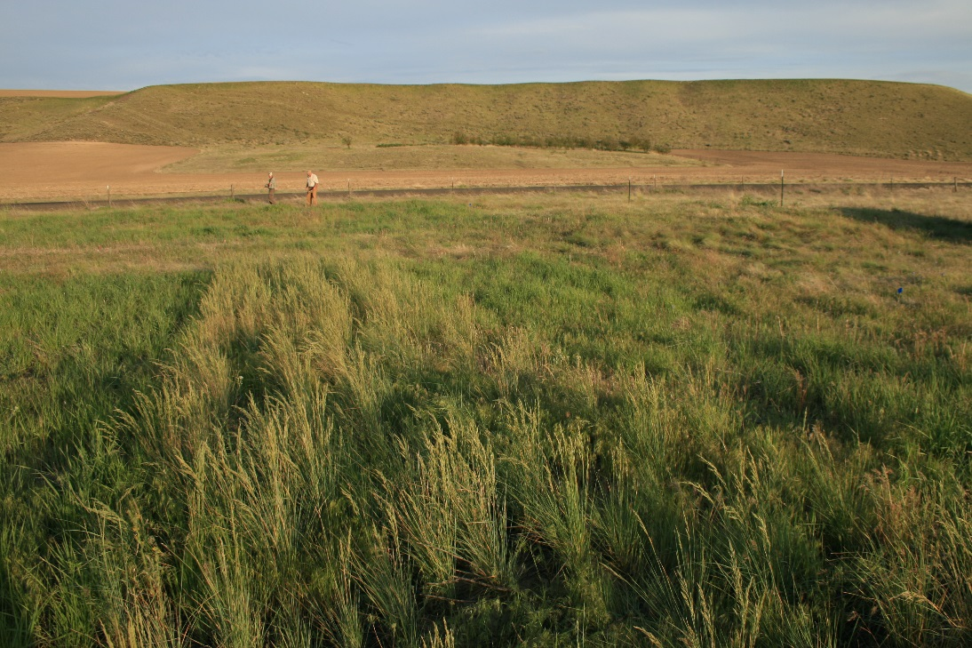
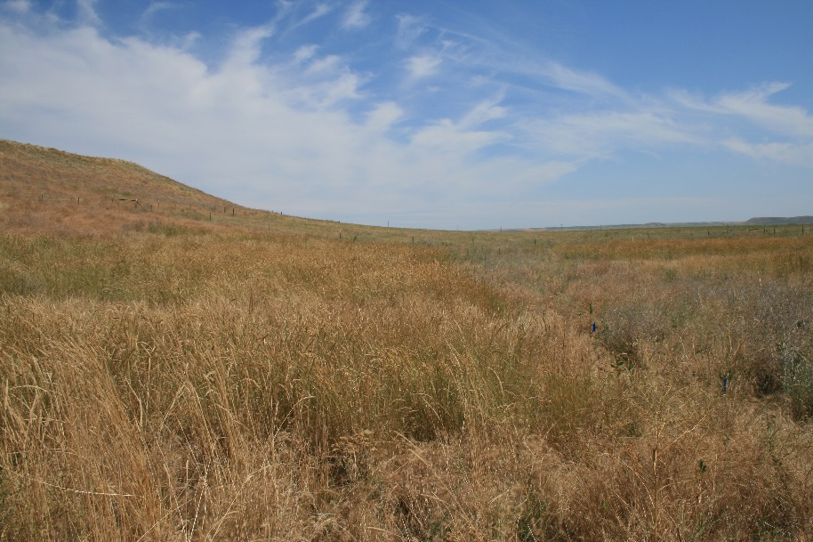
Figure 7. Replicated plots on the Spencer Ranch. The photo at the top shows the successful germination and establishment of Sherman Big Blue grass. Dr. Kevin Jensen and technician Craig Rigby evaluate plots and take frequency data. The bottom photo shows a replicated plot later in the season and clearly demonstrates a good stand of perennial grasses with the weeds at the center right border of the plot (center and upper right quadrant of the photo).

