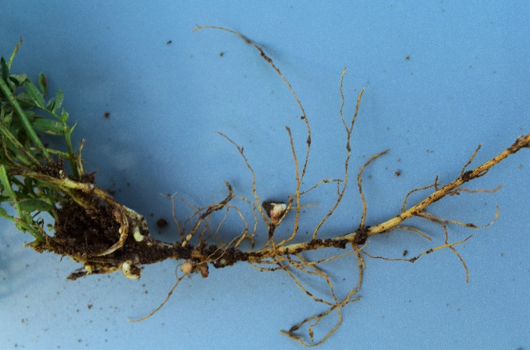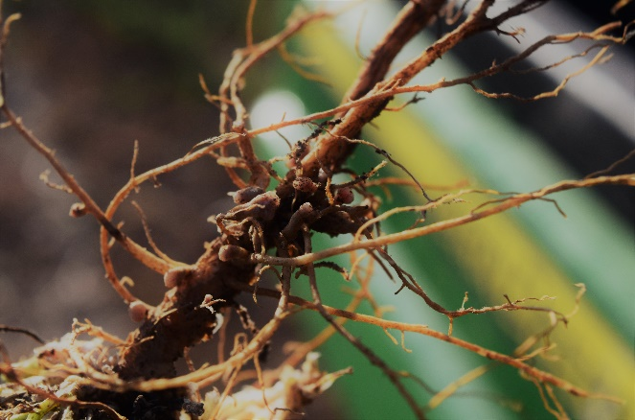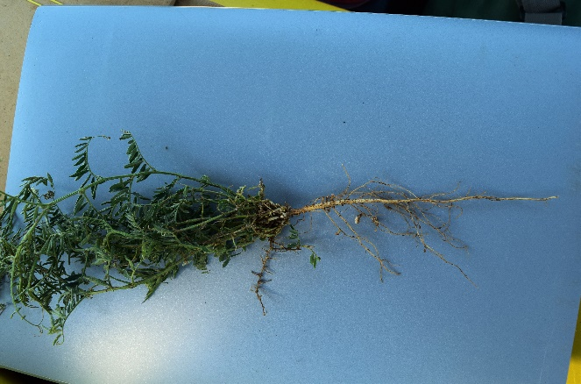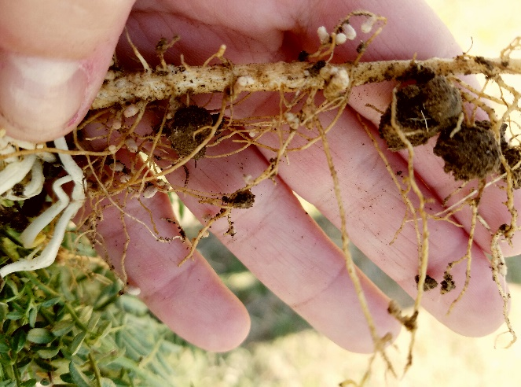

**1**

**2**

**3**

**4**

**Figure 7. Examples of each nodulation score visually assigned in this experiment, with 1 denoting least nodulation and 4 denoting greatest nodulation.**