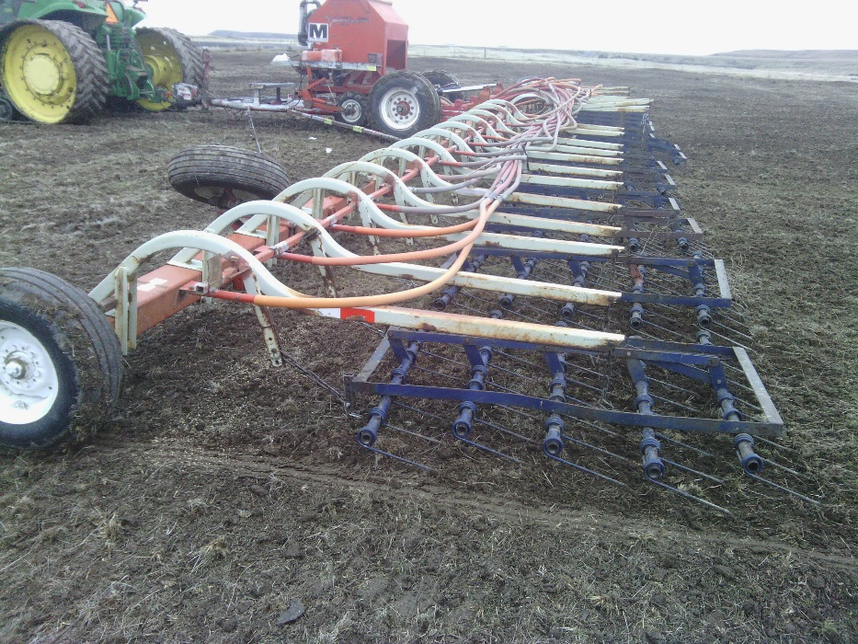
Figure 8. Preparation for drilling perennial grass seed into the demonstration plots and the ranch scale pastures with a tine harrow after the cattle have grazed the medusahead plants and thatch to bare ground using targeted grazing methods.

