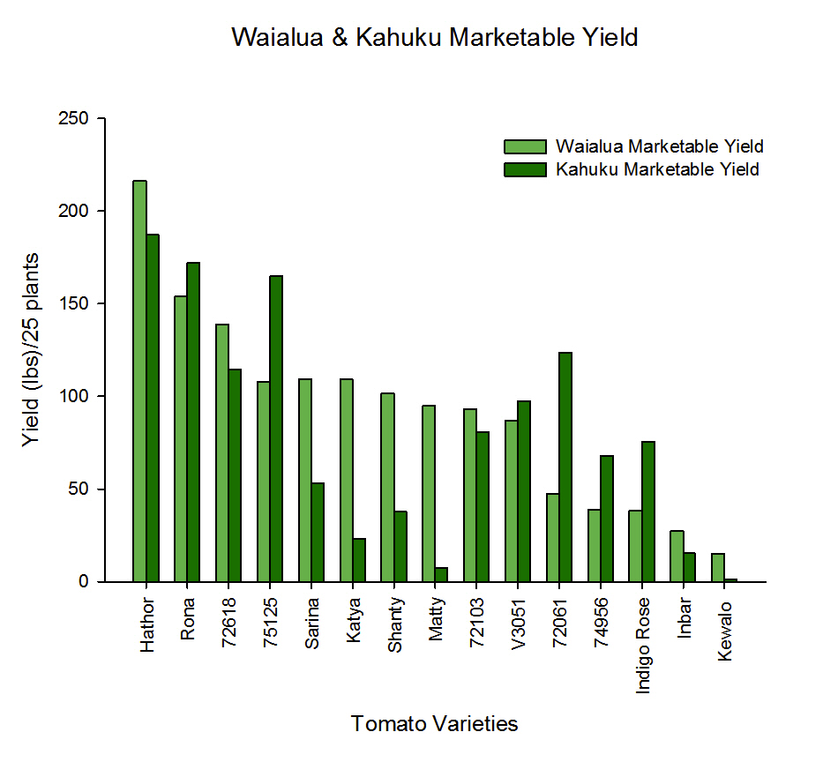

Figure1. Field trials Waialua and Kahuku Marketable Yield for all tomato varieties

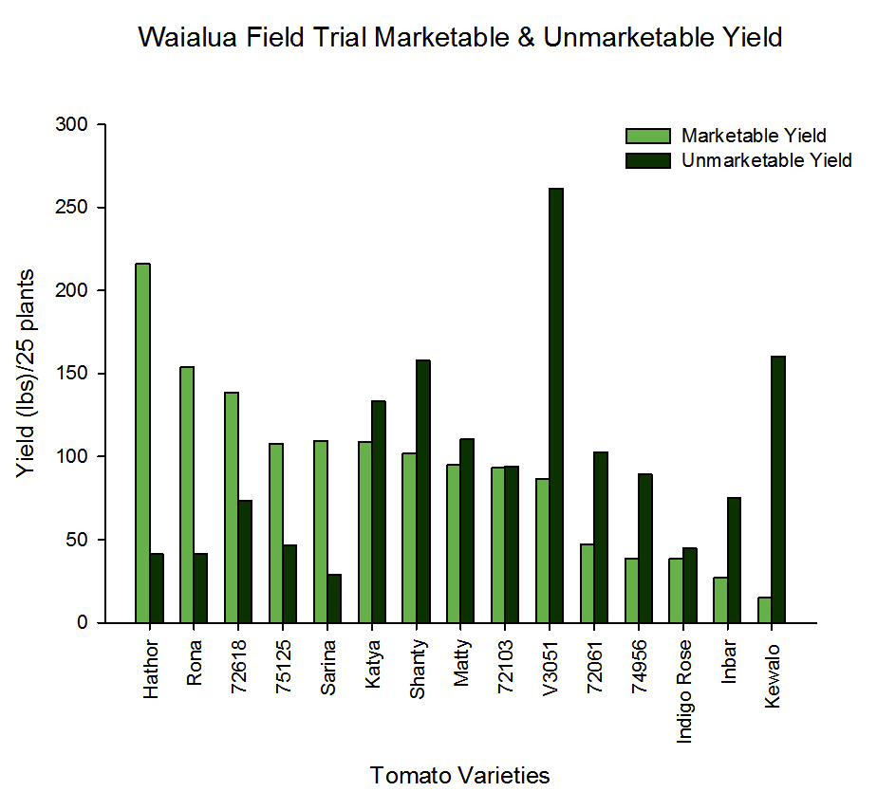

Figure 2. Waialua Unmarketable Yield comprised of five different categories; Damaged/Injured, Mite, Splotchy, Fruit Fly and Hemiptera Yield.

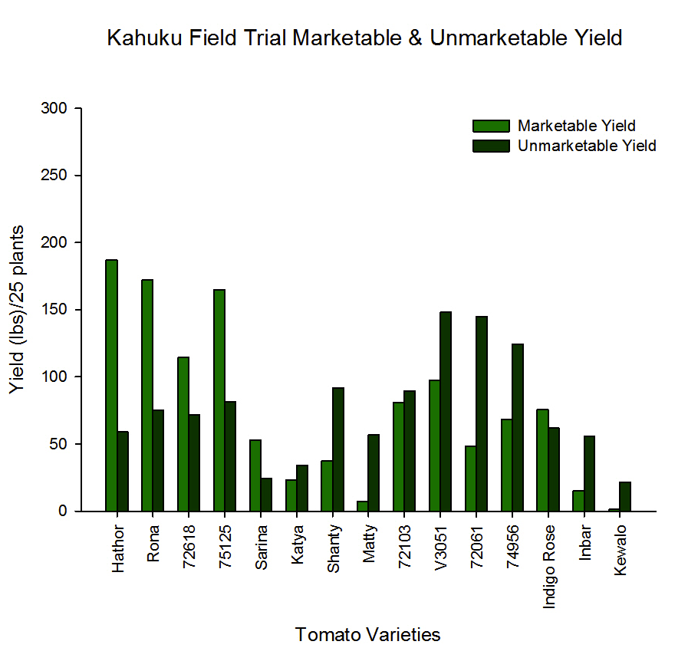

Figure 3. Kahuku Unmarketable Yield comprised of five different categories; Damaged/Injured, Mite, Splotchy, Fruit Fly and Hemiptera Yield.

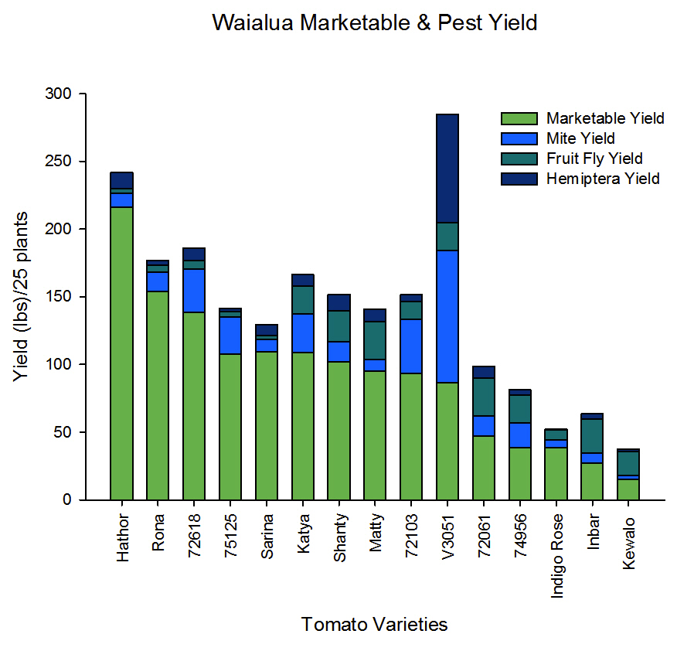

Figure 4. Waialua Marketable Yield with Pest yield comprised of Mite, Fruit Fly, and Hemiptera yield.

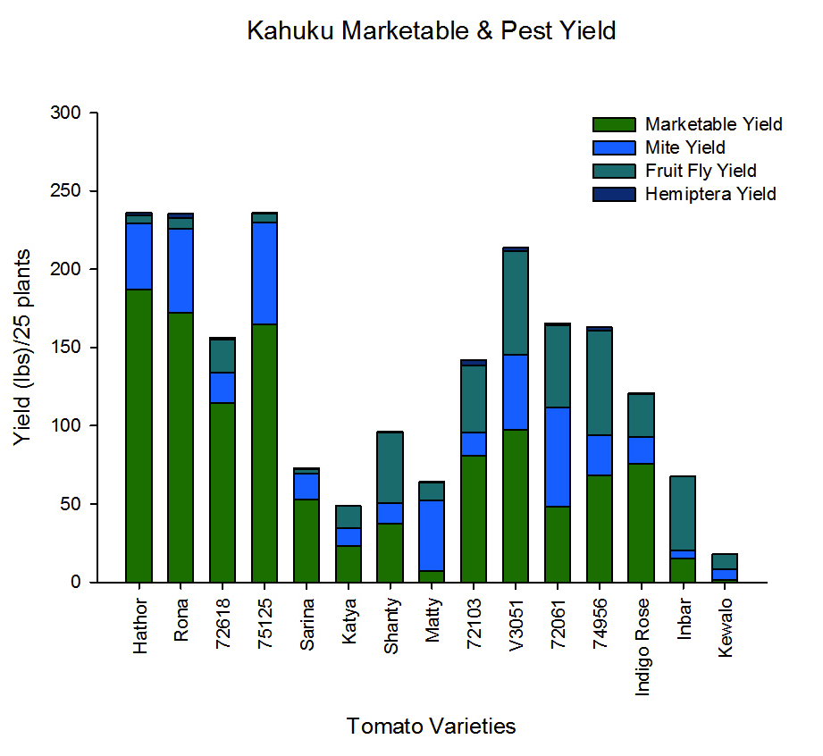

Figure 5. Kahuku Marketable Yield with Pest yield comprised of Mite, Fruit Fly, and Hemiptera yield.



Figure 6. Dried biomass (grams) by mulch treatment and variety



Figure 7. Mean number of fruit bunches per plant

****

b

b

ab

a

a

a

a

ab

Figure 8. Mean number of whitefly eggs and nymphs per leaf



Figure 9. Mean number of leafminers per leaf



Figure 10. Mean number of red spider mites and russet mites per leaf