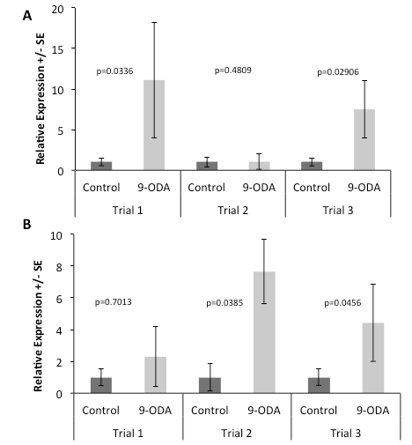
Figure 1. 9-ODA exposure increases Vg expression in drones, across multiple rearing regimes. A. Vg expression in callow-reared drones exposed to 9-ODA for three days. Vg expression was significantly higher in the 9-ODA exposed groups of Trial 1 (t(19)= - 1.94, p=0.0336) and Trial 3 (t(21)= -1.994, p=0.0296), but not in Trial 2 (t (14)= -0.049, p=0.4809). B. Vg expression in nurse-reared drones exposed to 9-ODA for three days. Vg expression was significantly higher in the 9-ODA exposed groups of Trial 2 ( t(13)= - 1.921, p=0.0385) and Trial 3 (t(22)= -1.766, p=0.0456), but not in Trial 1 (t(14)= 0.5405, p=0.7013). A trend for higher levels of Vg expression in the exposed groups was consistent throughout every trial. N=8-12 per treatment per trial.
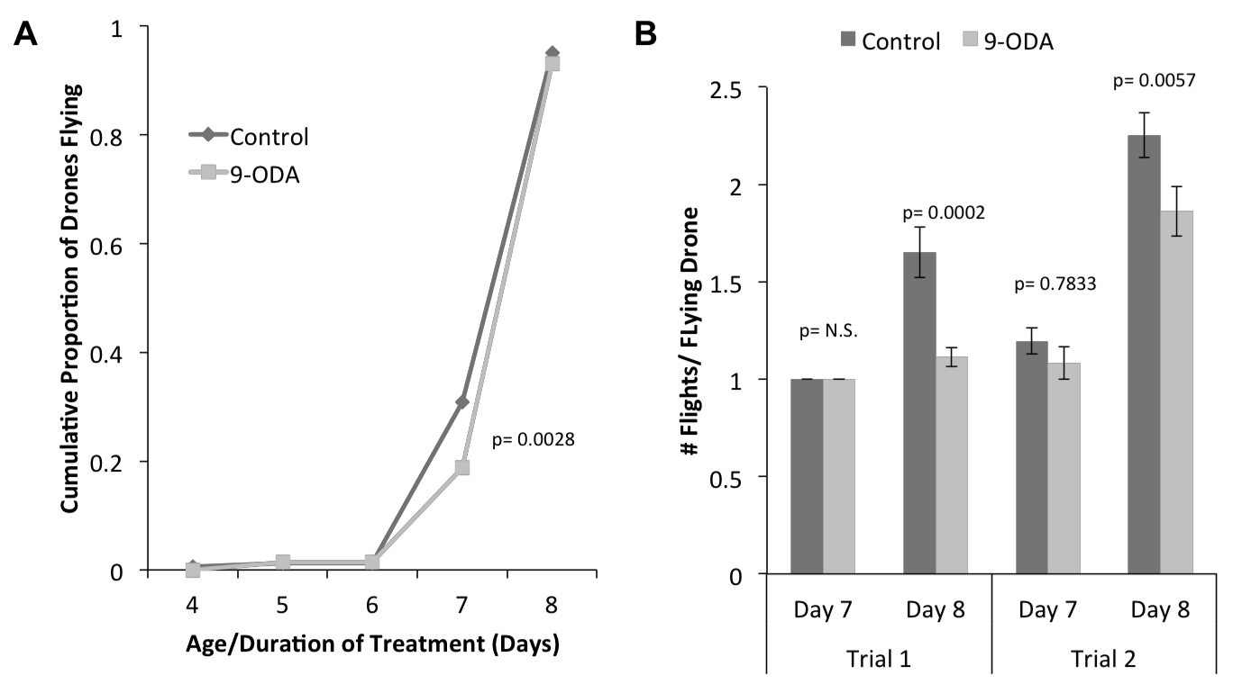
Figure 2A. 9-ODA exposure delays the onset of flight in drones. Flying behavior begins on day 7 in both groups, with a significantly lower proportion of 9-ODA exposed drones flying on day 7 relative to control drones (Kaplan Meir Survival Analysis, Wilcoxon X2(1)= 8.959, p=0.0028). Data represents cumulative number of individuals flying across two combined trials. 10 control-exposed and 15 9-ODA-exposed drones were censored (did not take a single flight through the completion of the study). B. 9-ODA exposed drones take significantly fewer flights. In both trials, there was no significant difference in the average number of flights individuals took on day 7(T1 Wilcoxon Rank Sums X2 (1) = 0; T2 Wilcoxon Rank Sums X2 (1)= 0.7833, p=0.3761). However, on day 8, control drones took a significantly greater number of flights on average (T1 Welch’s ANOVA F1,74= 14.99, p=0.0002; T2 Wilcoxon Rank Sums X2 (1)= 7.638, p=0.0057).

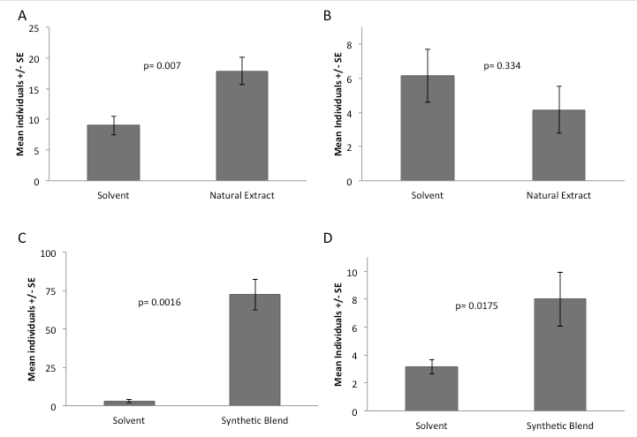
Figure 3. Drone long-range (A,C) and short-range (B,D) responses to lures impregnated with a solvent control and natural drone mandibular gland extracts (A,B; N=7) or a synthetic blend (C,D; N=7) of the six major components of the drone mandibular gland. Long-range recruitment of drones by the natural extract was significantly greater than by the solvent control (3A, Wilcoxon Rank Sums X2(1)= 7.264, p=0.007 ) and short-range responses did not differ (3B, Wilcoxon Rank Sums X2(1)=0.935, p=0.334). Long- (3C, Wilcoxon Rank Sums X2(1)=9.91, p=0.0016) and short-range responses (3D, Wilcoxon Rank Sums X2(1)= 5.65, p=0.0175) of drones to the synthetic blend was significantly greater than by the solvent control.

